Diffusion
Materials like oxygen, carbon dioxide and glucose enter and leave cells by diffusion. Diffusion occurs when particles spread. They move from a region where they are in high concentration to a region where they are in low concentration.
Diffusion happens when the particles are free to move (gases and particles dissolved in solutions). Particles diffuse down a concentration gradient, from an area of high concentration to an area of low concentration. No energy is required.

Examples of diffusion in living systems:
Location | Substances | From | To | Adaption
lung | oxygen | air space | red blood cells | alveoli (moist lining,  good blood supply)
lung | carbon dioxide | blood plasma | air space | alveoli (moist lining,  good blood supply)
digestive system | food molecules  e.g. glucose | stomach, intestine | blood | villi, microvilli, good blood supply
uterus | food molecules and oxygen | mother's blood supply | foetus' blood | placenta with villi, thin walls, good blood supply
leaf | oxygen | leaf cell | air space | thin leaves, air spaces, spongy layer
Osmosis
The diffusion of water from a less concentrated solution to a more concentrated solution through a partially permeable membrane.
Osmosis is important to plants. They gain water by osmosis through their roots. Water moves into plant cells by osmosis, making them turgid or stiff so that they are able to hold the plant upright.
What is a partially permeable membrane?
Some membranes in plant and animal cells allow certain particles to pass through them but not others. They are partially permeable membranes.
What is active transport?
Substances are sometimes absorbed against a concentration gradient. Particles move across a cell membrane from an area of low concentration to an area of high concentration. This requires energy from respiration and is called active transport.
Respiration: glucose + oxygen carbon dioxide + water + energy
Active transport enables cells to absorb ions from very dilute solutions.

How are human cells specialised to increase the rate of exchanging materials?
Lungs
In the lungs, the blood will continue to take in oxygen from the alveolar air spaces, provided there is more oxygen in the air spaces than in the blood. Oxygen diffuses across the alveolar walls into the blood. The circulatory system takes the oxygen-rich blood away and replaces it with blood that is low in oxygen.
- Alveoli have a large surface area so a greater volume of gases can be exchanged
- Good blood supply so oxygen and carbon dioxide are exchanged more quickly
- Thin membranes allow diffusion
- Moist lining of the alveoli allow the gases to dissolve so they can be diffused
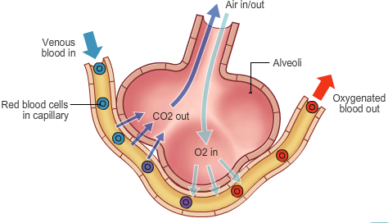
Small intestine
Villi are tiny protrusions in the wall of the small intestine which are well adapted for absorbing digested food by diffusion.
- Increase the surface area of the intestinal wall – more surface available for absorbtion of food
- Thin cell walls allow molecules to pass through to capillaries/blood quickly
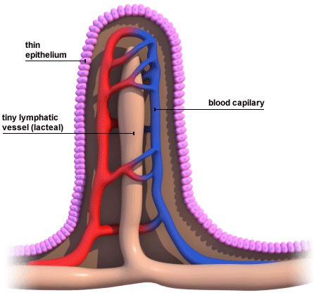
How are plant cells specialised to increase the rate of exchanging materials?
Leaf cells – carbon dioxide (needed for photosynthesis) enters leaf by diffusion, oxygen (by-product of photosynthesis) exits leaf by diffusion
Surface area of leaf increased by flat shape.
Internal air spaces give increased surface area for gas exchange.
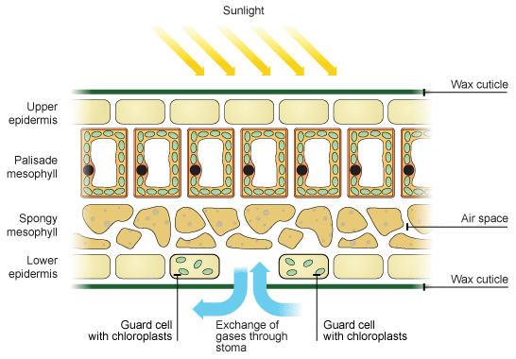
Photosynthesis:chlorophyll
carbon dioxide + water glucose + oxygen
sunlight
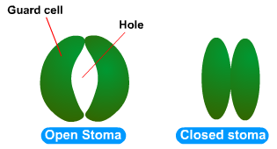
Plants have stomata to obtain carbon dioxide from the atmosphere. Plants lose water vapour from the surface of their leaves – this is called transpiration.
The rate of transpiration is increased in hot, dry and windy conditions. Plants living in these conditions have a thick waxy layer to reduce water loss.
Most transpiration is through the stomata. The size of the stomata is controlled by guard cells. If plants lose water faster than it can be replaced by the roots, the stomata can close up to prevent wilting and to stop photosynthesis from slowing.They would normally only close in the dark when no carbon dioxide is needed for photosynthesis.
Root hair cells –Plants absorb water from the soil by osmosis through their root hair cells. Osmosis is the movement of water from a high water concentration to a low water concentration through a partially permeable membrane.Plants use water for several vital processes including photosynthesis and transporting minerals.
The long shape/large surface area, thin walls and proximity to the xylem cells used for transporting water up the plant means the root hair cells are specially adapted to gaining water from the soil.
You need to bear in mind:
the direction of movement of water
the effect of water movement on the volume and therefore the pressure of the different solutions
that particles move in both directions through the membrane. Changing the pressure or the concentration on one side of the membrane will change the movement of the particles until equilibrium is reached.
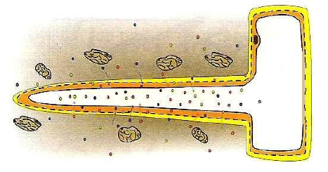
Root hair cells also absorb mineral ions by active transport:
The concentration of minerals in the soil is very low.
They dissolve in water and move around the soil in solution.
Minerals cannot be absorbed byosmosis(which is the movement of water only) or diffusion (because the minerals are in very low concentration).
The root hair cells have carrier molecules on their surface that pick up the minerals and move them into the cell against the concentration gradient.
This requires energy, and is called active transport.

How are dissolved materials transported around the body?
The heart pumps blood around the body. Blood flows from the heart to the organs through arteries and returns through veins. In the organs, blood flows through capillaries.
Substances needed by cells in the body tissues pass out of the blood, and substances produced by the cells pass into the blood through the walls of the capillaries.
There are two separate circulation systems, one to the lungs and one to all the other organs of the body.
The blood is a liquid tissue consisting of:
Plasma
Red blood cells
White blood cells
Platelets
Blood plasma transports:
carbon dioxide from the organs to the lungs
soluble products of digestion from the small intestine to other organs
urea from the liver to the kidneys
hormones
Red blood cells transport oxygen from the lungs to the organs. Red blood cells have no nucleus. They are packed with a red pigment called haemoglobin.
In the lungs oxygen combines with oxygen to form oxyhaemoglobin.
In other organs oxyhaemoglobin splits up into haemoglobin and oxygen.
White blood cellsingest and destroy pathogens, produce antibodies to destroy pathogens, and produce antitoxins that neutralise the toxins released by pathogens.
Platelets are irregularly shaped bodies. They help to form clots to stop bleeding.

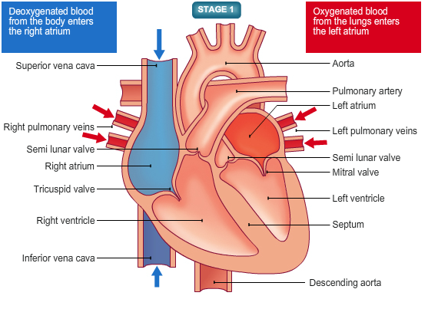

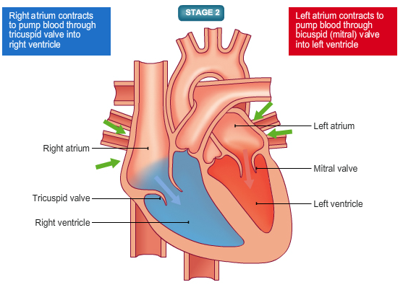
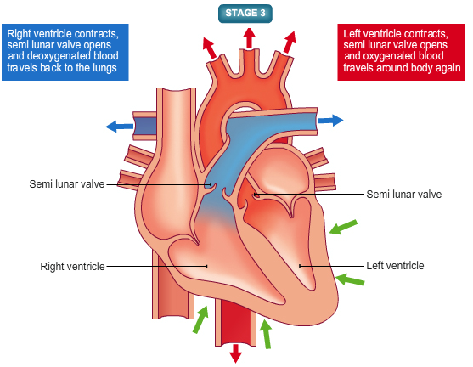

How does exercise affect the exchanges taking place within the body?
During exercise heart rate increases, rate and depth of breathing increases and arteries supplying the muscles dilate.
Blood flow to the muscles is increased (as well as the supply of sugar and oxygen), and the rate of removal of carbon dioxide is increased.
Energy released through respiration is used to enable muscles to contract. Respiration happens in mitochondria in cells. Glycogen stores in the muscles are used during exercise.
Respiration is the process of breaking down glucose to release energy:
Aerobic respiration uses oxygen:
glucose + oxygen carbon dioxide + water (+energy)
This is the most efficient way to release energy from glucose.
Anaerobic respiration happens when there is not enough oxygen available:
glucose lactic acid (+energy)
This is not the best way to release energy from glucose – it is a last resort.
Poisonous lactic acid builds up in the muscles and causes painful cramps. When exercise stops there is an oxygen debt – you must keep breathing in order to get oxygen to the muscles and oxidise the lactic acid into carbon dioxide and water.

The kidneys
Our bodies need to get rid of waste products. Three waste products our bodies must excrete are CO₂, urea and sweat. This is known as homeostasis (controlling conditions inside the body).
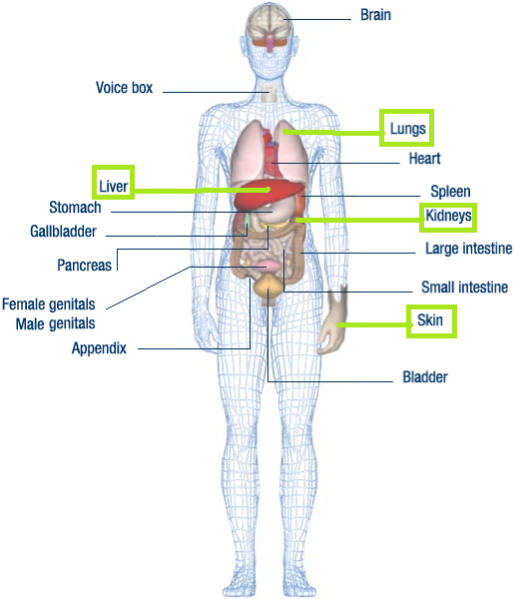
The lungs breathe out CO₂. The liver produces urea.
The kidneys make urine. The skin sweats.

Liver
Urea (a waste product from the breakdown of amino acids) is produced in the liver. Urea is toxic in high concentrations, although the liver releases it into the blood stream to be filtered out by the kidneys.
Kidneys
We take in water from food and drink, and water is a waste product of respiration. We lose water in sweat, faeces, urine and breathing out.
For our cells to work properly their water content must be maintained at the correct level. Our kidneys help us to maintain that balance.
Stages of blood filtration in the kidneys:
Stage 1: Ultrafiltration. Blood is brought to the kidneys to be filtered – blood passes through tiny tubules and water, salt, glucose and urea are squeezed out.
Stage 2: Selective reabsorption.The kidneys send all of the glucose and as much water and salt as the body needs into the blood. Sugar and dissolved ions may be actively absorbed against a concentration gradient.
Stage 3: Waste. Water, salt and urea are left – this is urine. Urine is sent to the through the ureter to the bladder where it is stored before being excreted.
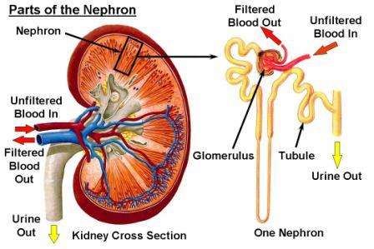

Controlling water content:
The amount of urine produced can be affected by water intake, heat and exercise.
The concentration of urine is controlled by anti-diuretic hormone (ADH) produced by pituitary gland. ADH production is controlled by a negative feedback mechanism:
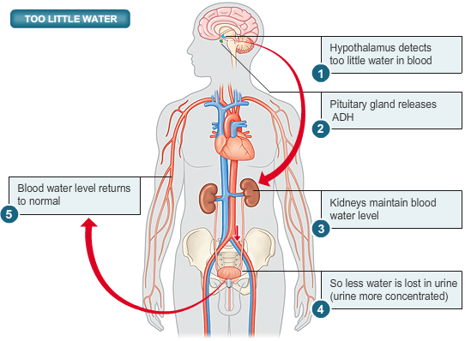
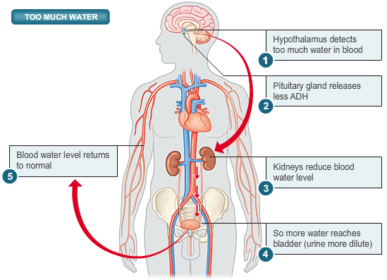
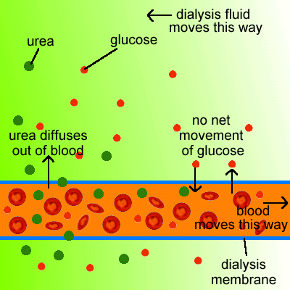
Kidney failure:
Sometimes the kidneys can fail due to infections, toxic substances or genetic reasons. A patient with kidney failure will soon die unless there is a way to rid the body of the urea and excess salt.
A kidney dialysis machine provides an artificial kidney for the sufferers of kidney failure. The patient must use a dialysis machine for 3-4 hours three times a week.
The patients’ blood flows alongside a partially permeable membrane, surrounded by dialysis fluidwhich contains the same concentration of dissolved ions and glucose as the blood (this ensures that glucose and useful mineral ions are not lost)
Ions and waste can pass through, but big molecules like blood cells and proteins can’t pass through (like in the kidneys).
Dialysis removes urea and maintains blood sodium and glucose levels.
Instead of dialysis a kidney could be transplanted into the patient. This option is cheaper than dialysis but it requires a donor (a normal person can still function with one kidney). The new kidney might be rejected by the body’s immune system.
To prevent rejection of the transplanted kidney a donor kidney with a ‘tissue-type’ similar to the recipient is used and the patient can take immunosuppressant drugs.
Transplanted kidneys only work for around 9 years, then the patient has to return to dialysis.
 | Dialysis | Kidney Transplant
Advantages | Can be carried out at home if the patient owns a dialysis machine  No hospital visits are required  Longer living life | Fewer diet and fluid restrictions  More energy  Better quality of life
Dis-advantages | Takes up a lot of time  Risk of infection  Side effects – nausea, vomiting, headaches, muscle cramps, depression | Surgery risks  Risk of rejection  Need to take anti-rejection drugs for life

Bacteria
Bacteria are a type of microorganism – they are microscopic (1/1000 of a mm wide) and are much simpler than animal cells.
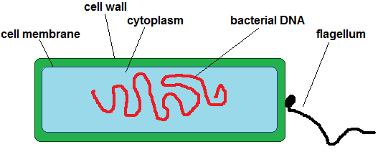
A typical bacterial cell
Bacteria can consume a huge range of organic nutrients from their surroundings. This provides them with energy. Some bacteria can produce their own nutrients.
This means that they can survive pretty much anywhere – soil, water, air, in the human body, in food etc.
Bacteria reproduce by asexual reproduction – they are clones of each other.
They reproduce very quickly, and under certain conditions they reproduce even more quickly.
The study of microorganisms is called microbiology. Scientistssuch as Spallanzani (1768), Schwann (1837) and Pasteur (1878) made important developments in the field of biogenesis:
Spallanzanifound that boiling microbes killed them
Schwannobserved yeast and the fermentation process
Pasteur invented the pasteurisation process, which involves heating to kill most bacteria present in liquids such as milk
Growing a large quantity of microorganisms is called culturing them – this involves growing large numbers to see their behaviour as a colony.
For this to happen, the bacteria need energy, mineral ions and sometimes proteins and vitamins – these are provided in agar, which is a jelly-like substance poured into a petri dish. Cultures are usually incubated to promote growth.
It is essential that microbe culture is done carefully. Even when growing safe microorganisms there is a risk that they can mutate and become harmful pathogens. To reduce the risk of contamination:
1. Petri dishes and culture media must be sterilised to kill unwanted microorganisms
2. Inoculating loops used to transfer microorganisms must be sterilised by passing them through a flame
3. The microorganisms need oxygen, but the lid of the petri dish should be taped down to prevent microorganisms from the air contaminating the culture
Microorganisms can be useful. Yeast is a single-celled organism that is used in making bread and alcoholic drinks.
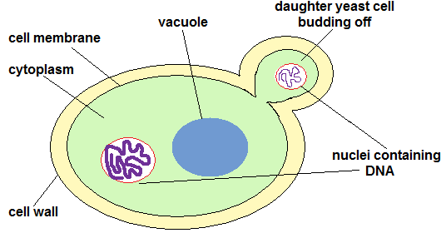
Yeast is a type of fungus. It reproduces asexually by a process called budding.
Yeast can respire aerobically or anaerobically.
Aerobic: glucose + oxygen carbon dioxide + water (+energy)
Anaerobic: glucose ethanol + carbon dioxide (+energy)
C₆H₁₂O₆ 2C₂H₅OH + 2CO₂ (+energy)
Aerobic respiration is the preferred way to break down glucose as it provides more energy necessary for growth and reproduction; however it can respire anaerobically when oxygen is scarce.Ethanol is alcohol. The process of anaerobic respiration is called fermentation.

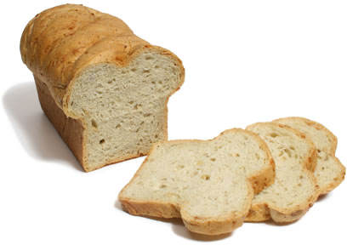 | In bread production, the yeast grows and respires, producing carbon dioxide which causes the bread to rise.  The gas bubbles expand when baked due to the high temperatures.  All yeast cells are killed by the heat in the cooking process.
Beer production relies on the process of malting, where barley grains are soaked in water to keep them warm.
Germination begins and enzymes break down the starch in the grains into a sugary solution.
The solution is extracted and used as an energy source for the yeast.
The yeast and sugar mixture is fermented to produce alcohol, and hops are added for flavour.

The increased concentration of alcohol kills the yeast
The beer is pasteurised to completely stop fermentation
Wine production uses the natural sugars found in grapes for the yeast’s sugar source.
The grapes are pressed for their juice, which is mixed with yeast and water.
The yeast respires anaerobically until all of the sugar is used up.
The wine is filtered to remove the yeast and is left to mature.
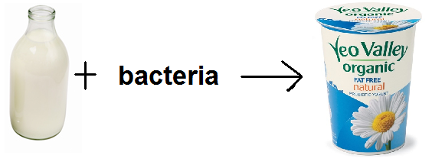 | To make yoghurt, bacteria are used to ferment milk  1. A culture of bacteria are added to warm milk (a blend of Streptococcus thermophilus (ST) and Lactobacillus (LB) are used)  2. The bacteria ferment the milk sugar (lactose) and produce lactic acid – this gives the yoghurt it’s tangy taste  3. The lactic acid causes the milk to solidify to form a yoghurt
Cheese-making is similar to yoghurt production, a different type of bacteria is added that makes far more lactic acid – the solid parts (curds) solidify almost completely
Enzymes are added to separate the milk – the curds are dried out before adding bacteria, and the liquid whey is used for animal feed
Industrial microorganisms
We need microbes in large quantities for production of drugs (e.g. antibiotics) and food. To grow microbes on an industrial scale, large vessels called fermenters are used. They are designed to prevent occurrences which stop bacterial growth by maintaining a stable environment.
Industrial fermenters usually have:
1. An oxygen supply so the microorganisms can respire
2. A stirrer to keep the microorganisms in suspension, maintain an even temperature and ensure oxygen and food are evenly spread out
3. A water-cooled jacket which removes excess heat produced through respiration
4. Measuring devices for pH and temperature so changes can made if necessary
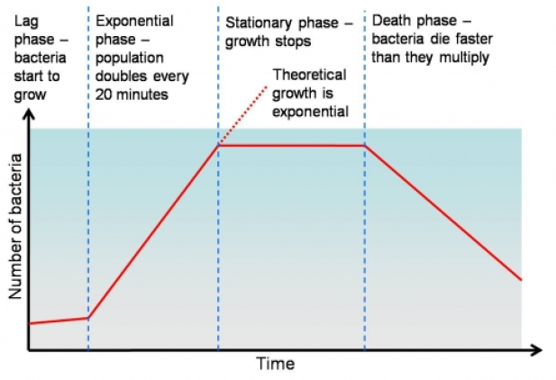
A graph showing bacterial growth for real-life conditions, not ideal industrial conditions

In 1928 Alexander Fleming left some bacteria culture he had been growing near an open window, when he returned, microbes had grown, but there were patches of mould where bacteria had stopped growing – the mould that blew in from the wind had killed the bacteria.
He analysed the mould and found it to be the fungus Penicilliumnotatum. He extracted penicillin from it, which he used to treat a wound.It was difficult to extract much penicillin so he gave up.
During the Second World War, Howard Florey and Ernst Chain did more research into penicillin.They found that mould growing on a melon yielded 200x more penicillin than before. It was grown in deep tanks industrially and by 1945 enough was produced to treat 7 million people per year.
Nowadays, we use strains of the Pencicillium mould that give even higher yields. The mould is grown in a sterilised medium which contains sugar, amino acids, mineral salts and nutrients.
The mould grows rapidly in the first 40 hrs of production, where most of the nutrients are used up. Only when most of these nutrients have gone can penicillin begin to produce, which explains why there is a 40 hr lag between the start of fermentation and the start of penicillin production.
Over the next 140 hrs, broth is removed and nutrients are repeatedly added to get the maximum yield of penicillin.

Mycoprotein is a low-fat, protein-rich food suitable for vegetarians. It is made from the fungus Fusarium.
The fungus grows and reproduces rapidly on a cheap energy supply (sugar syrup) in a fermenter.
It requires aerobic conditions to grow. Its mass doubles every 5 hours or so.
The biomass is harvested, purified and dried to leave mycoprotein – colours and flavours are added to enhance it.

Fuels from fermentation
Biogas, a flammable mixture of gases (mostly methane), forms when bacteria break down the waste material of dead animals or plants in anaerobic conditions.
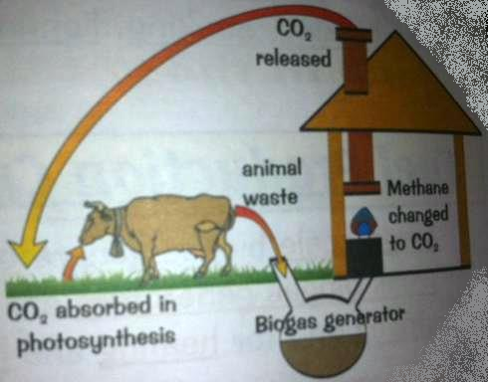
Animal waste, dead animal and plant material, and garden waste all contain carbohydrates which make them a good energy source for biogas generators.
They tend to work best at around 30°C so are usually in hot countries. The reactions that take place are exothermic, so if kept insulated the generator can be used in a cold country.
10kg of dry dung can produce 3m³ of biogas, which can fuel 3 hours of cooking, 3 hours of lighting, or 24 hours of running a fridge.
The leftovers that aren’t converted to gas can be used as fertiliser.
In China, vegetables, human and animal faeces and urine are used,
this produces low quality gas and high amounts of fertiliser.
In India only animal waste is fed in (there are taboos against using human waste), this produces high quality gas but little amounts of fertiliser.
Biogas can be produced on a large scale, or on a small scale.
For example, a small biogas generator can be used to supply the energy needs of a family, or the waste of a sugar factory or sewage works can be used to power a village or town.
Ethanol-based fuels
Sugar cane crops can grow fast – 4-5m per year. Their juice is rich in carbohydrates like sucrose. The starches of Maize can be broken down into glucose by using carbohydrase enzymes.If the sugar rich products of sugar cane or maize are fermented with yeast anaerobically, the sugars break down into ethanol and water.
Ethanol is extracted by distillation and used as a car fuel. Some cars (e.g. in Brazil) run on a mixture of ethanol and petrol (called gasohol - 90% petrol, 10% ethanol). Ethanol does not produce toxic gases when burned and so does not pollute as much as other fuels (which produce CO and SO₂).
Countries like America do not have enough maize crops to produce large amounts of ethanol, and poorer countries that do have the crops don’t have the money to buy the equipment.
Using a fuel like ethanol is called carbon neutral because you are not contributing to carbon dioxide levels in the air by using it.
Distillation
Thisprocess increases the alcohol content of the products of fermentation.
Spirits such as vodka, rum and whisky can be produced.
Vodka is made by distilling fermented potatoes, rum is made by distilling fermented cane sugar, and whisky is made by distilling fermented malted barley.
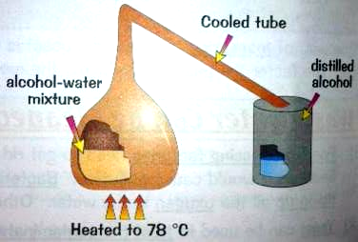
Distillation separates the alcohol out of the alcohol-water solution that is produced by fermentation.
The fermentation products are heated to 78°C – at this temperature alcohol boils and turns into a vapour, the water is left behind as it is not hot enough to boil it.
The alcohol vapour rises and travels through a cooled tube, this causes it to condense back into liquid alcohol, and it runs down the tube into a collecting vessel.
Alcohol can be distilled more than once to increase the quality and purity of the product.
This is more expensive but it means the product has less impurities and people may pay more for it.

Batch generators  These make biogas in small batches  They are manually loaded up with waste, which is left to break down, and the by-products are cleared away at the end of each season | Continuous generators  These make biogas constantly  Waste is continuously fed in, and biogas is produced at a steady rate  These are more suited to large-scale projects
Biogas generators
There are two main types:
A simple biogas generator:
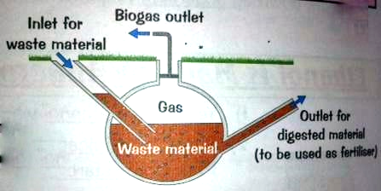
Whether it’s batch or continuous, it needs:
1. an inlet for the waste material to be put in
2. an outlet for the digested material to be removed through
3. a second outlet for the biogas to be piped to where it is needed

Factors to consider when designing a generator:
Cost – Continuous generators are more expensive as waste has to be mechanically pumped in, and digested material has to be mechanically removed constantly
Convenience – Batch generators are less convenient, as they have to be continually loaded, emptied and cleaned
Efficiency – Gas is produced most quickly at 35°C. If the temp.falls below this, gas production will be slower. Generators in some areas will need to be insulated or kept warm. The generator shouldn’t have any leaks, or gas will be lost.
Position – The waste will smell, so generators should be sited away from homes. The generator is also best located close to the waste source.

