Q1. (a) Complete the following sentence by drawing a ring around the correct line in the box.
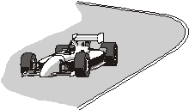

A racing car can accelerate by changing | its direction only  its speed only  either its direction or its speed | .

(1)

(b) A racing car moves round a circular part of a racetrack.
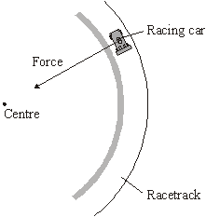
A force acts on the racing car. The force is towards the centre of the circular part of the racetrack.

Complete the following sentences by drawing a ring around the correct line in each of the boxes.
(i)
The force is caused by | electrostatics  friction  gravity | .

(1)

(ii)
The force is a | centripetal force  circular force  perpendicular force | .

(1)

(iii) If another racing car has a greater mass and travels at the same speed
around the same racetrack, then the force will need to | decrease  stay the same  increase | .

(1)

(iv)
When the racing car goes faster, the force will need to | decrease  stay the same  increase | .

(1)

(c) This is an item from a newspaper.
No to racetrack plan
At last night’s meeting, one local resident said, “The racetrack will be noisy but motor racing leads to safety improvements in all our cars.’’
“We’ll need better brakes. Motor racing encourages speeding and leads to more accidents’’, said another.
Most of the residents were against the plan to build a racetrack.

Do you agree with most of the residents?
Put a tick () in the box next to your answer and explain.
Yes No Not sure
.....................................................................................................................................
.....................................................................................................................................
.....................................................................................................................................
.....................................................................................................................................
(2)
(Total 7 marks)

Q2. Malik uses a camera to photograph the Moon.
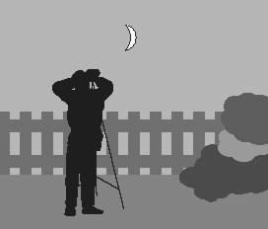

(a) Complete each sentence by choosing the correct words from the box.
You may use each word once, more than once or not at all.
converging | diverging | image | longer
object | real | shorter | virtual

In a camera a ........................................ lens is used to produce an ............................
of an ........................................ on a film. The ........................................ is smaller than
the ........................................ and it is a ........................................ distance from the lens.
(6)

(b) The Moon moves in a nearly circular path around the Earth.
(i) What is the name of the force which causes the Moon to move around the Earth?
...........................................................................................................................
(1)
(ii) In which direction does this force act?
...........................................................................................................................
(1)

(c) A force is needed to make a car change direction when it goes round a bend.
(i) What is the name of this force and where does it act?
...........................................................................................................................
...........................................................................................................................
(2)

(ii) Complete the two spaces in the sentence.
The force needed is greater if the ........................................ of the car is greater and
the ........................................ of the bend is smaller.
(2)

(d) What word is used to describe any force which causes an object to move in a circular path?
....................................................................................................................................
(1)
(Total 13 marks)

Q3. The diagram shows two children playing with a toy called a swing ball. The ball is joined to a pole by a strong string. The children hit the ball so that it goes round in a circular path.
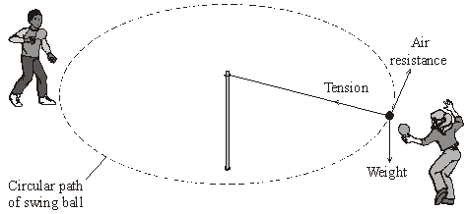
(a) Which force causes the ball to move in a circle?
Draw a ring around your answer.
air resistance tension weight
(1)

(b) Complete the sentences by ticking () the correct ending.

(i) The force needed to make the ball move in a circular path is larger if
the speed of the ball is increased.
the speed of the ball is decreased.
the string is made longer.
(1)

(ii) The continuous acceleration of a ball moving in a circular path changes
the speed of the ball.
the direction of the ball.
the weight of the ball.
(1)

(c) Which of the following words is used to describe any force that causes an object to move in a circular path?
Draw a ring around your answer.
centripetal frictional gravitational universal
(1)
(Total 4 marks)

Q4. The drawing shows a set of carriages on a roller coaster.
The carriages are moving upwards in a nearly circular path at a constant speed.
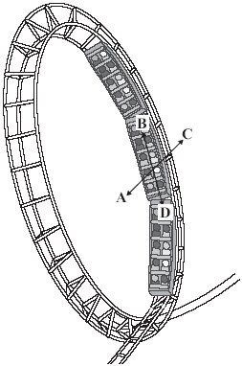

(a) Complete the following sentences by drawing a ring around the correct line in each box.

(i) The carriages will accelerate because of a change in their | direction  mass  speed | .

(1)

(ii) The resultant force which causes the carriages to accelerate is the

circular  centripetal  gravity | force.

(1)

(b) In which direction, A, B, C or D, does the resultant force act?
Write your answer in the box.
(1)

(c) Complete the following sentence by drawing a ring around the correct line in the box.

The resultant force will need to be greater if the | mass of the passengers is greater  radius of the circle is greater  speed of the carriages is less | .

(1)
(Total 4 marks)

Q5. The picture shows a fairground carousel.
The diagram shows the position of one child, at one point in the ride, viewed from above.
Picture Diagram
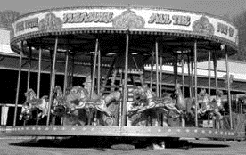 | 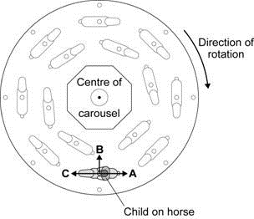

Draw a ring around the correct answer to complete the following sentences.
(a) The resultant force needed to keep the child moving in a circular path is

centripetal
circular
gravitational
called the |  | force.

(1)

A.
B.
C.
(b) The resultant force on the child acts in the direction

(1)

(c) At the end of the ride, as the carousel slows down, the resultant force on

decreases.
stays the same.
increases.
the child

(1)
(Total 3 marks)

Q6. The diagram below shows the orbits for two types of satellite, a polar orbit and a geostationary orbit.
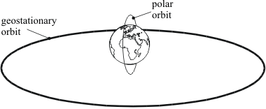

A satellite in stable Earth orbit moves at a constant speed in a circular orbit because there is a single force acting on it.
(i) What is the direction of this force?
.....................................................................................................................................
(1)

(ii) What is the cause of this force?
.....................................................................................................................................
(1)

(iii) What is the effect of this force on the velocity of the satellite?
.....................................................................................................................................
(1)

(iv) In which of the orbits shown above would this force be bigger?
Explain the reason for your answer.
.....................................................................................................................................
.....................................................................................................................................
(2)

(v) Explain why the kinetic energy of the satellite remains constant.
.....................................................................................................................................
.....................................................................................................................................
.....................................................................................................................................
(2)
(Total 7 marks)

Q7. (a) A student has fastened a ball to a piece of string and is swinging it round in a horizontal circle.

(i) The diagram below shows an overhead view of the movement of the ball.
Add an arrow, from the centre of the ball, to show the direction in which the ball would move if the string broke at this instant.
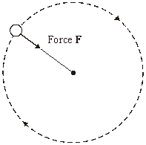
(1)

(ii) Complete the table to show how force F changes if the student changes what he is doing. In each case, all the other factors stay the same.

If the student | Force F needs to
uses a ball with a greater mass | .................................................
swings the ball at a greater
speed | .................................................
swings the ball with a shorter
piece of string | .................................................

(3)

(b) The Moon orbits the Earth in a circular path. Use words from the box to complete the three spaces in the sentence.

direction resistance speed velocity

You may use each word once, more than once or not at all.
The Moon’s ................................. is constant but its .......................................... changes
because its .......................................... changes.
(2)

(c) When any object moves in a circular, or nearly circular, path a force must act towards the centre of the circle.
(i) What word is used to describe this force?
...........................................................................................................................
(1)

(ii) The Moon orbits the Earth. What provides the force towards the Earth?
...........................................................................................................................
(1)

(iii) In an atom, name the particles which are moving in circular paths around the nucleus.
...........................................................................................................................
(1)

(iv) In the case of an atom, what word describes the forces which keep these particles moving in circular paths around the nucleus?
...........................................................................................................................
(1)
(Total 10 marks)

Q8. The fairground ride called ‘The Rotor’ is a large cylinder which rotates. When the cylinder reaches its maximum speed the floor drops away and the riders inside the cylinder are left against the cylinder wall.
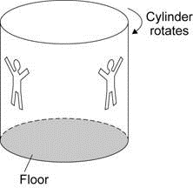

(a) Explain how the cylinder is rotating at a constant speed but at the same time the riders inside the cylinder are accelerating.
........................................................................................................................
........................................................................................................................
........................................................................................................................
........................................................................................................................
........................................................................................................................
........................................................................................................................
(3)

(b) In which direction do the riders accelerate?
........................................................................................................................
(1)

(c) What name is given to the resultant force that causes the riders to accelerate?
........................................................................................................................
(1)

(d) At the end of the ride the floor goes back into place and the cylinder slows down and stops.
How does the resultant force on the riders change as the cylinder slows down?
........................................................................................................................
........................................................................................................................
(1)
(Total 6 marks)

Q9. The London Eye is the largest observation wheel in the world.
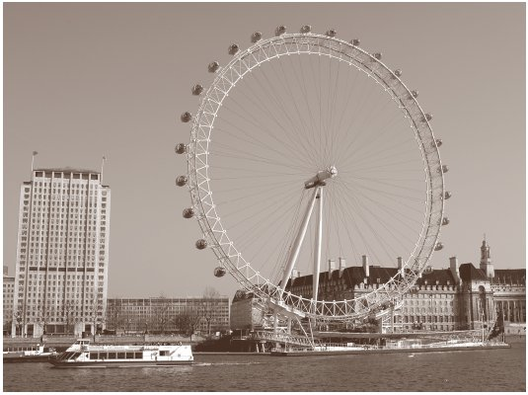
The passengers ride in capsules. Each capsule moves in a circular path and accelerates.
(a) Explain how the wheel can move at a steady speed and the capsules accelerate at the same time.
....................................................................................................................................
....................................................................................................................................
....................................................................................................................................
(2)

(b) In which direction does each capsule accelerate?
....................................................................................................................................
(1)

(c) What is the name of the resultant force that causes the capsules to accelerate?
....................................................................................................................................
(1)

(d) The designers of the London Eye had to consider three factors which affect the resultant force described in part (c).
Two factors that increase the resultant force are
• an increase in the speed of rotation
• an increase in the total mass of the wheel, the capsules and the passengers.
Name the other factor that affects the resultant force and state what effect it has on the resultant force.
....................................................................................................................................
....................................................................................................................................
(1)
(Total 5 marks)

Q10. This page is from a science magazine.

The Red Planet
The two natural satellites, or moons, of Mars are Phobos (fear) and Deimos (terror). They are named after the horses which pulled the chariot of Mars, the god of war in the mythology of Ancient Greece.
Phobos takes less than eight hours to orbit Mars and gets slightly closer every time it does so. Scientists predict that in about 100 million years time it will either be ripped apart by the gravitational force or will crash onto the surface of Mars.

(a) Suggest how scientists have arrived at their prediction of about 100 million years.
.....................................................................................................................................
.....................................................................................................................................
(2)

(b) The centripetal force on Phobos is gradually changing as it orbits Mars.
Is the force increasing or decreasing?
.....................................................................................................................................
Explain your answer.
.....................................................................................................................................
.....................................................................................................................................
.....................................................................................................................................
(2)

(c) Scientists expect that the mass of Mars and the mass of Phobos will not increase.
Explain what will happen to the gravitational force on Phobos as it orbits Mars.
.....................................................................................................................................
.....................................................................................................................................
.....................................................................................................................................
.....................................................................................................................................
(2)
(Total 6 marks)

M1. (a) either its direction or its speed
1
(b) (i) friction
1
(ii) centripetal
1
(iii) increase
1
(iv) increase
1

(c) examples
(yes) noisy (1)
disturbs people living nearby (1)
(yes) encourages people to drive fast (1) which makes (road) accidents more serious/likely (1)
(no) leads to improvements in safety features (1) such as better brakes (1)
(don’t know) noisy (1) but new tyres have a better grip (1)
whichever box has been ticked, the mark(s) is/are for an appropriate response
note, accept responses which assume that the public may use the racetrack
2
[7]

M2. (a) converging
1
image
1
object
1
image
1
object
1
shorter
1

(b) (i) (Earth’s) gravity
accept centripetal
accept minor misspellings, however,
do not credit any response which could be ‘centrifugal’
1
(ii) to(wards) (the centre of the) Earth
allow inwards do not accept downwards
1

(c) (i) either
friction (force) or centripetal force
allow grip
1
between the tyres / wheels and (the surface of) the road
allow on the tyres / wheels
or towards the centre of the bend / arc / circle
1
(ii) mass or speed or momentum
allow weight allow velocity
1
radius / diameter
do not credit ‘curvature’ or ‘circumference’
1

(d) centripetal
accept minor misspellings (see above)
1
[13]

M3. (a) tension
accept any unambiguous method of indication eg it’s underlined or ticked
1

(b) (i) speed of the ball is increased
1
(ii) the direction of the ball
1

(c) centripetal
accept any unambiguous method of indication
eg it’s underlined or ticked
1
[4]

M4. (a) (i) direction
accept any unambiguous indication
1

(ii) centripetal
accept any unambiguous indication
1

(b) A
accept any unambiguous indication
1

(c) mass of the passengers is greater
accept any unambiguous indication
1
[4]

M5. (a) centripetal
1
(b) B
1
(c) decreases
1
[3]

M6. (i) towards Earth
for 1 mark
1

(ii) gravity
for 1 mark
1

(iii) changes direction
for 1 mark
1

(iv) polar orbit;
closer
for 1 mark each
2

(v) speed constant (1)
mass constant (1)
for 1 mark each
2
[7]

M7. (a) (i) arrow from centre of the ball and at right angles to the string
and in the correct direction
arrow should point to the student’s belt
accept free-hand ‘straight’ line
do not accept curved line
1
(ii) increase
accept ‘be stronger / bigger’
1
increase
accept ‘be stronger / bigger’
1
increase
accept ‘be stronger / bigger’
1

(b) speed
velocity
direction
all three correct
any two correct for 1 mark
otherwise 0 marks
2

(c) (i) centripetal
accept ‘centripedal’ and other minor misspellings
do not accept anything which could be ‘centrifugal’
1

(ii) gravity
accept ‘weight’
accept ‘force of attraction due to mass(es) (of the
Moon and the Earth)’
1

(iii) electron(s)
1

(iv) electrostatic
accept ‘electrical’
do not accept just ‘centripetal’
1
[10]

M8. (a) the direction of the riders is constantly changing
1
therefore the velocity of the riders is changing
1
and because acceleration is the rate of change of velocity
the acceleration is changing
1

(b) to(wards) the centre (of the cylinder / rotor)
1

(b) centripetal
1

(b) it is reduced
1
[6]

M9. (a) any two ideas:
• (acceleration occurs when) the direction (of each capsule) changes
• velocity has direction
• acceleration is (rate of) change of velocity
2

(b) to(wards) the centre (of the wheel)
1

(c) centripetal
allow minor misspellings but do not credit a response which could be ‘centrifugal’
1

(d) the greater the radius / diameter / circumference (of the wheel)
the smaller the (resultant) force (required)
accept ‘the size’
both parts required for the mark
accept converse
1
[5]

M10. (a) (from present/recent) data/evidence/observations of (the rate of change in)
Phobos’/the moon’s orbit (1)
or appropriate example of data (1)
and its correct use (1)
(and) continued/extended/extrapolated
(the pattern/trend for the next 100 million years) (1)
example (present) distance from Phobos to Mars (1)
÷ (average) rate of approach (1)
2

(b) (it is) increasing (1)
Phobos/the moon will be nearer (to Mars) (1)
or the radius/circumference/diameter of the orbit of Phobos/the moon will decrease/be less
only credit 2nd mark if the first mark is correct
2

(c) it will increase/be more (1)
(because) Phobos/the moon will get/be closer to Mars/the planet (1)
only credit 2nd mark if the first mark is correct
note part(s) of this response may be included as the answer to part (b)
read both before marks are awarded
2
[6]

E1. (a)(b) Less than half the candidates recognised that a racing car can accelerate by (b) changing either its direction or its speed and identified friction as the force acting on a racing car and towards the centre of a circular part of the track.
However, nearly all recognised that friction is acting as the centripetal force and most knew that it would be increased if the racing car had a greater mass and travelled faster.
(c) Most candidates gained full marks on this item. Some candidates thought that members of the public would be able to use the racetrack and the mark scheme makes it clear that this idea is acceptable.

E2. (a) Many candidates obtained full marks in this part.
(b) (i) Most candidates correctly gave ‘gravity’ or ‘gravitational attraction’ in this part.
(ii) Not all the candidates who gave the correct answer in part (b)(i) were able to give the correct direction in this part. ‘Towards the Sun’ and ‘clockwise’ were sometimes suggested and the examiners did not consider that ‘downwards’ was an appropriate response in the context of the question.
(c) (i) ‘Friction’ was rarely suggested in this part although, if it was, then it was usually correctly located between the tyres and the road surface.
(ii) Most candidates correctly indicated that the force would be greater if the mass, or the speed, of the car was greater, but very few could express themselves correctly and describe a tighter bend. Many candidates suggested ‘angle’ or ‘curve’ for the second word and if these words convey any meaning here, it is the opposite of what might have been intended. The word ‘diameter’ or ‘radius’ was hardly ever seen.
(d) Only a very small minority gave the correct response to this part. Of the incorrect responses, ‘orbit’ was the most common.

E3. (a) Most candidates correctly selected ‘tension’.

(b) (i) More candidates chose the incorrect response ‘the string is made longer’ than candidates who chose the correct response ‘the speed of the ball is increased’.
(ii) Only a small minority of candidates correctly associated ‘acceleration’ with a change in direction.

(c) A large majority of candidates correctly selected ‘centripetal’.

E4. (a) (i)(ii) Just over half the candidates correctly linked acceleration with change in direction and two thirds were able to identify the resultant force as centripetal.

(b) A minority of candidates gave the correct direction for this force.
(c) About half of the candidates knew that it will need to be greater if the mass of the passengers is greater.

E6. The direction and cause of the force were well known but the effect on the velocity was not. The correct orbit was frequently chosen but many missed the simple answer to part (v), namely the mass and speed remain constant.

E7. Part (a)(i) was only answered correctly by a minority of candidates. In part (a)(ii) many seemed to have convinced themselves that the answers could not all be the same. The most common mistake was to conclude that, if the radius is smaller, the force needed will also be smaller.

Only a minority gained both marks. Candidates often did not seem to have a clear understanding of the Moon’s circular motion nor of the difference between speed and velocity.

In part (c) the answers to parts (ii) and (iii) were usually correct but ‘centripetal’ in part (i) was less well known, and in part (iv) ‘electrostatic’ was almost never seen.

E9. (a) A minority of candidates realised that, as velocity is speed in a particular direction and the direction of each moving carriage is changing then each moving carriage must be accelerating.
(b) Only a minority of candidates stated that the acceleration is towards the centre of the wheel.
(c) Most candidates correctly identified the resultant force as a ‘centripetal’ force.
(d) Examiners were pleased to note that a significant proportion of candidates were able to identify the other factor as the radius of the wheel and were able to state that the greater the radius the smaller the resultant force.

E10. (a) Most candidates realised that the scientists must have made observations and gave an example of the data, such as the rate at which Phobos is approaching Mars, they would use to help them make their estimate of 100 million years. However, only a minority were able to gain the second mark by explaining how the data could be used.
(b) Most candidates knew that the centripetal force must be increasing and correctly explained this by stating that the radius of its orbit is decreasing or that Phobos is getting closer to Mars.
(c) Most candidates realised that the explanation is that the gravitational force will increase as the moon gets closer to Mars.

