Q1. (a) The diagram shows the cross-section of an eye.
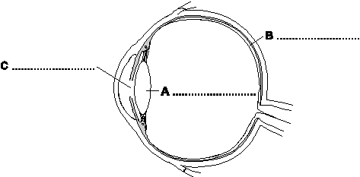
Use words from the box to label the parts, A, B and C.

cornea iris lens pupil retina

(3)

(b) The diagram shows one of the eyes of a person who is short-sighted.
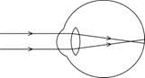
Which one of the following lenses, J, K or L, could be used to correct the person’s eyesight?
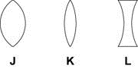
Lens .......................................
Give a reason for your choice.
........................................................................................................................
........................................................................................................................
(2)
(Total 5 marks)

Q2. The diagram shows a ray of light travelling through a glass block.
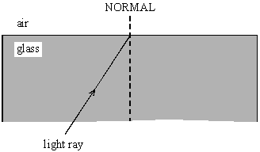

(a) Complete the diagram to show what happens to the ray of light when it comes out of the glass.
(2)

(b) Explain why this happens to the ray of light.
.....................................................................................................................................
(2)
(Total 4 marks)

Q3. (a) The diagram shows two parallel rays of light, a lens and its axis.
(i) Complete the diagram to show what happens to the rays.
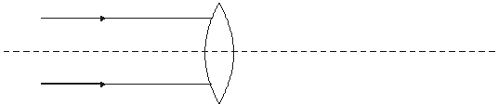
(2)

(ii) Name the point where the rays come together.
...........................................................................................................................
(1)

(iii) What word can be used to describe this type of lens?
...........................................................................................................................
(1)

(b) The diagram shows two parallel rays of light, a lens and its axis.
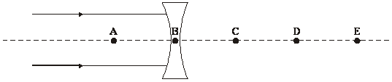

(i) Which point A, B, C, D or E shows the focal point for this diagram?
Point ..................
(1)

(ii) Explain your answer to part (b)(i).
...........................................................................................................................
...........................................................................................................................
(1)

(iii) What word can be used to describe this type of lens?
...........................................................................................................................
(1)

(c) Complete the following three sentences by crossing out the two lines in each box which are wrong

 | film
In a camera a converging lens is used to produce an image on a | lens | .
 | screen

The image is | larger than  smaller than  the same size as | the object.

Compared to the distance of the image from the lens, the object is | further away from  nearer to  the same distance from

the lens.
(3)

(d) Explain the difference between a real image and a virtual image.
.....................................................................................................................................
.....................................................................................................................................
.....................................................................................................................................
.....................................................................................................................................
.....................................................................................................................................
.....................................................................................................................................
(3)
(Total 13 marks)

Q4. (a) The diagram shows how parallel rays of light pass through a convex lens.
(i) Mark the position of the focus.
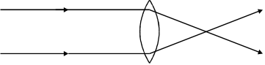
(1)

(ii) Is this a converging lens, a diverging lens, both or neither?
.........................................................................................................................
(1)

(b) The diagram shows how parallel rays of light pass through a concave lens.
(i) Mark the position of the focus.
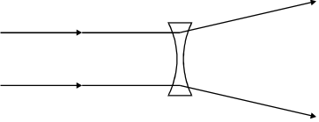
(1)

(ii) Is this a converging lens, a diverging lens, both or neither?
.........................................................................................................................
(1)

(c) Complete these sentences by crossing out the two lines in each box that are wrong.
In a camera, a 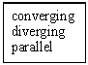 lens is used to produce an image of an object on a 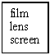.
The image is 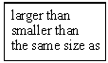 the object.
The image is 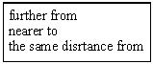 the lens, compared to the distance of the object from the lens.
(4)

(d) In a cinema projector, a convex lens is used to produce a magnified, real image.
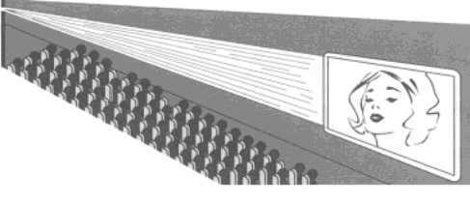

(i) What does magnified mean?
.........................................................................................................................
.........................................................................................................................
(1)

(ii) What is a real image?
.........................................................................................................................
.........................................................................................................................
(1)

(e) You are in a dark room. You have a box containing some lenses. Only one of them is a
converging lens.
Describe how, by just feeling the lenses, you can pick out the converging lens.
...................................................................................................................................
...................................................................................................................................
...................................................................................................................................
...................................................................................................................................
(2)
(Total 12 marks)

Q5. The ray diagram shows the position and size of the image, I, of an object, O, formed by a lens, L.
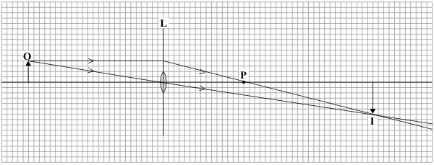
(a) What type of lens is shown in the ray diagram?
.....................................................................................................................................
(1)

(b) Name the point labelled P.
.....................................................................................................................................
(1)

(c) The ray diagram has been drawn to scale.
Use the equation in the box to calculate the magnification.
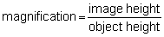

Show clearly how you work out your answer.
.....................................................................................................................................
.....................................................................................................................................
Magnification = ..............................
(2)

(d) How can you tell from this ray diagram that the image is a real image?
.....................................................................................................................................
.....................................................................................................................................
(1)
(Total 5 marks)

Q6. The ray diagram shows a converging lens being used as a magnifying glass.
The diagram has been drawn to scale.
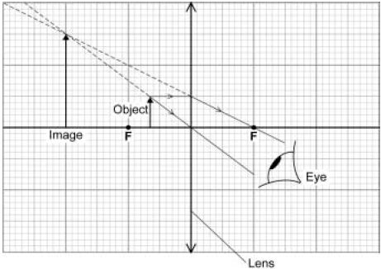

(a) What name is given to the type of lens used as a magnifying glass?
........................................................................................................................
(1)

(b) Calculate the magnification produced by the lens.
Write down the equation you use, and then show clearly how you work out your answer.
........................................................................................................................
........................................................................................................................
........................................................................................................................
........................................................................................................................
........................................................................................................................
........................................................................................................................
Magnification = .....................................
(2)

(c) Describe the image produced by a magnifying glass.
........................................................................................................................
........................................................................................................................
........................................................................................................................
(3)
(Total 6 marks)

Q7. (a) A student investigated the refraction of light as it passes out of a transparent plastic block.
She aimed a ray of light at point X. She marked the position of the ray as it passed through the transparent plastic block and into the air.
The angle i is the angle of incidence.
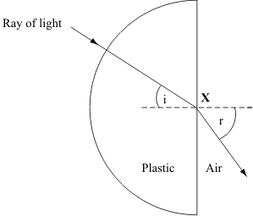
(i) What is the name of angle r?
..........................................................................................................................
(1)

(ii) What is the name of the dashed line?
..........................................................................................................................
(1)

(b) A camera uses a lens to produce an image which falls on a light detector.
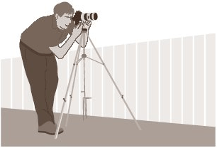
Name a light detecting device which may be used in a camera.
....................................................................................................................................
(1)

(c) The diagram shows the position of an image formed in a camera.
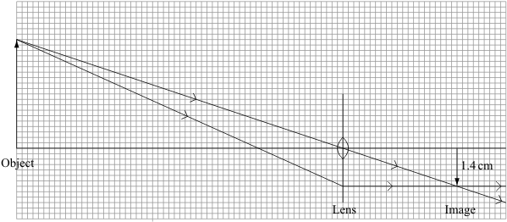
(i) What type of lens is shown in the diagram?
..........................................................................................................................
(1)

(ii) Use the equation in the box to calculate the magnification.
magnification = 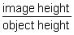

Show clearly how you work out your answer.
..........................................................................................................................
..........................................................................................................................
Magnification = ....................
(2)

(d) Why does the image formed in a camera have to be a real image?
....................................................................................................................................
....................................................................................................................................
(1)
(Total 7 marks)

Q8. The diagrams show how the same two lenses can be used to make a microscope or a telescope.
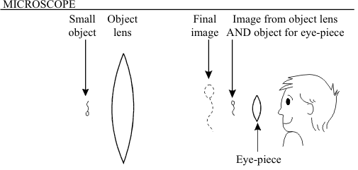
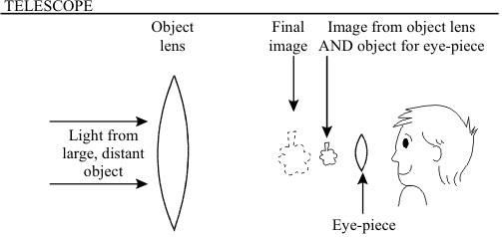

The microscope and the telescope made from the two lenses are similar in some ways but different in others.
Complete the table to show these similarities and differences.
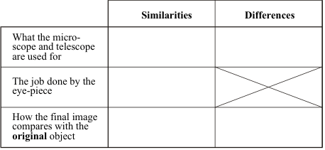
(Total 7 marks)

Q9. Lenses are used in many optical devices.
Complete the table below about the images formed by some optical devices.

OPTICAL  DEVICE | NATURE OF  IMAGE | SIZE OF  IMAGE | POSITION OF  IMAGE
Eye | real
Projector |  | Magnified
camera |  |  | Closer to lens  than the object

(Total 6 marks)

Q10. (a) The diagrams show rays of light. Each ray strikes a surface of a glass block.
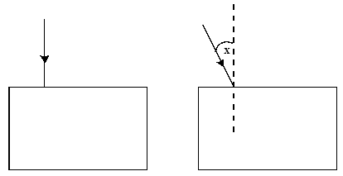

(i) On the diagram draw the path of each ray through the glass block and out into the air again.
(ii) Label another angle on the diagram which is equal to the angle marked X. Label this angle Y.
(4)

(b) The diagrams show two beakers. Both beakers have a drawing pin inside as shown.
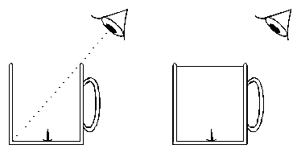

The first beaker is empty. The eye cannot see the drawing pin.
The second beaker is full of water and the eye can see the drawing pin.

Explain how the eye is able to see the drawing pin in the second beaker. You may add to the diagram if it helps your answer.
.....................................................................................................................................
.....................................................................................................................................
.....................................................................................................................................
(3)
(Total 7 marks)

Q11. The diagram shows an object located vertically on the principal axis of a diverging lens. A student looks through the lens and can see an image of the object.
(a) Using a pencil and ruler to draw construction lines on the diagram, show how light from the object enters the student’s eye and the size and position of the image.
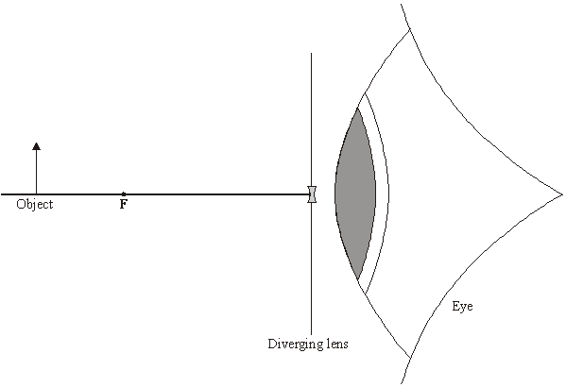
(3)

(b) Describe the nature of the image by comparing it to the object.
.....................................................................................................................................
.....................................................................................................................................
.....................................................................................................................................
.....................................................................................................................................
(2)
(Total 5 marks)

Q12. (a) The diagrams below show rays of light striking a mirror and a perspex block.
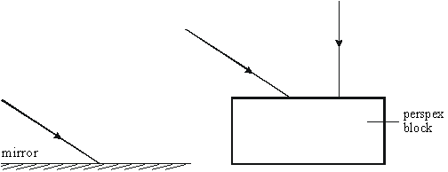

Complete the paths of the three rays of light on the diagrams to show the rays leaving the mirror and the perspex block.
(4)

(b) The diagram below shows a beam of light striking a perspex block.
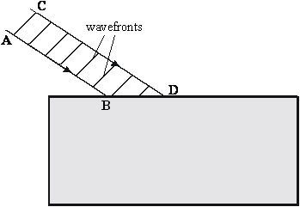

(i) Continue the paths of the rays AB and CD inside the perspex block.

(ii) Draw the wavefronts of the beam of light in the perspex.

(iii) Explain why the beam behaves in the way you have shown.
..........................................................................................................................
..........................................................................................................................
..........................................................................................................................
(7)

(c) The diagram below shows a ray of light striking a perspex-air surface from inside the perspex. The critical angle is 45º.
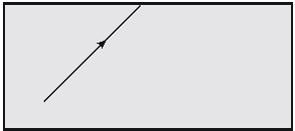
Draw the path of the ray after it reaches the perspex-air boundary.
(2)
(Total 13 marks)

Q13. The diagram shows the cross-section of an eye.
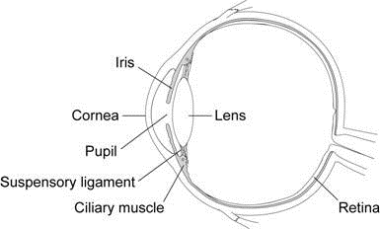

(a) Use words from the box to complete each sentence.

ciliary muscle cornea iris pupil

The shape of the lens is changed by the ....................................................... ,
this allows the lens together with the ......................................... to focus light
onto the retina.
(2)

(b) A man, as he gets older, needs to hold a book further from his eyes in order to be able to see the writing clearly.
The diagram shows that his eye lens is not able to focus light on the retina.
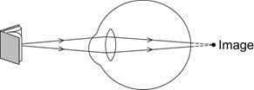

(i) How has the ‘near point’ of the man’s eyes changed as he has got older?
...............................................................................................................
...............................................................................................................
(1)

(ii) The problem can be solved by wearing reading glasses.
Complete the diagram below to show how the lens below is able to correct the man’s vision.
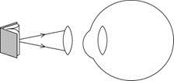
(2)

(c) Give two similarities between an eye and a camera.
1 .....................................................................................................................
........................................................................................................................
2 .....................................................................................................................
........................................................................................................................
(2)
(Total 7 marks)

Q14. (a) The diagram shows a lens used as a magnifying glass. The position of the eye is shown and the size and position of an object standing at point O.
(i) What type of lens is shown in the diagram?
...........................................................................................................................
(1)

(ii) Two points are marked as F. What are these points?
...........................................................................................................................
(1)

(iii) What is the name of the straight line which goes through the point F, through the point L at the centre of the lens, and through the point F on the other side?
...........................................................................................................................
(1)

(iv) On the diagram, use a ruler to construct accurately the position of the image. You should show how you construct your ray diagram and how light appears to come from this image to enter the eye.
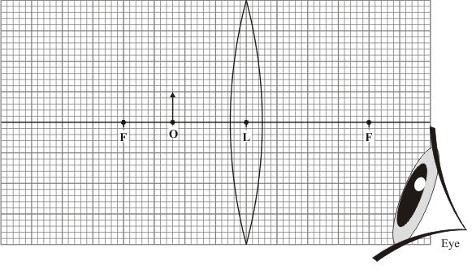
(5)

(v) The image is virtual. What is a virtual image?
...........................................................................................................................
...........................................................................................................................
(1)

(b) The lens shown in the diagram in part (a)(iv) can be used in a camera to produce a real image.
Explain why a real image must be produced in a camera and how the object and the lens are positioned to produce a real image which is smaller than the object.
Do not draw a ray diagram as part of your answer.
....................................................................................................................................
....................................................................................................................................
....................................................................................................................................
....................................................................................................................................
....................................................................................................................................
....................................................................................................................................
(3)
(Total 12 marks)

Q15. The diagram shows the image IC formed by a lens, of an object OB a long way from it. The points F mark the focal points of the lens.
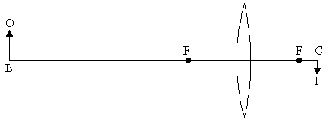

(a) Describe, either by writing below or drawing on the diagram, how the size and position of the image changes:

(i) when the object OB is moved towards the focal point F.
.........................................................................................................................
.........................................................................................................................

(ii) when the object OB is moved past F to a point nearer the lens than the focal point.
.........................................................................................................................
.........................................................................................................................
(4)

(b) Explain how a converging lens in a camera is used to produce sharp images on the film when the object is a long distance away from the camera, and when it is close to the camera.
...................................................................................................................................
...................................................................................................................................
...................................................................................................................................
...................................................................................................................................
...................................................................................................................................
(3)
(Total 7 marks)

Q16. The diagram shows a ray of light passing through a diverging lens.
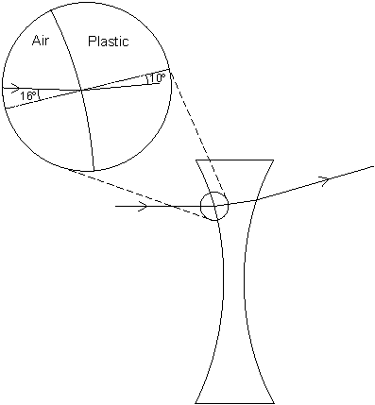

(a) Use the information in the diagram to calculate the refractive index of the plastic used to make the lens.
Write down the equation you use, and then show clearly how you work out your answer.
........................................................................................................................
........................................................................................................................
........................................................................................................................
........................................................................................................................
........................................................................................................................
........................................................................................................................
Refractive index = ..................................
(2)

(b) The focal length of the lens is 5 cm. A student looking through the lens sees
the image of a pin.
Complete the ray diagram below to show how the image of the pin is formed.
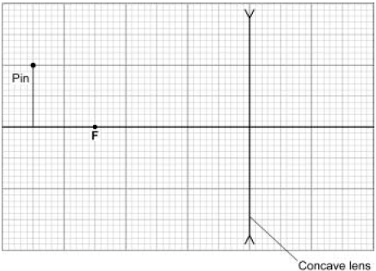
(3)
(Total 5 marks)

M1. (a) A – lens
1
B – retina
1
C – pupil
1

(b) L
1
it diverges the light (before entering the eye)
or
it will make the light focus on the retina
accept spreads for diverges
1
[5]

M2. (a) ray shown refracted (to rhs or along normal)
gains 1 mark
but
ray shown refracted away from normal
gains 2 marks
2

(b) idea that
travels at a different speed
gains 1 mark
(allow refracted / travels slower in air / air is less dense) (do not allow bent)
but
travels more quickly in air
gains 2 marks
2
[4]

##
(a) (i) rays continued to meet on the right hand side of the lens and beyond
must be straight lines from the right hand side of the lens
ignore details through the lens
allow if no arrows
1
meet exactly on the axis
negate mark if contradictory arrow(s) added
do not need to go beyond the focus for this mark
1

(ii) (principal) focus
or focal (point)
1
(iii) converging
or convex
1

(b) (i) A
1

(ii) rays seem to come from this point
or words to this effect
or shows this on the diagram
1

(iii) diverging
or concave
1

(c) film
accept any unambiguous method of showing the correct response
1
smaller than
1
further away from
1

(d) any three from:
• real image can be put on a screen
allow film
• virtual image cannot be put on a screen / film
• virtual image is imaginary
• real image is formed where (real) rays cross / converge
allow real image has light travelling through it
• virtual image is where virtual / imaginary rays (seem to) come from
or virtual image is where rays seem to come from
• virtual image formed where virtual rays intersect / cross
3
[13]

M4. (a) (i) point where the rays cross
do not credit if ambiguous
1
(ii) converging (lens)
do not accept convex
1

(b) (i) point where the rays appear to diverge from
this should appear to be within 10mm in front of the back of the arrows on the approximate centre line
need not be accurately constructed using a ruler
1

(ii) diverging (lens)
do not accept concave
1

(c) converging
1
film
1
smaller than
nearer to
accept any clear indication of the response e.g. ticking, ringing, writing in after a mistake
1

(d) (i) (image) bigger than object enlarge
accept just 'made bigger'
1

(ii) it / real image can be put on a screen or real image on the opposite side
of the lens to the object
accept 'not an imaginary or virtual image'
assume 'it' refers to a real image
do not credit 'it can be seen'
1

(e) either (the converging lens is) thick in the middle thin(ner) at the edge
1
thickest in the middle gains 2 marks
1
or (both) sides bend outwards (1) in the middle (1)
convex gains 2 marks
suitable diagrams gains 2 marks
or one side bends in the middle (1) more than the other side bends inwards
(in the middle) (1)
1
[12]

M5. (a) converging
or convex
1

(b) (principal) focus
or focal point
1

(c) either (×)1.5 or (×)1½ or 150%
unambiguous evidence of appropriate measurements for 1 mark only eg 4 and 6 or 8 and 12 or 0.8 and 1.2
2

(d) real rays cross to form it / formed at the intersection of real rays
accept ‘image on the opposite side of the lens to the object’
accept ‘can be put onto a screen’
1
[5]

M6. (a) converging
accept convex
1

(b) 3
allow 1 mark for substitution into the correct equation
ie 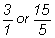
2

(c) bigger
accept magnified
1
upright
1
virtual
1
[6]

M7. (a) (i) (angle of) refraction
take care not to credit ‘angle of reflection’
1

(ii) normal
do not credit ‘horizontal’
1

(b) either
(photographic) film
or CCD(s) (charge-coupled device(s)) / CMOS(s) (sensor(s)) / (active) pixel sensor(s)
accept ‘LDR(s)’ / ‘light dependent resistor(s)’
not lux meter
do not accept light sensor(s)
1

(c) (i) converging
or ‘convex’
1

(ii) either
(0).35
or (0).4(1...)
do not give any credit for an answer greater than 1
or
7 ÷ 20 for 1 mark
or
clear evidence that appropriate measuring / counting, has been made for 1 mark
2

(d) otherwise it will have no effect on the light detector
or otherwise no (real) light will fall on the light detector
or ‘a virtual / imaginary image will have no effect on the light detector’
allow error carried forwards for ‘light detector’
allow so it can be formed on the film
1
[7]

M8. makes things look bigger/clearer/nearer M used for small objects;
or to see things better T used for distant objects
magnifies or makes it bigger
‘it’ = image of object; bigger for M;
inverted/upsidedown/ other way up smaller for T
any seven for 1 mark each
[7]

M9. Eye – Diminished/smaller than object
Nearer the lens than object or on the retina
for 1 mark each
2
Projector – real
Further from lens than object
for 1 mark each
2
Camera – real
Smaller (than object)
for 1 mark each
2
[6]

M10. (a) (i) Ignore arrows on rays
perpendicular rays goes straight in and out
other ray refracts towards normal (not along)
emerges parallel incident ray (by sight) if refraction correct (ignore reflections)
for 1 mark each
3

(ii) emergent angle marked Y if emerges parallel to right of normal
for 1 mark
1

(b) straight ray to water surface refracts/bends
straight to eye/towards surface on right image correctly shown
or states the same mark prose only of diagram incomplete
any 3 for 1 mark each
3
[7]

M11. (a) straight line from the tip of the object
… straight through the centre of the lens (1)
… parallel to the axis, then diverges from the lens as if from F (1)
image drawn from where these lines intersect, vertically to the axis (1)
example
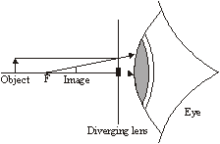
3

(b) any two from:
• smaller (than the object)
• (both) upright
• image is virtual / imaginary (whereas object is real)
no errors carried forward from the candidate’s diagram
mark first two points given
2
[5]

M12. (a) Reflection correct
Normal incidence correct in and out
Correct refraction in
Parallel ray out
each for 1 mark
4

(b) (i) Each ray correctly refracted in
1 + 1 = 2
7

(ii) Wavefronts perp sides
Wavefronts closer
(Cannot score wavefront marks if refracted rays clearly wrong)

(iii) Speed reduces
Starting at B
Then D
each for 1 mark

(c) TIR correct
gets 2 marks
Else rough reflection
gets 1 mark
2
[13]

M13. (a) ciliary muscle
1
cornea
1

(b) (i) moved further (from his eyes)
1

(ii) rays between lens and eye converging
1
rays inside eye focus on the retina
1

(c) any two from:
• both use a converging lens
• image formed is real
• image is inverted
• image in eye formed on retina, image in camera formed
on film / CCDs
• amount of light entering eye and camera can be controlled
2
[7]

M14. (a) (i) converging / convex / biconvex
1
(ii) focal (points) or foci
accept focuses or focus (point)
1
(iii) (principal) axis
1

(iv)
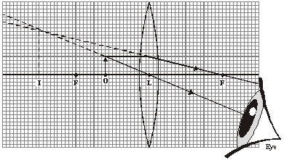

all lines drawn with a ruler for full marks
no ruler, penalise 1 mark from first four
last mark can still be awarded
double refraction drawn could get 4 out of 5 marks
ray that continues from the top of the object through L
to the eye
1
horizontal ray from the top of the object, refracted by the lens
and continued through F on the r.h.s. to the eye
1
back projections of these rays (shown as dotted lines)
1
image 25 mm high at 61 mm left of L
(tolerance 1 mm ± vertically, 2 mm ± horizontally)
1
at least one arrow shown on real ray and towards the eye
but do not credit if contradicted by other arrow(s)
1

(v) formed where imaginary rays intersect / cross or not formed by real rays
accept (virtual image) is imaginary
accept cannot be put on screen
do not credit just ‘… is not real’
1

(b) (the image) needs to fall on film / sensors / LDRs / CCDs
accept just ‘charged couples’
do not credit ‘… solar cells’
do not accept virtual image cannot be stored
1
either to cause a (chemical) reaction or to be digitalised
for credit response must be appropriate to camera type
1
object (should be) on the far side of F / the focus (from the lens)
or … more than the focal length (away from the lens)
allow ‘beyond the focus’
or object should be more than twice the distance / 2F (from the lens) (2 marks)
or … more than twice the focal length (away from the lens)
(2 marks)
1
[12]

M15. (a) (i) Image distance increases
Image size increases
Remains inverted
Remains real
for 1 mark each
2

(ii) Image distance decreases
Image size decreases
Becomes upright
Becomes virtual
for 1 mark each
2

(b) Move lens with respect to film
Closer for distant objects
Further for near objects
for 1 mark each
3
[7]

M16. (a) 1.59
accept an answer that rounds to this
allow 1 mark for correct substitution into correct equation
ie refractive index = 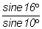
2

(b) 2 lines correctly drawn from the top of the pin through the lens
allow 1 mark for each
2
position of image correct
image must be upright
1
[5]

E3. In part (a)(i) most candidates gained at least one mark. The most common mistakes were either to not continue the lines once the focus had been reached or to not have the focus on the axis. About half were able to name the point where the rays come together and the majority were able to name the type of lens. In (b) parts (i) and (ii) were rarely correct but most were able to name the type of lens.

In part (c) it is likely that some answers were guessed as it was rare to see a set of three correct answers.

Few candidates gained any credit in part (d). The minority who did usually knew that real images can be formed on a screen or a film whilst virtual images cannot.

E4. (a) In part (a)(i) most candidates were able to identify this as a converging lens and to indicate the position of the focus.
(b) Though most candidates identified this as a diverging lens, only a small minority were able to indicate the position of the focus. Many made no effort to do so and this may indicate that some candidates did not think that a diverging lens has a focus.
(c) Nearly all candidates attempted this part and followed the instructions. Some gained all four marks.

(d) Attempts at explaining the word magnified were much more successful than attempts at real. The many, wildly incorrect responses indicated that few had been able to find any clues in the artwork.
(e) Only a minority of candidates had the confidence to simply state that the converging lens would be convex. However, ‘thicker in the middle and thinner at the edges’ was a fairly popular correct answer. Some candidates were not assisted by their limited ability to communicate clearly. A minority claimed that if only one lens was a converging lens then all the others would be the same. This is not correct; each lens in the box might be a different shape.

E5. (a) Usually the lens was incorrectly identified as a diverging or concave lens rather than as a converging or convex lens.
(b) Only about a quarter of candidates recognised that the point is a principal focus or a (focal) point.
(c) More able candidates were able to take appropriate values from the diagram and to calculate the magnification.
(d) A very small minority of candidates gained the mark because they stated that the image could be put on a screen. No one referred to a correct diagram and stated that the image is real because it is formed where real rays cross.

E7. Foundation Tier
(a) (i) A third of candidates identified the angle of refraction correctly.
(ii) A quarter of candidates could name the dash line as the normal.

(b) A small minority of candidates answered in terms of a digital camera. Only a few of the candidates identified any king of light detecting device eg film.

(c) (i) About half of candidates recognised that this is a converging or convex lens.
(ii) The diagram had been reduced to fit the page but, regrettably, the dimension 1.4cm had not been altered. However no candidate was disadvantaged. This question was answered well with 50 % of candidates gaining at least 1 mark. Numerically correct answers obtained by measuring or by counting or by using the dimension in some appropriate combination were awarded both marks. Where, for example, a correct method and calculation had been employed but a small mistake had been made, eg the object had been miscounted as 21 small squares rather than 20, then one mark was scored.

(d) Very few candidates related the formation of a real image to the necessity for light to fall on a light detector.

Higher Tier
(a) (i)(ii) Most candidates knew that the angle is the angle of refraction and that the dotted line is the normal.
(b) About a half of candidates suggested photographic film though some had it as photographic paper; LDRs were sometimes proposed but there were few correct references to the light sensors in digital cameras.

(c) (i) A high percentage of candidates recognised that this is a converging or convex lens.
(ii) The diagram had been reduced to fit the page but, regrettably, the dimensions 1.4cm had not been altered. However no candidate was disadvantaged. Numerically correct answers obtained by measuring or by counting or by using the dimension in some appropriate combination were awarded both marks. Where, for example, a correct method and calculation had been used but a minor mistake had been made, eg the object had been miscounted as 21 small squares rather than 20, then one mark was scored.

(d) Few candidates seemed to understand that, in order to have an effect on the light sensor; light must fall on it.

E8. Candidates fared badly with this interpretation question. While most candidates noted the eyepiece magnified very few noted that the final image was inverted and smaller for the telescope but bigger for the microscope.

E9. Optical devices were not well known with few candidates gaining full marks. There was no pattern amongst the many wrong answers offered by the candidates. There was some hedging of bets, e.g. for size “magnified/smaller”. Demagnified image was a not uncommon incorrect answer. The description of the image position was often unclear. Although not anticipated when the mark scheme was written, the position of the eye image when given as “on the retina” was credited.

E10. This question proved to be quite demanding with few candidates gaining full marks. In part (a)(i) most candidates drew the ray continuing along the straight line into and out of the block to gain the mark. A few candidates finished their ray on the lower surface, thus losing the mark, the question having asked for the ray “out into the air again”. In (ii) many again drew the correct ray path for both marks, several had the ray refracting away from the normal in the glass to lose the marks. A few had the ray refracting down the normal which again lost both marks. In part (b) the prose answers tended to be vague and although some candidates scored full marks most could only gain part marks. Many written answers attributed the effect to reflection rather than refraction. Fortunately all three marks could be gained for a correct ray diagram and the majority of candidates doing so gained their marks in this way. A few candidates lost marks for rays which “clipped” the side of the mug and could clearly not refract out of the water surface. Some candidates experienced trouble drawing ray diagrams without the aid of a ruler.

E11. (a) There were many examples of incorrect constructions. Only a minority of candidates drew two straight lines; one from the top of the object which continued through the centre of the lens and the other parallel to the principal axis which continued as if from F when it reached the lens. However, some of those candidates who got this far went on to secure their third mark by showing the image located vertically with the intersection of these lines marking the top of the image.

(b) Adjectives and features which may be used to describe images were employed fairly randomly. Diminished/smaller, erect/upright, and virtual/imaginary are correct but only about one quarter of the candidates secured two marks.

E14. (a) (i) Nearly all candidates correctly recognised the lens as convex or converging.
(ii) Most candidates identified F as a focal point or focus.
(iii) Only a small minority of candidates were able to name the central horizontal line as the axis.
(iv) Some candidates seemed quite unfamiliar with the process of optical construction. Those who made a fair attempt generally secured at least three marks. The most common errors were failure to show correctly the direction of at least one ray with any contradiction, lack of accuracy and failure to show the position of the image from the point of intersection of the virtual rays to the axis.
(v) Few candidates mentioned that a virtual image was formed as a result of the intersection of virtual rays. Many correctly noted that a virtual image cannot be projected onto a screen. Some contented themselves, but not their examiners, by simply stating ‘a virtual image is not real’.
(b) Some candidates were confident that it needed to be a real image because it needed to fall on the exposed film, but many answers were vague and generally poorly expressed. A very small minority of responses in terms of digital cameras, and similar answers, were usually worthy of credit. Many candidates knew that the object would need to be beyond the focal length, but few had sufficient understanding to state that the object would need to be at more than twice the focal length from the lens.

