Q1. The drawing shows a car tyre which is hanging from the branch of a tall tree.
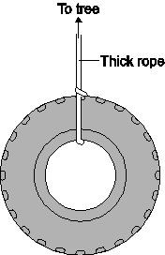

(a) Draw an X on the diagram to mark the centre of mass of the tyre.
(1)

(b) Some children use the tyre as a swing. Pulling the tyre to one side and letting it go makes the tyre swing backwards and forwards like a pendulum.
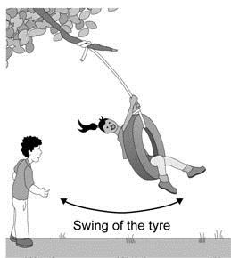
The time it takes the tyre to swing from one side to the other and back again is called the time period.

(i) What is the unit for time period?
...............................................................................................................
(1)

(ii) How would using a shorter rope change the time period of the swing?
...............................................................................................................
...............................................................................................................
(1)
(Total 3 marks)

Q2. A spanner makes it a lot easier to loosen a bolt.
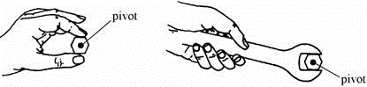
You cannot usually loosen It is easier
a bolt with your fingers. with a spanner.

Choose words from this list to complete the sentences below.
lever piston pivot pulley turning effect
The spanner is a simple ............................................................
You use it to produce a bigger ........................................................... on the bolt.
A longer spanner works better.
This is because there is a bigger distance between your force and the ...............................
(Total 3 marks)

Q3. (a) The diagram shows a rectangle made out of a sheet of cardboard.
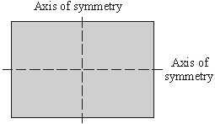
Draw an X on the diagram so that the centre of the X is at the centre of mass of the rectangle.
(1)

(b) The drawing shows a car tyre.
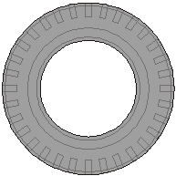

(i) Where is the centre of mass of the tyre?
...........................................................................................................................
(1)

(ii) Explain your answer to (b)(i).
...........................................................................................................................
...........................................................................................................................
(1)
(Total 3 marks)

Q4. (a) The diagram shows a lampshade hanging from the ceiling. Draw an X on the diagram so that the centre of the X marks the centre of the mass of the lampshade.
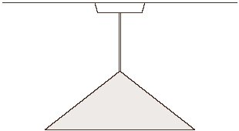
(1)
­
(a) Complete the sentence using the correct word or phrase from the box.

above below to the left of to the right of

A suspended object will come to rest with its centre of mass directly
................................................. the point of suspension.
(1)

(c) The diagrams show equipment that a student uses to find the centre of mass of a thin sheet of card.
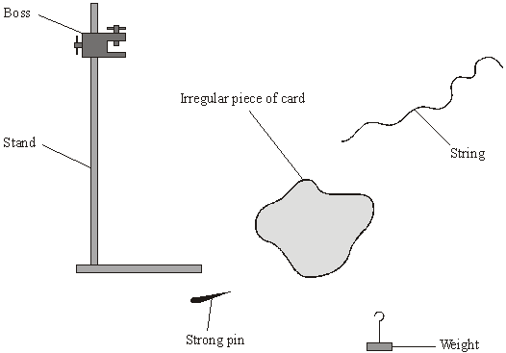

Arrange these sentences in the correct order to describe how the student can find the centre of mass of the card.
The sequence starts with sentence D and finishes with sentence E.
A A line is drawn on the card marking the position of the string.
B The pin is put through one of the holes in the card and held in the boss.
C This is repeated using the other hole.
D Two holes are made in the card with each hole near to the edge of the card.
E The centre of mass is where the lines cross on the card.
F The weight is tied to the string and then the string is hung from the pin.

D |  |  |  |  | E

(3)
(Total 5 marks)

Q5. The drawing shows a sign which hangs outside a shop.
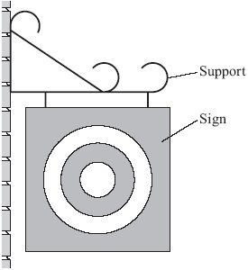

(a) Draw an X on the sign so that the centre of your X is at the centre of mass of the sign.
(1)

(b) Use a ruler to draw one axis of symmetry on the sign.
(1)

(c) One force which acts on the sign is its weight.
Complete the following sentence by drawing a ring around the correct line in the box.

The moment of the weight produces | an accelerating  a balancing  a turning | effect.

(1)
(Total 3 marks)

Q6. A girl and her father visit a children’s playground.
(a) The diagram shows the girl holding on to a roundabout which is turning.
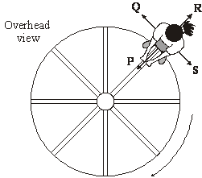
A centripetal force must act because the girl moves in a circular path.

(i) In which direction, P, Q, R or S, does the centripetal force act?
Direction ..........
(1)
(ii) What provides this centripetal force?
..........................................................................................................................
..........................................................................................................................
(1)

(iii) Her father pushes the roundabout so that it turns faster. The girl continues to stand on the same part of the roundabout.
Complete the following sentence by drawing a ring around the correct line in the box.
The centripetal force on the girl | decreases  does not change  increases

(1)

(b) The diagram shows the girl and her father on a see-saw.
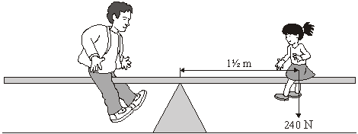
(i) Use the equation in the box to calculate the moment of the girl.
moment = force × perpendicular distance from the line of action of the force to the axis of rotation

..........................................................................................................................
..........................................................................................................................
Moment of the girl = ....................................... Nm
(2)

(ii) What must her father do to increase his moment?
..........................................................................................................................
..........................................................................................................................
(1)

(c) The diagram shows part of a level road that they take when they drive home. They drive at a steady speed.
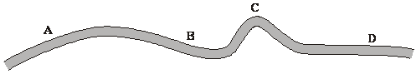
(i) At which point, A, B, C or D, will the centripetal force on the car be greatest?
Centripetal force is greatest at .................... .
(1)

(ii) What provides the centripetal force when the car goes round a bend?
..........................................................................................................................
..........................................................................................................................
(1)
(Total 8 marks)

Q7. A child stands a wooden brick on its end as shown in the diagram.
The child then pushes the brick to make it tilt.

How far must the brick be tilted to make it fall over?
Explain your answer.
(You may draw a labelled diagram if you wish.)
...............................................................................................................................................
...............................................................................................................................................
...............................................................................................................................................

(Total 2 marks)

Q8. The diagram shows two buses. Bus A is empty. Bus B contains bags of sand upstairs to represent passengers.
Each bus has been tilted as far as it can without falling over.
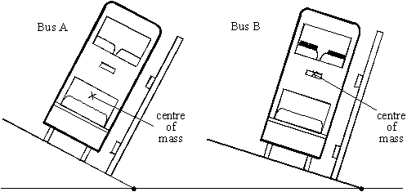

(a) Each bus will topple over if it is tilted any further.
Explain, in as much detail as you can, why this will happen.
(You can draw on one of the diagrams as part of your answer if you want to.)
....................................................................................................................................
....................................................................................................................................
....................................................................................................................................
(2)

(b) What difference does it make to the stability of the bus when the upper deck is full of “passengers”? Explain your answer as fully as you can.
....................................................................................................................................
....................................................................................................................................
....................................................................................................................................
(3)

(c) Why are the bags of sand in bus B only put upstairs?
....................................................................................................................................
....................................................................................................................................
(1)
(Total 6 marks)

Q9. (a) The diagram shows three similar toys. Each toy should be able to balance on a narrow rod. The arrows show the direction in which the weight of the toy acts.
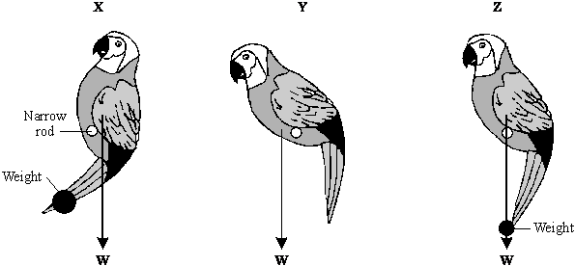

Only one of the toys balances on the rod, the other two fall over. Which one of the toys is balanced? Explain the reason for your choice.
.....................................................................................................................................
.....................................................................................................................................
.....................................................................................................................................
.....................................................................................................................................
(3)

(b) The diagram shows a simple toy. Different animal shapes can be positioned so that the 50 cm rod balances horizontally.
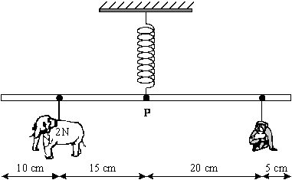

(i) Use the following equation to calculate the moment exerted by the elephant shape of weight 2N about the pivot P. Show clearly how you work out your answer and give the unit.
moment = force × perpendicular distance from pivot
..........................................................................................................................
..........................................................................................................................
Moment = ...................................
(3)

(ii) Use the following relationship to calculate the weight of the monkey shape.
total clockwise moment = total anticlockwise moment
..........................................................................................................................
..........................................................................................................................
Weight = ................................ N
(2)
(c) The graph shows how the length of the spring changes as the total weight of the different animal shapes change.
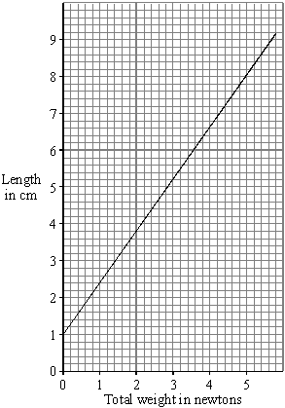

Use the graph to find how much the spring extends when the elephant shape and the monkey shape are hung from the rod. Show how you get your answer.
.....................................................................................................................................
.....................................................................................................................................
Extension of spring = ................... cm
(2)
(Total 10 marks)

Q10. The diagram shows a simple machine for lifting water from a river.
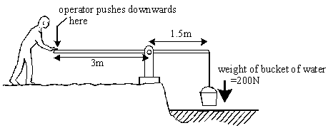

(a) Calculate the turning force (moment) of the bucket of water.
(Show your working.)
.....................................................................................................................................
.....................................................................................................................................
.....................................................................................................................................
Answer .......................................................... Nm (newton metre)
(2)

(b) What can you say about the size of downwards force the operator must use to balance the moment of the bucket of water?
(Explain your answer, using numbers if you can.)
.....................................................................................................................................
.....................................................................................................................................
.....................................................................................................................................
.....................................................................................................................................
(4)
(Total 6 marks)

Q11. (a) The diagram shows a lifebelt. It is hanging freely from hook Y.
(i) On the diagram, mark with an X the point where you think the centre of mass of the lifebelt will be.
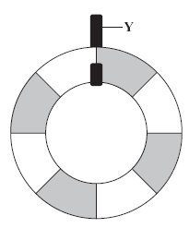
(1)

(ii) Explain why you have chosen this point.
...........................................................................................................................
...........................................................................................................................
...........................................................................................................................
(2)

(b) The drawing shows Susan on a diving board. She is 1.5 metres from point P and she weighs 500 N.
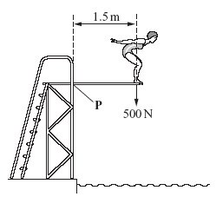
Calculate her moment (turning effect) about point P.
Show clearly how you work out your answer and give the unit.
.....................................................................................................................................
.....................................................................................................................................
Moment about P = ................................................
(3)

(c) Susan has a case with wheels.
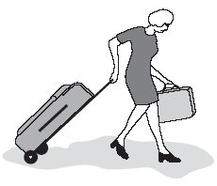

When she packs this case, she puts the heaviest items at the end where the wheels are.
This means that the heaviest items are less likely to crush the other contents and it helps her to find things when she opens the case.
Explain another advantage of packing her case in this way.
To gain full marks in this question you should write your ideas in good English. Put them into a sensible order and use the correct scientific words.
.....................................................................................................................................
.....................................................................................................................................
.....................................................................................................................................
.....................................................................................................................................
.....................................................................................................................................
.....................................................................................................................................
.....................................................................................................................................
.....................................................................................................................................
(4)
(Total 10 marks)

Q12. The diagram below shows an outline of a balance. The balance is used to weigh lorries. A fraction of the weight of a lorry is used as the load on the right side of the pivot.
A standard weight W is moved along the arm until the weight of the load is balanced.
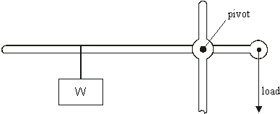

(a) As the weight W is moved away from the pivot it can support a heavier load.
Why is this?
.....................................................................................................................................
.....................................................................................................................................
(2)

(b) (i) The weight W is 100 N. When it is 0.2 m from the pivot it balances the load.
Calculate the moment of the weight W about the pivot.
...........................................................................................................................
...........................................................................................................................
Answer ..................................... Nm
(2)

(ii) The load is one hundredth of the weight of the lorry and is 0.02 m from the pivot.
Calculate the weight of the lorry.
...........................................................................................................................
...........................................................................................................................
Answer ..................................... N
(2)
(Total 6 marks)

Q13. (a) The diagram shows a gardener using a steel bar to lever a tree stump out of the ground.
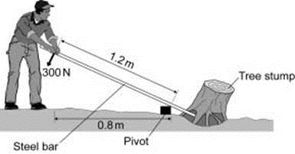
When the gardener pushes with a force of 300 N the tree stump just begins to move.

Calculate the moment produced by the gardener on the steel bar.
Write down the equation you use, and then show clearly how you work out your answer and give the unit.
........................................................................................................................
........................................................................................................................
........................................................................................................................
........................................................................................................................
........................................................................................................................
........................................................................................................................
Moment = ........................................
(4)

(b) Using a longer steel bar would have made it easier for the gardener to lever the tree stump out of the ground.
Explain why.
........................................................................................................................
........................................................................................................................
........................................................................................................................
........................................................................................................................
........................................................................................................................
(3)
(Total 7 marks)

Q14. For part of the ride the cyclist pushed on the pedals with a constant vertical force of 300 N. The simplified diagrams show the pedals in three different positions.
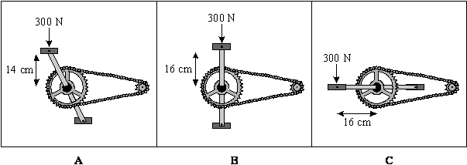

(i) Which position, A, B, or C, gives the largest moment on the pedal?
.....................................................................................................................................
(1)

(ii) Use the following equation to calculate, in Newton metres, the size of the largest moment on the pedal.
moment = force × perpendicular distance from pivot
.....................................................................................................................................
.....................................................................................................................................
Moment = ................................... Nm
(2)
(Total 3 marks)

Q15. (a) Every object has a centre of mass. What is meant by the centre of mass?
...................................................................................................................................
...................................................................................................................................
(1)

(b) The drawing shows a thin sheet of plastic. The sheet is 250 mm wide. Two holes, each with a radius of 2 mm, have been drilled through the sheet.
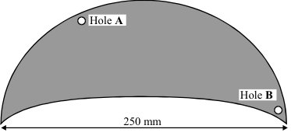

Describe how you could use:
• a clamp and stand
• a steel rod 100 mm long and with a radius of I mm
• a weight on a thin piece of string (= a plumb line)
• a ruler
• a pen which will write on the plastic sheet
to find the centre of mass of the plastic sheet.

To gain full marks in this question you should write your ideas in good English. Put them into a sensible order and use the correct scientific words.
...................................................................................................................................
...................................................................................................................................
...................................................................................................................................
...................................................................................................................................
...................................................................................................................................
...................................................................................................................................
...................................................................................................................................
...................................................................................................................................
...................................................................................................................................
...................................................................................................................................
(5)

(c) There is a trapdoor in the ceiling of a house.
The trapdoor weighs 44 N.
The drawing shows a side view of the trapdoor.
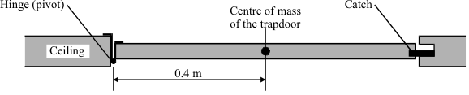

(i) Complete the three spaces to give the equation which is used to calculate the turning effect of a force.
............................... = ................................... × perpendicular.........................
between line of action and pivot
(1)

(ii) Calculate the turning effect, about the hinge, due to the weight of the trapdoor.
Show clearly how you work out your final answer and give the unit.
.........................................................................................................................
.........................................................................................................................
Turning effect = ..............................................
(3)
(Total 10 marks)

Q16. The diagram shows a small mobile crane. It is used on a building site.
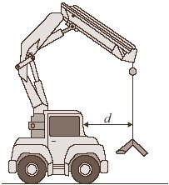

The distance, d, is measured to the front of the cab.
The table shows information from the crane driver’s handbook.

Load in kilonewtons (kN) | Maximum safe distance, d, in metres (m)
10 | 6.0
15 | 4.0
24 | 2.5
40 | 1.5
60 | 1.0

(a) What is the relationship between the load and the maximum safe distance?
.....................................................................................................................................
.....................................................................................................................................
.....................................................................................................................................
(2)

(b) The crane driver studies the handbook and comes to the conclusion that a load of 30 kN would be safe at a distance, d, of 2.0 metres.
Is the driver correct?
Explain your answer.
.....................................................................................................................................
.....................................................................................................................................
.....................................................................................................................................
.....................................................................................................................................
(2)

(c) What is the danger if the driver does not follow the safety instructions?
.....................................................................................................................................
.....................................................................................................................................
(1)

(d) How should the data in the table have been obtained?
Put a tick () in the box next to your answer.

average results from an opinion poll of mobile crane drivers
copied from a handbook for a similar crane
results of experiments on a model mobile crane
results of experiments on this mobile crane

(1)
(Total 6 marks)

Q17. (a) The diagrams show a windsurfer pulling up the sail of a sailboard. The mast pivots at point P.
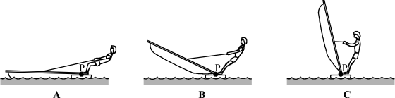

In which position, A, B or C must the windsurfer pull with the largest force? Give a reason for your answer.
.....................................................................................................................................
.....................................................................................................................................
.....................................................................................................................................
(2)

(b) Once the mast is upright, the windsurfer and the sailboard are in equilibrium.
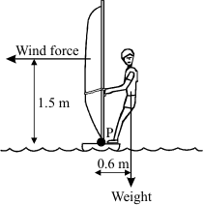

(i) What does in equilibrium mean?
...........................................................................................................................
...........................................................................................................................
(1)

(ii) The weight of the windsurfer is 700 newtons. Use the equation below to calculate the moment exerted by the windsurfer on the sailboard. Show clearly how you work out your answer.
moment = force × perpendicular distance from pivot
...........................................................................................................................
...........................................................................................................................
Moment = ......................................... Nm
(2)

(iii) Use the relationship below to calculate the horizontal force of the wind on the sail. Show clearly how you work out your answer.
total clockwise moment = total anticlockwise moment
...........................................................................................................................
...........................................................................................................................
Force = ........................................ N
(2)

(c) As the wind speed increases the windsurfer leans further out from the sailboard.
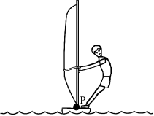
This position allows the windsurfer and sailboard to stay in equilibrium. Explain why.
.....................................................................................................................................
.....................................................................................................................................
.....................................................................................................................................
.....................................................................................................................................
.....................................................................................................................................
(3)
(Total 10 marks)

Q18. The diagram shows a crane which is loading containers onto a ship.
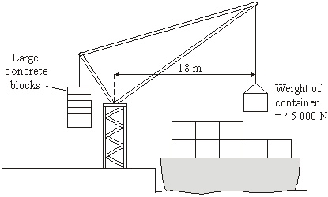
(a) Use the equation in the box to calculate the moment of the container which is being loaded.
moment = force × | perpendicular distance from the line of  action of the force to the axis of rotation

Show clearly how you work out your answer and give the unit.
....................................................................................................................................
....................................................................................................................................
Moment of the container = .......................................................
(3)

(b) Suggest and explain the purpose of the large concrete blocks.
....................................................................................................................................
....................................................................................................................................
....................................................................................................................................
....................................................................................................................................
....................................................................................................................................
(3)
(Total 6 marks)

Q19. A spanner gives a turning effect to undo a nut.
(a) Complete the sentence.
The turning effect of a force is called the .................................................... of the force.
(1)

(b) The diagram shows a spanner being used.
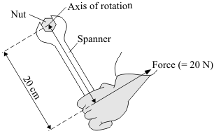
Use the equation in the box to calculate the spanner’s turning effect in newton metres.
turning effect = perpendicular distance from the line of action of the force to the axis of rotation

Show clearly how you work out your answer.
.....................................................................................................................................
.....................................................................................................................................
Turning effect = .............................. Nm
(2)

(c) Give two ways in which you can increase the spanner’s turning effect.
1 ..................................................................................................................................
2 ..................................................................................................................................
(2)
(Total 5 marks)

Q20. The diagram shows a spanner being used to undo a tight nut.
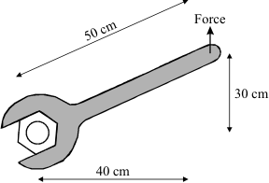
The nut was tightened using a moment of 120 newton metres.

Use the following equation to calculate the force needed to undo the nut. Show clearly how you work out your answer.
moment = force × perpendicular distance from pivot
...............................................................................................................................................
...............................................................................................................................................
Force = ............................................. N
(Total 2 marks)

Q21. Tractors are often used on sloping fields, so stability is important in their design.
On the diagram, the centre of the X marks the centre of mass of the tractor.
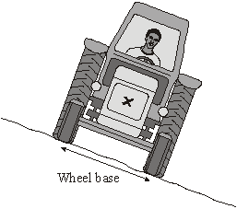
(a) Explain why the tractor has not toppled over. You may add to the diagram to help you to explain.
.....................................................................................................................................
.....................................................................................................................................
.....................................................................................................................................
.....................................................................................................................................
.....................................................................................................................................
.....................................................................................................................................
(3)

(b) Give two features of the tractor which affect its stability and state how each feature could be changed to increase the tractor’s stability.
Feature 1 .....................................................................................................................
.....................................................................................................................................
Feature 2 .....................................................................................................................
.....................................................................................................................................
(2)
(Total 5 marks)

Q22. (a) The diagram shows a child’s mobile. The mobile hangs from point P on the ceiling of the child’s bedroom.
(i) Mark the position of the centre of mass of the mobile by drawing a letter X on the diagram. Do this so that the centre of the X marks the centre of mass of the mobile.
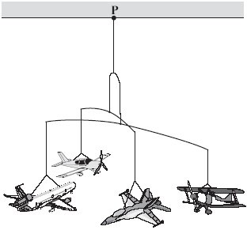
(1)

(ii) Explain why you have chosen this position for your letter X.
...........................................................................................................................
...........................................................................................................................
...........................................................................................................................
...........................................................................................................................
(2)

(b) The diagram shows a device which helps to prevent a ladder from falling over.
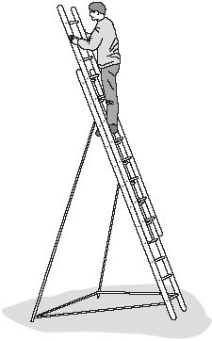
Use the term centre of mass to explain why the ladder, in the situation shown, is unlikely to topple over.
You may add to the diagram to illustrate your explanation.
.....................................................................................................................................
.....................................................................................................................................
.....................................................................................................................................
.....................................................................................................................................
.....................................................................................................................................
.....................................................................................................................................
(3)
(Total 6 marks)

Q23. Tractors are often used on sloping fields, so stability is important in their design.
On the diagram, the centre of the X marks the centre of mass of the tractor.
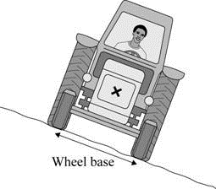

(a) What is meant by the term centre of mass?
........................................................................................................................
........................................................................................................................
(1)

(b) Explain how the design of the tractor could be changed in order to increase the tractor’s stability.
........................................................................................................................
........................................................................................................................
........................................................................................................................
........................................................................................................................
(2)

(c) Explain why the tractor does not topple over. You may add to the diagram to help your explanation.
........................................................................................................................
........................................................................................................................
........................................................................................................................
........................................................................................................................
........................................................................................................................
(3)
(Total 6 marks)

Q24. A student wants to weigh himself but the only balance available is a newtonmeter that measures up to 200 newtons.
The diagram shows how the student solved the problem using moments.
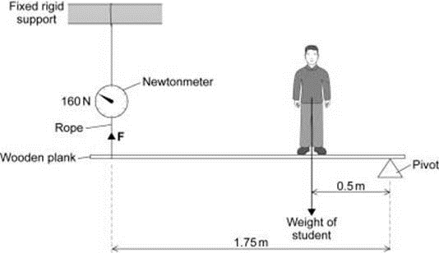

(a) Use the information in the diagram to calculate the weight of the student given by this method.
Write down the equation you use, and then show clearly how you work out your answer and give the unit.
........................................................................................................................
........................................................................................................................
........................................................................................................................
........................................................................................................................
........................................................................................................................
........................................................................................................................
........................................................................................................................
........................................................................................................................
Weight = ....................................
(5)

(c) Even though all the measurements are accurate the student’s weight obtained by this method is inaccurate.
Explain why.
........................................................................................................................
........................................................................................................................
........................................................................................................................
........................................................................................................................
........................................................................................................................
(2)
(Total 7 marks)

M1. (a) X drawn at the centre of the tyre
judge by eye
1

(b) (i) second
1
(ii) decreases it
1
[3]

M2. lever
turning effect
pivot
for 1 mark each
[3]

M3. (a) centre of X at the point where the axes cross
to within 1 mm in any direction
1
(b) (i) (at / in the) centre (of the tyre)
or unambiguously shown on the diagram
1
(ii) (this is) where axes of symmetry (of the tyre) cross / intersect / meet
or point at which the mass of the tyre seems to be (concentrated)
1
[3]

M4. (a) centre of X should appear to be on the continued line of the flex and in the
body of the lamp as judged by eye

example
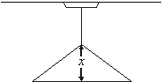
1

(b) below
1

(c) (D)→B→F→A→C→(E)
all four correct for 3 marks
or any two correct for 2 marks
or just one correct for 1 mark
3
[5]

M5. (a) centre of X at the centre of the concentric circles
judge by eye that the intention is correct
1

(b) drawn from any corner to the diagonally opposite corner
judge by eye that the intention is correct
or from the mid-point of any side to the mid-point of the opposite side
if more than one axis of symmetry has been drawn,
accept only if both / all are correct
1

(c) a turning
accept any unambiguous indication
1
[3]

M6. (a) (i) P
1
(ii) the child’s grip / hold / pull (on the roundabout / bar / rail)
or ‘the tension in the child’s arms’
accept ‘the child’s muscles’
accept ‘friction between the child and the roundabout’
do not accept just ‘friction’
1

(iii) increases
accept any unambiguous indication that this ending has been selected
1

(b) (i) 360 (Nm)
credit either 240 × 1 ½
or 240 × 1.5 with 1 mark
2

(ii) move to(wards) the left / to(wards) the / his end
or move away from the centre / pivot / axis (of rotation)
or move away from the girl / the child / his daughter
1

(c) (i) C
1
(ii) friction / grip of the car / tyres / wheels (on the road)
do not accept just ‘friction / grip’
1
[8]

M7. any evidence of idea that weight acts through/near centre of mass/gravity/brick
gains 1 mark
but clear indication that brick topples if
vertical line through centre of mass is outside base line of brick
or line of action of weight is outside base line of brick
gains 2 marks
[2]

M8. (a) idea
• line of action of weight/force/gravity
(if drawn: a vertical line through the centre of mass)
• falls outside the (wheel) base (mark NOT from diagram)
for 1 mark each
2
(b) ideas that
• less stable/topples more easily
• centre of mass at a higher level
• so need small angle to make line of action of weight fall outside
(wheel) base
for 1 mark each
3

(c) idea that
this is the most unstable condition (when bus used)
or
this makes c. of m. as high as it is likely to be
for 1 mark
1
[6]

M9. (a) Z
1
weight or mass acts through pivot
accept rod or base for pivot
accept centre of gravity in line with pivot
1
no (resultant) (turning) moment
accept clockwise moment equals anticlockwise moment
do not accept same weight on each side of rod
1

(b) (i) 30
allow 1 mark for 2 15
or 2 0.15
2
N cm
or
for full credit the unit must be consistent with the numerical answer
0.3
Nm
do not accept joules
1

(ii) 1.5 (N)
allow 1 mark for correct transformation
allow 2 marks ecf their part (b)(i)/20 (ecf only if correct physics)
2

(c) 5 (cm)
allow 1 mark for 6.0 (cm)
allow 1 mark for a subtraction of 1 from a value clearly obtained from the graph
allow 2 marks for correct ecf using an incorrect value for (b)(i) 0.2cm
allow 1 mark for clearly showing correct use of graph using an incorrect value for (b)(ii)
2
[10]

M10. (a) evidence of moment = force × distance
or 200 × 1.5
gains 1 mark
but 300
gains 2 marks
2

(b) ideas that smaller than load
gains 1 mark
but 100 N or half the load
gains 2 marks
because applied further from pivot
gains 1 mark
but applied 2 × distance from pivot or evidence of balancing moments
gains 2 marks
(working for (b) shown in (a) gains credit – transfer mark)
4
[6]

M11. (a) (i) X at the centre of the lifebelt
measuring from the centre of X, allow 2 mm tolerance
in any direction
1

(ii) any two from:
if X is on vertical line below the hanger (but not at
centre) can gain the first point only
below the point of suspension
accept ‘(vertically) below Y’
at the centre (of the lifebelt)
accept ‘in the middle’
(because) the lifebelt / it is symmetrical
or (because) the mass / weight is evenly distributed
2

(b) Nm or newton metre(s)
accept Newton metre(s)
do not accept any ambiguity in the symbol ie NM, nM or nm
1
750
(moment) = force (perpendicular) distance (between line of action and pivot)
or (moment) = 500 1.5 gains 1 mark
2

(c) Quality of written communication:
for 2 of the underlined terms used in the correct context
1
any three connected points from:
low(er) centre of mass / gravity
or centre of mass / gravity will be close(r) to the wheels
/ axle / ground
(more) stable
or less unstable
less likely to fall over
accept ‘less likely to overturn’
do not accept ‘will not fall over’
the turning effect / moment (of the weight of case) is less
or so less effort is needed to hold the case
ignore references to pulling the case
so the pull on her arm is less
3
[10]

M12. (a) moment/torque increases as moves away
gains 2 marks
leverage/force increases as moves away
gains 1 mark
2

(b) (i) 20
gains 2 marks
else working
gains 1 mark
2

(ii) 100 000 ecf
gains 2 marks
else working
gains 1 mark
2
[6]

M13. (a) (i) 360
allow 1 mark for correct length used ie 1.2 m
allow 2 marks for substitution into correct equation - ie 300 × 1.2
allow 1 mark only for an answer 240
3

(ii) Newton-metre or Nm
1

(b) the force is applied further from the pivot
1
which causes an increased moment to act on the steel bar
1
and therefore an increased force acts on the tree stump
1
[7]

M14. (i) C
1

(ii) 48
an answer of 4 800 gains 1 mark
if answer (b)(i) is given as A then 42 scores 1 mark
4200 scores 0 marks substitution of correct figures = 1 mark
2
[3]

M15. (a) point at which its mass (seems to) act or point at which gravity (seems to) act
accept ... its weight acts
accept correct statements if the intent is clear e.g.. .. if suspended, the centre of gravity will be directly under the point of suspension
e.g.... (if the object is symmetrical), the centre of gravity is on the or an axis (of symmetry)
do not credit just 'it is a point'
1

(b) The answer to this question requires good English in a sensible order with correct use of scientific terms. Quality of written communication should be considered in crediting points in the mark scheme
maximum of 4 marks if ideas not well expressed

any five from:
clamp (steel) rod (horizontally)
no marks if method quite unworkable
hang plastic / sheet by rod through (one) hole
hang plumb line from rod
mark ends of plumb line on the sheet and
use the ruler to draw a straight line

repeat with other hole
centre of mass is where the lines cross
check by balancing at this point
maximum of 3 marks if no 'repeat with other hole'
5

(c) (i) (turning) effect or moment
force
distance
all three correct
accept weight
accept length
1

(ii) 17.6
allow 44 x 0.4 or 0.4 x 44 for 1 mark
2
Nm or newton metre(s)
do not accept N/m or N/cm
1760 Ncm gains all 3 marks
1
[10]

M16. (a) any two from:
• inversely proportional
• as the load gets biggerthe (maximum safe) distance gets less
allow ‘as the mass increases the distance decreases’
accept an unspecified response e.g. ‘big load at a short distance’ for (1)
• load × distance = 60 (kNm)
2

(b) yes, because 30 × 2 = 60 (2)
accept for (1) a correct but insufficiently explained response
e.g. ‘yes because it’s safe’
accept for (2) a correct response which is sufficiently explained
e.g. ‘yes, because 60 (kNm) at 1 metre is safe and 30 (kNm) is half the load at twice the distance
do not accept ‘no’ and do not accept just ‘yes’
do not accept ‘yes, because 30 is between 24 and 40 and 2 is between 2.5 and 1.5’
do not accept ‘the crane/ cable may break’ or other dangers
2

(c) the crane may/will topple over/fall over/forward
1
(d) results of experiments on this mobile crane
accept any unambiguous indication
1
[6]

M17. (a) A
must be correct for reason to score
moment (due to weight) of sail is the largest
1
or
(perpendicular) distance from pivot to rope the smallest
do not accept sail is low or sail is too heavy
1

(b) (i) no resultant turning moment or in a state of balance or balanced
allow clockwise moments =
anticlockwise moments
allow no resultant force
allow (forces are) balanced
allow no acceleration
do not allow forces are equal
1

(ii) moment = 420
allow 1 mark for moment = 700 × 0.6
or
700 × a distance from diagram (1.5, 2.1, 0.9)
2

(iii) force = 280
420 = F × 1.5
or
F = 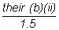 1 mark only

if (b)(ii) obtained by a correct method (1470, 630, 1050)
2

(c) (as wind speed increases) the force on the sail increases
accept pressure
1
aniticlockwise moment increases or moment on sail increases
1
so clockwise moment (or opposite moment) needs to increase (by increasing
the distance from the pivot)
1
[10]

M18. (a) 810 000
allow 45 000 × 18 for 1 mark
2
newton-metres / Nm
1

(b) any three from:
ignore references to force throughout
• their weight / mass can be altered / adjusted
• so that the crane remains stable
allow does not topple
• so that the (total) clockwise moment equals the (total)
anticlockwise moment
do not allow just ‘moments are equal’
• because not all containers are the same weight / mass
do not allow ‘not all containers are the same size / volume’
• because not all containers will be / need to move the same
distance (from the crane)
• to keep the centre of mass (of the upper crane and container) in/
above the base of the tower
• so that the crane remains in equilibrium/balanced
3
[6]

M19. (a) moment
or torque do not credit ‘leverage’
1

(b) 4 (2)
either 0.20 × 20 (1) or allow ‘400’ (1)
2

(c) use a longer spanner
or increases the perpendicular distance / length
or ‘fit a pipe over the (end of the) spanner (to lengthen it)’
note ‘lever’ refers to ‘spanner’
note change the . . . (0)
ignore references to wider / larger nut
1
use a greater force / pull
either order
1
[5]

M20. 300
allow 1 mark for rearranging equation or correct substitution
[2]

M21. (a) (line of action of) its weight
1
falls inside its wheel base
accept ‘falls between the wheels’
the first two points may be credited by adding a vertical line from the centre of the X on the diagram (1)
and labelling it weight / force / with a downwards arrow (1)
provided there is no contradiction between what is added to the diagram and anything which may be written
1
(so there is) no (resultant / clockwise) moment / turning effect
1

(b) centre of mass should be lower
accept ‘… centre of gravity’
accept ‘weight / mass low down’
not just ‘lower the roof’
1
wheel base should be wider
accept ‘long axle(s)’ for ‘wide wheel base’
allow bigger / larger wheel base
do not credit ‘long wheel base’
responses in either order
1
[5]

M22. (a) (i) centre of X directly below P and between the model aeroplanes
as judged by eye but between centre of propeller of top aeroplane and canopy of bottom aeroplane
example
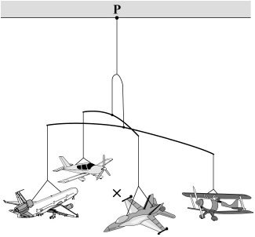
1

(ii) the centre of mass is (vertically) below the point of suspension / P
1
the centre of mass is in the middle of the aeroplanes
accept the centre of mass is level with the aeroplanes
1

(b) centre of mass of the worker and the ladder (and device)
1
line of action of the weight is inside the base
accept the centre of mass is above / within / inside the base (of the ladder and device)
1
so there will not be a (resultant) moment
accept so he / it / the ladder will not topple even if he leans over
or it will (only) topple over if the line of action of the weight / the
centre of mass is outside the base
accept each point, either on the diagram or in the written explanation, but do not accept the point if there is any contradiction between them
1
[6]

M23. (a) where the mass of the object can be thought to be concentrated
1

(b) lower the C of M
1
and make the wheelbase wider
1
accept a practical description of how these changes could be achieved

(c) the line of action of its weight
accept a vertical arrow drawn from X
2
falls inside its wheel base
accept falls between the wheels
therefore there is no resultant / clockwise moment
1
[6]

M24. (a) 560
allow 1 mark for
clockwise (moments) = anticlockwise (moments)
allow 1 mark for correct substitution
ie 160 × 1.75 = W × 0.5
allow 1 mark for correct transformation
ie 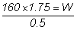
4
newtons, N
1

(c) the weight of plank which has been ignored
1
causes an anticlockwise moment which has not been
considered / included in the calculation
1
[7]

E2. There were many accurate answers to this recognition question.

E3. (a) This question was well-answered with the great majority of candidates placing the centre of mass at the point where the axes of symmetry cross.
(b) (i) A majority of candidates were able to identify the centre of the tyre as the location of and 1(b)(ii) the centre of mass, though those who did were generally unable to offer an appropriate explanation.
(ii) Some candidates erroneously stated that an object with an empty space in the middle does not have a centre of mass.

E4. (a) Just less than half of the candidates gained the mark. Those that did not often failed to place the X inside the lampshade. A favoured incorrect position was at the junction of the lampshade and the cable.
(b) The majority of candidates identified that the centre of mass is directly below the point of suspension.
(c) A third of candidates gained all 3 marks by identifying the correct sequence for the experiment.

E5. (a) Nearly all candidates were able to mark the centre of mass of the square sign.
(b) Nearly all candidates were able to draw one axis of symmetry.
(c) Only a small minority of candidates associated a moment with a turning effect.

E6. (a) (i) Slightly fewer than half the candidates could identify P as the direction of the centripetal force.
(ii) Very few candidates realised that the centripetal force was provided by the girl’s grip.
(iii) Three quarters of candidates identified that if the speed of the roundabout increases that the centripetal force increases.

(b) (i) This question was well answered with more than 80 % of candidates gaining the 2 marks available.
(ii) Two thirds of candidates were able to identify the direction in which the father moves correctly.

(c) (i) Over 80 % of candidates gave the correct answer and therefore gained a mark.
(ii) Very few candidates could identify the friction between the tyres and the road as the source of centripetal force.

E7. Paper 3 Option Q
This question elicited a lot of angles with little mention of the centre of gravity being beyond the base of the brick.
Paper 5 Option R
This question was generally well answered.

E8. Paper I3
This question was generally poorly answered.
(a) Nearly all candidates compared Bus A and B rather than explaining that the vertical line through the centre of mass must be within the wheel base for the bus to remain upright.

(b) Many candidates thought the greater weight of the extra passengers upstairs would make the bus more stable. Good answers noted that the centre of mass would be higher, making it less stable, so the bus could not be tilted at such a big angle.
(c) Few candidates realised that it was to make the centre of mass as high as possible or make the bus as unstable as possible.

Paper H5
(a) Many candidates failed to indicate, either in words or - equally acceptable - on a diagram, that it is the line of action of the weight, vertically through the centre of mass, which must not fall outside of the wheel-base.

(b) This item was generally answered as well as candidates’ answers to (a) permitted.
(c) This was badly answered by the great majority of candidates, very few candidates referring to the need to test the most extreme situation likely to be met when the bus is in operation. Providing candidates with information at the start of the question about the point of the test would probably have resulted in better answers to this item.

E9. Foundation Tier
In part (a) most candidates could identify the balanced toy but found difficulty explaining the reason for their choice, even though the concept of moments was in the stem of part (b)(i). Although many candidates calculated the moment correctly in part (b)(i), the unit was often incorrect, N/cm was a favourite error. Many candidates were unable to correctly complete the subsequent calculation of the weight. In part (c) the original length of the spring was often not subtracted to produce a correct value for the extension. However, the better candidates were able to correctly complete all the calculations demonstrating a sound understanding of the topic.

Higher Tier
In part (a) most candidates could identify the balanced toy but found difficulty explaining the reason for their choice, even though the concept of moments was in the stem of part (b)(i). Although many candidates calculated the moment correctly in part (b)(i), the unit was often incorrect, N/cm was a favourite error. Most candidates were able to complete the subsequent calculation of the weight. In part (c) the original length of the spring was often not subtracted to produce a correct value for the extension.

E10. In part (a) good answers multiplied 1.5m by 200N to get 300Nm.
Where candidates showed evidence of multiplying force by distance credit was given. Weaker candidates multiplied or divided 200N by various combinations of 1.5/3.0/4.5.

In part (b) weaker candidates guessed as to whether more or less force was needed. Stronger candidates compared the distances 1.5:3.0 and thus compared forces in the same way i.e. 100N:200N.

E11. Only a small minority were able to give the correct position of the centre of mass. Usually positions in the body of the lifebelt either above or below the hook were suggested and very few earned any marks in part (ii). Incorrect responses to part (i) made a rational explanation more difficult in part (ii) but responses which could still gain credit, such as ‘below the point of suspension’ and ‘the lifebelt is symmetrical’, were only given by a minority of candidates.

Susan’s moment was usually numerically correct but the unit was often omitted or incorrect.

In part (c) it was rare for candidates to gain more than one mark. Where credit was gained it was usually for ‘low centre of mass’, ‘less likely to fall over’ or ‘easier to hold’. Very few made correct statements in relation to the moments involved and the communications mark, which was given for the correct use of terms, was rarely awarded.

E12. Part (a) was badly answered. In part (b) many candidates scored at least part marks.

E14. Foundation Tier
In part (i) few candidates identified the position C as being the situation to produce the largest moment on the pedal. Of those giving either B or C, the majority gave the numerical answer of 4 800 in part (ii), though the correct scientific unit was given in both the stem of the question and on the answer line.

Higher Tier
In part (i) only the more able candidates correctly used the idea of perpendicular distance to identify position C as being the situation to produce the largest moment on the pedal. Of those giving either B or C, the majority gave the numerical answer of 4 800 in part (ii), though the correct scientific unit was given in both the stem of the question and on the answer line.

E15. Foundation Tier
(a) In this part the examiners were looking for a correct statement which would explain, or help to explain, the term centre of mass. The candidate did not have to account for cases in which the centre of mass lies outside of the object but, even so, appropriate responses, for example ‘the object will balance if it is supported at its centre of mass’, were rare. ‘The centre of the object’ and ‘the mass will be the same on both sides’ were fairly popular, but incorrect, responses.
(b) The specification states that ‘candidates should be able to describe how to find the centre of mass of a thin sheet of material’. Some invalidated their responses either by clamping the sheet or by suspending it through one hole and hanging the plumb line from the other hole. Others ignored any sensible consideration of the size of the sheet and bent it so that the 100 mm long rod could go through both holes. However, there was a minority of candidates who seemed to understand what was required.
(c) Only a minority of candidates were able to recollect the equation to calculate the turning effect of a force. A large proportion injected the words mass and/or height_ into their erroneous responses. Some were able to find the product of 44 and 0.4 but some spoilt their efforts by increasing or decreasing by a factor of 10 or by doubling the distance to 0.8 m. If there was an attempt at a unit it was usually to suggest N/m.

Higher Tier
(a) In this part the examiners were looking for a correct statement which would explain, or help to explain, the term centre of mass. The candidate did not have to account for cases in which the centre of mass lies outside of the object but, even so, appropriate responses, for example ‘the object will balance if it is supported at its centre of mass’, were not too frequent. ‘The centre of the object’ and ‘the mass will be the same on both sides’ were fairly popular, but incorrect, responses.
(b) The Specification states that ‘candidates should be able to describe how to find the centre of mass of a thin sheet of material’. Many were able to do this, and to express themselves clearly, so gained all five marks. A small minority invalidated their responses by clamping the sheet or by suspending it through one hole and hanging the plumb line from the other hole. Some others ignored any sensible consideration of the size of the sheet and bent it so that the 100 mm long rod could go through both holes.
(c) Most candidates were able to recollect the equation to calculate the turning effect of a force. Some injected the words mass and/or height_ into their erroneous responses. Most candidates were able to find the product of 44 and 0.4 but some spoilt their efforts by increasing or decreasing by a factor of 10 or by doubling the distance to 0.8 m. A significant minority gave the unit as N/m. It could be that some correctly knew that their answer was in newton-metres but incorrectly thought that this was the way to write its symbol.

E16. Foundation Tier
(a)(b) Many candidates realised that the data shows that as the load increases the maximum safe distance decreases but only a minority of these could explain why the crane driver’s conclusion is correct.
(c) Several hazards were mentioned with a minority of candidates stating that the mobile crane may topple over, or words to that effect.
(d) Most candidates were able to select ‘results of experiments on this crane’ as the appropriate source for the data in the table.

Higher Tier
(a)(b) A large majority realised that the data shows that as the load increases the maximum safe distance decreases but fewer could explain why the crane driver’s conclusion is correct.

(c) Several hazards were mentioned with the majority of candidates stating that the mobile crane may topple over, or words to that effect.
(d) A large majority of candidates correctly selected ‘results of experiments on this crane’ as the appropriate source for the data in the table.

E17. Foundation Tier
Answers to all parts of this question were poor, with many candidates scoring few marks. Many identified ‘A’ as the correct response in part (a), but were unable to explain why. The word ‘equilibrium’ was often interpreted as ‘equal forces’. The equations given in parts (b)(ii) and (b)(iii) allowed some candidates to score marks, however, there was a general lack of understanding as to which distance to use. In part (c) answers often mentioned balanced forces rather than balanced moments. Few candidates mentioned that the wind force had increased. Clearly many candidates understood the mechanics of windsurfing, but were unable to articulate the explanation necessary to score any marks.

Higher Tier
Many candidates identified ‘A’ to be the correct response in part (a), but were unable to explain why. The word ‘equilibrium’ was not well understood and it was often interpreted as meaning ‘equal forces’. The equations given in parts (b)(ii) and (b)(iii) allowed most candidates to score marks, however, there was a general lack of understanding as to which distance to use. In part (c) answers often mentioned balanced forces rather than balanced moments. Few candidates mentioned that the wind force had increased. Clearly many candidates understood the mechanics of windsurfing, but were unable to articulate the explanation necessary to score any marks.

E18. (a) The calculation was generally correct, although some candidates multiplied the 45 000 N by 10. However, a significant proportion of candidates either failed to give the unit, or gave an incorrect unit or could not write newton metres correctly either in words or as the symbol (Nm).
(b) Almost all candidates showed some understanding of the principle involved and scored at least one mark. A large proportion failed to use scientific terms, such as clockwise/anticlockwise moments, correctly, or wrote about centre of mass but failed to show understanding of where it is or should be.

E19. Foundation tier
(a) Only about a quarter of candidates knew that a turning effect is a ‘moment’. There were many responses which appeared to be guesses involving other terms used in Physics.
(b) Many candidates obtained one mark for ‘400’ but few took account of the units and so the correct response ‘4 (Nm)’ was infrequently seen.
(c) Most candidates knew that increasing the force and/or using a longer spanner could increase the turning effect.

Higher tier
(a) Nearly all candidates knew that a turning effect is a moment.
(b) Many candidates gained one mark because they offered ‘400’. However, less than half took account of the units and gave the correct response of ‘4 (Nm)’.
(c) Almost all candidates knew that increasing the force and using a longer spanner could increase the turning effect and so obtained full marks. However, only a small minority expressed themselves in practical terms, for example, ‘fit a pipe over the handle (of the spanner)’.

E20. The majority of candidates found the idea of moments difficult to understand and subsequently very few completely correct answers to this question were seen. Most candidates were able to rearrange the equation but very few converted distance to metres and even fewer could identify the correct distance to use.

E21. (a) Many candidates were able to explain, either on the diagram or in writing, that the line of action from the centre of mass falls vertically and is within the wheel base.
However, very few indicated that the weight of the tractor results in a moment which keeps it turned to the slope or alternatively that if the line of action were to fall to the right of the right wheel in the diagram the resulting moment would topple the tractor.

(b) The great majority of candidates gained two marks because they knew that having a wider wheel base and a lower centre of mass would increase the tractor’s stability.

E22. (a) (i) Only a minority of candidates located the centre of mass on the part of the vertical line beneath P and between the planes. A common error was to select the junction of the supporting strings as the location of the centre of mass.
(ii) Though a third of candidates were able to gain a mark for explaining that X must be vertically beneath the point of suspension, only a small minority explained the correct location.

(b) Only a very small minority of candidates realised that it’s the combined mass of worker, ladder and device which needs to be considered. However ,over half secured one mark. This was for expressing the idea that the line of action of the weight falls within the base. About a quarter of candidates obtained their second mark by going on to explain what would cause the ladder to topple.

