Q1. When a conductor carrying an electric current is placed in a magnetic field a force may act on it.
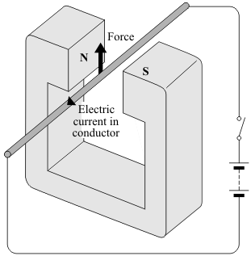
(a) State two ways in which this force can be increased.
1 ..................................................................................................................................
2 ..................................................................................................................................
(2)

(b) State two ways in which this force can be made to act in the opposite direction.
1 ..................................................................................................................................
2 ..................................................................................................................................
(2)

(c) In what circumstance will no force act on a conductor carrying an electric current and in a magnetic field?
.....................................................................................................................................
.....................................................................................................................................
(1)
(Total 5 marks)

Show clearly how you work out your answer.
.....................................................................................................................................
.....................................................................................................................................
Kinetic energy = ............................................... J
(2)
(Total 7 marks)

Q2. The diagram shows the equipment used by a student to investigate the strength of five different electromagnets.
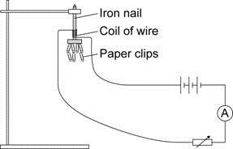
The stronger the electromagnet, the more paper clips it will hold.

(a) Why is it important that the paper clips used in the investigation are all the same size?
........................................................................................................................
........................................................................................................................
........................................................................................................................
(1)

(b) The five electromagnets, J, K, L, M and N, used by the student are shown below.
Each electromagnet was made by wrapping lengths of insulated wire around identical iron nails.
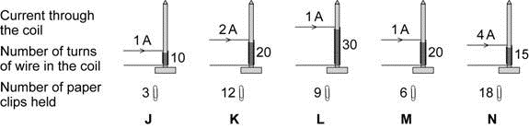
The student wants to find out how the strength of an electromagnet depends on the number of turns of wire in the coil.
Which electromagnets should the student compare in order to do this?
........................................................................................................................
(1)

(c) The student concluded:
“The strength of an electromagnet is always directly proportional to the number of turns on the coil.”
(i) Explain how the data from the investigation supports the student’s conclusion.
...............................................................................................................
...............................................................................................................
...............................................................................................................
...............................................................................................................
...............................................................................................................
(2)

(ii) The student makes one more electromagnet by winding 100 turns onto a nail.
Before testing the electromagnet, the student predicted the number of paper clips that the electromagnet would hold when the current is 1 amp.
How many paper clips should the student predict that the electromagnet would hold?
Show clearly how you work out your answer.
...............................................................................................................
...............................................................................................................
...............................................................................................................
number of paper clips = .....................................
(2)

(iii) When the student tested the electromagnet it held 20 paper clips.
This is not what the student predicted.
Explain what the student should do when new data does not seem to support the prediction that was made.
...............................................................................................................
...............................................................................................................
...............................................................................................................
...............................................................................................................
...............................................................................................................
...............................................................................................................
...............................................................................................................
(3)
(Total 9 marks)

Q3. The diagram shows apparatus used to demonstrate the motor effect. X is a short length of bare copper wire resting on two other wires.
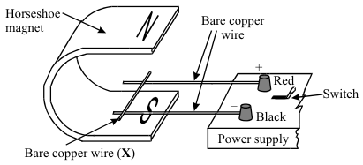

(a) (i) Describe what happens to wire X when the current is switched on.
...........................................................................................................................
...........................................................................................................................
...........................................................................................................................

(ii) What difference do you notice if the following changes are made?
A The magnetic field is reversed.
...........................................................................................................................
...........................................................................................................................
B The current is increased.
...........................................................................................................................
...........................................................................................................................
(3)

(b) The diagram shows a coil placed between the poles of a magnet. The arrows on the sides of the coil itself show the direction of the conventional current.
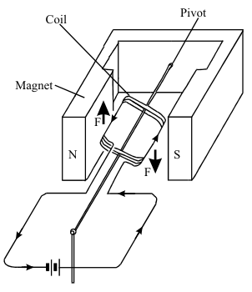

The arrows labelled F show the direction of the forces acting on the sides of the coil. Describe the motion of the coil until it comes to rest.
.....................................................................................................................................
.....................................................................................................................................
.....................................................................................................................................
.....................................................................................................................................
.....................................................................................................................................
(3)

(c) Most electric motors use electromagnets instead of permanent magnets. State three of the features of an electromagnet which control the strength of the magnetic field obtained.
1 ................................................................................................................................
2 ................................................................................................................................
3 ................................................................................................................................
(3)
(Total 9 marks)

Q4. Many electrical appliances use the circular motion produced by their electric motor.
(a) Put ticks () in the boxes next to all the appliances in the list which have an electric motor.

electric drill
electric fan
electric food mixer
electric iron
electric kettle
electric screwdriver

(2)

(b) One simple design of an electric motor is shown in the diagram. It has a coil which spins between the ends of a magnet.
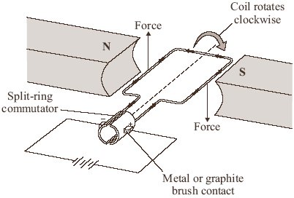

(i) Give two ways of reversing the direction of the forces on the coil in the electric motor.
1 ........................................................................................................................
...........................................................................................................................
2 ........................................................................................................................
...........................................................................................................................
(2)

(ii) Give two ways of increasing the forces on the coil in the electric motor.
1 ........................................................................................................................
...........................................................................................................................
2 ........................................................................................................................
...........................................................................................................................
(2)
(Total 6 marks)

Q5. The diagram shows apparatus used to demonstrate the electric motor effect. When he switch is closed the wire moves.
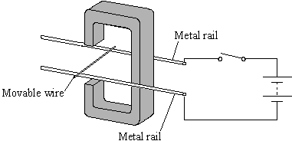

(i) Draw an arrow on the diagram to show the direction the wire moves.
(1)

(ii) Explain why the wire moves.
.....................................................................................................................................
.....................................................................................................................................
.....................................................................................................................................
.....................................................................................................................................
(2)
(Total 3 marks)

M1. (a) increase the current (1)
credit increase the p.d./voltage
credit reduce the resistance
credit have thicker wiring
credit add extra / more cells
1
increase the magnetic field (strength) (1)
credit ‘have stronger magnet(s)
do not credit ‘bigger magnets’ either order
1

(b) either reverse polarity
or connect the battery the other way round
1
either reverse direction of the magnetic field
or put the magnet the other way round / reverse the magnet
do not give any credit to a response in which both are done at the same time
either order
1

(c) either
conductor parallel to the magnetic field
or lines of magnetic force and path of electricity do not cross
1
[5]

M2. (a) so the results can be compared fairly
fair test is insufficient
1

(b) J L M
all 3 required and no other
1

(c) (i) for a given current the number of paper clips increases
by the same factor as the number of turns
1
plus a mathematical explanation using the data
eg a current of 1 A with 10 turns picks up 3 clips, a
current of 1 A with 20 turns picks up 6 clips
1

(ii) 30
allow 1 mark for showing correct use of figures eg
20 turns × 5 = 100 turns
2

(iii) check the new data / repeat the experiment
1
to identify any anomalous results
1
then reconsider prediction / hypothesis in the
light of new evidence
1
[9]

M3. (a) (i) it moves or experiences a force horizontally to the right
for 1 mark
1

(ii) A – moves in opposite direction or force reversed e.c.f.
B – faster movement or larger force
(not move further)
for 1 mark each
2

(b) turns clockwise
oscillates/reverses
comes to rest facing field/at 90º to field/vertically
for 1 mark each
3

(c) number of turns or linear number density of turns current core
for 1 mark each
3
[9]

M4. (a) electric drill, electric fan, electric food mixer and electric screwdriver
all four ticked and no others (2)
either all four of these ticked and only one other (1)
or any three of these ticked and none/one/two of the others (1)
2

(b) (i) reverse (the direction of the) current (1)
or reverse the connections (to the battery)
reverse (the direction of the) magnetic field (1)
or reverse the (magnetic) poles /ends
do not credit ‘swap the magnets (around)’
2

(ii) any two from:
• increase the strength of the magnet(s)/(magnetic) field
do not credit ‘use a bigger magnet’
• increase the current
allow ‘increase the voltage/p.d.’
allow add cells/batteries
allow increase the (electrical) energy
allow increase the power supply
allow ‘decrease the resistance’
allow ‘increase charge’
allow ‘ increase the electricity’
do not credit ‘use a bigger battery’
• reduce the gap (between coil/armature
and poles/magnets)
allow increase the (number of) coils
• increase the turns (on the coil/armature)
do not credit ‘use a bigger coil’
2
[6]

M5. (i) away from magnet
arrow should be perpendicular to field lines and current as judged by eye
1

(ii) current in wire creates magnetic field around wire
1
two fields interact or combine giving a resultant force (on the wire)
1
[3]

E1. (a) Most candidates chose ‘increase the current’ or a correct way of doing this, such as to increase the p.d. or increase the number of cells, and some also suggested ‘have a stronger magnet’. However writing ‘have a bigger magnet’ did not gain credit as a bigger magnet would not necessarily be stronger and the poles could be further from the conductor.

(b) Some candidates correctly suggested that the battery would need to be connected the other way round or that the magnet would need to be put the other way round. However some answers were so poorly expressed that it was impossible to be reasonably sure what was being suggested.

(c) Few candidates knew that there would be no force on the conductor when the conductor is parallel to the magnetic field or, put another way, when the lines of magnetic force and the path of the electricity do not cross.

E3. In part (a)(i) very many candidates had the wire moving, unfortunately in many cases the movement was up or down. Few candidates stated that the wire would move along the copper wires to the right. In part (ii) many had the movement reversed, but reversing an up/down movement does not give a correct answer only answers stating that the wire would move to the left were acceptable. In the last part of the question a faster movement was the common correct answer. In part (b) candidates seemed to be familiar with the electric motor but experienced difficulty in applying their ideas in an unfamiliar situation. Most candidates started their answer with a clockwise movement for one mark, fewer went on to say the coil would then vibrate backwards and forwards for the second mark. The final mark, for stating (in their own words) that the coil would end up perpendicular to the field, was gained by a small number of candidates. Part (c) was quite well answered with most candidates scoring marks for increasing the number (or number density) of turns and the current. many went on to gain the third mark for the use of a soft iron core.

E4. (a) A large majority of the candidates chose the correct four appliances from the list.
(b) (i) The responses in part (b) were generally poor with only a minority able to gain a mark in (b)(i) with a similar, though improved, outcome in part (b)(ii).
(ii) Candidates should be advised that although ‘use more cells in the battery’ is correct in part (b)(ii) the ambiguous ‘use a bigger battery’ is not.
For similar reasons the vague responses of ‘use bigger magnets’ and ‘use a bigger coil’ were not awarded marks.

E5. In part (a)(i) the better candidates gave the correct direction of movement, however, many suggested the wire would oscillate back and forth. Part (a)(ii) was very poorly done. Only a very small number of candidates mentioned the magnetic field created by the current and even fewer indicated any interaction between the fields. Many candidates seemed to interpret the question as ‘how do you work out where the wire moves?’

