Physics revision sheet –Generating electricity and transmitting it
Direct current  If the current flows in only one direction it is called direct current, or DC. Batteries and solar cells. A typical battery may supply 1.5V | Alternating current  If the current constantly changes direction it is called alternating current, or AC. Mains electricity is an AC supply. The UK mains supply is about 230V. It has a frequency of 50Hz (50 hertz), which means that it changes direction and back again 50 times a second.
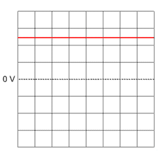 | 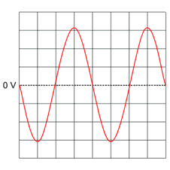
Q:what is the voltage of this device if each step on the graph is 1 volt | Q what is the peak voltage on this device if each step is 50V

Making electricity – Induction
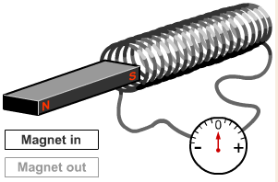 | An electric current is produced when a magnet is moved into a coil of wire in a circuit. The direction of the current is reversed when the magnet is moved out of the coil again. It can also be reversed if the other pole of the magnet is moved into the coil.  To increase the induced current:  - move the magnet faster  - use a stronger magnet  - increase the number of turns on the coil  - increase the area of the coil

Explain how a bicycle dynamo works in your own words
................................................................................................
...............................................................................................
.............................................................................................
............................................................................................
..............................................................................................
...............................................................................................

Cont........
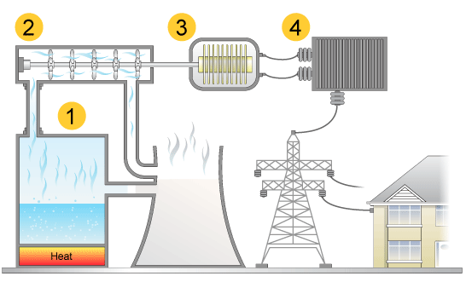 | This is a diagram of a fossil fuel power station  Describe what is happening in sections 1, 2 and 3  ....................................................  .....................................................  ...................................................  ...................................................  ..................................................  .....................................................  ..................................................  ..................................................

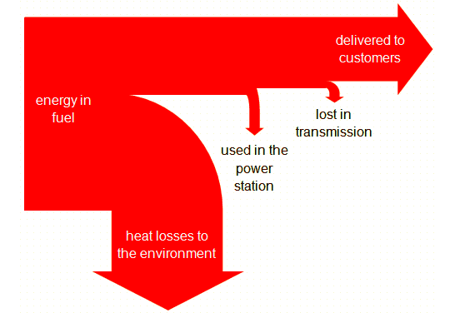 | This is called a Sankey diagram. Explain what it shows  .......................................................................  .......................................................................  .....................................................................  ...................................................................  ....................................................................  ....................................................................  ....................................................................  .....................................................................

Renewable energy sources will never run out fuels. These include:
- wind energy (but noisy and spoil the view, also only useful if windy)
- water energy, such as wave machines, tidal barrages and hydroelectric power
Disadvantages: ..................................................................................................................
- geothermal energy
Disadvantages ..................................................................................................................
- solar energy
Disadvantages ..................................................................................................................
- biomass energy, for example energy released from wood.
Disadvantages ...................................................................................................................

Non-renewable energy sources
There is a limited supply and will eventually run out. They include:
- fossil fuels, such as coal, oil and natural gas release carbon dioxide when they burn, which adds to the greenhouse effect and increases global warming. Coal produces the most carbon dioxide, natural gas generates the least.
Nuclear fuel is relatively cheap. But the power stations are expensive to build and very expensive to dismantle or store radioactive waste, which is a dangerous health hazard.

1. What type of current is electricity from the mains?
Direct current Alternating current
Both alternating and direct current
2. Which of the following is a way to increase an induced current?
Move the magnet more slowly
Use a weaker magnet
Move the magnet more quickly
3. Which of the following is a disadvantage of using a dynamo on a bike?
When the bike stops the light goes off
It is a renewable source of energy
The light gets brighter the faster the cyclist pedals
4. Which of the following are renewable energy resources?
Coal Geothermal Natural gas
5. Which of the following adds to the greenhouse effect?
Nuclear Tidal Oil
6. Approximately how much energy is transferred as useful energy to the customers from a power station?
All the energy
About a third of the energy
Nearly 90%
7. Which fossil fuel generates the most amount of carbon dioxide when it is burnt?
Coal Oil Natural gas

In an exam question you may be asked to discuss the advantages and disadvantages of methods of large-scale electricity production. You should list both renewable and non-renewable resources with advantages and disadvantages for both. – Plan you answer now:
............................................................................................................................................
..............................................................................................................................................
............................................................................................................................................
............................................................................................................................................
............................................................................................................................................
............................................................................................................................................
..............................................................................................................................................

Electricity is generated when a coil of wire moves in a magnetic field. This is the basis of electricity generators.
Transformers are used in the National Grid to reduce energy losses from the wires during transmission.

Transformers
A transformer changes a high-voltage supply into a low-voltage one, or vice versa.
- A transformer that increases the voltage is called a step-up transformer
- A transformer that decreases the voltage is called a step-down transformer
Step-down transformers are used in mains adapters and rechargers for mobile phones and CD players.
2. Which of the following do not use step down transformers used?
Mobile phone chargers
Mains adapters
Microwaves ovens

H paper
Step-up transformers have more turns on the secondary coil than they do on the primary coil.
Step-down transformers have fewer turns on the secondary coil than they do on the primary coil.

Calculating voltages
Primary voltage / secondary voltage = turns on primary / turns on secondary
This can also be written as:
1º V = 1º turns  2º V 2º turns | Remember – they will give you 3 of the four numbers – the one you don’t have, you must put at the top on its own – see me if you need help

Question
A transformer has 20 turns on the primary and 400 on the secondary. What is the output voltage if the input voltage is 500V?
Show each step of the calculation
Energy - Know the names we give energy – write them down here
.................................................................................................................................................................
(to help you, use ‘Most Kids Hate Learning GCSE Energy Names’, the first letter of each word is a hint)
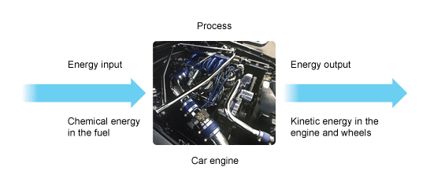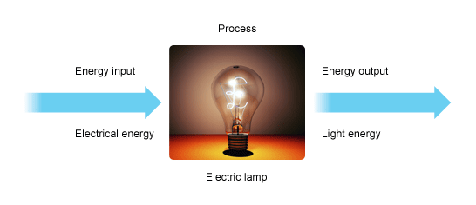
You do some examples of your own (same layout as above – but don’t waste time drawing pictures)
........................................................................................................................................................................
.........................................................................................................................................................................

Energy efficiency 'Wasted' energy
Energy cannot be created or destroyed. It can only be transferred from one form to another or moved. Energy that is 'wasted', like the heat energy from an electric lamp, does not disappear. Instead, it is transferred into the surroundings and spreads out so much that it becomes very difficult to do anything useful with it.
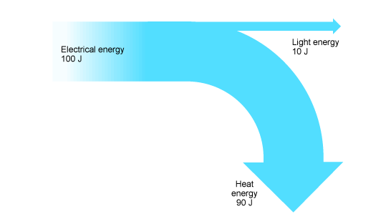 | 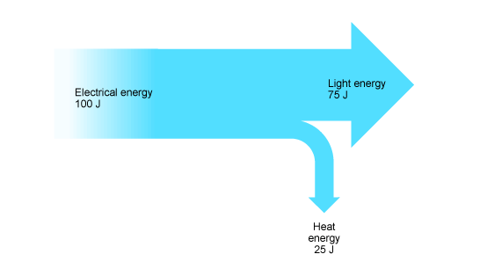
A filament lamp | A modern energy saving lamp
The efficiency of a lamp can be calculated using this equation:
Efficiency = (useful energy out÷ total energy in ) × 100
Do the calculation for both these lamps – show your working out
Note that the efficiency of a device will always be less than 100%.
Infrasound and Ultrasound

Sound waves
Sound waves are longitudinal ( )waves. Their vibrations occur in the same direction as the direction of travel. Sound waves can only travel through a solid, liquid or gas.(so not in space then!)

Vibrations
When an object or substance vibrates, it produces sound. The bigger the vibrations, the greater the amplitude and the louder the sound.
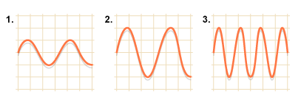 | Which one/two has the quietest sound?  Which one/two has the highest frequency?  Which two have the same amplitude?

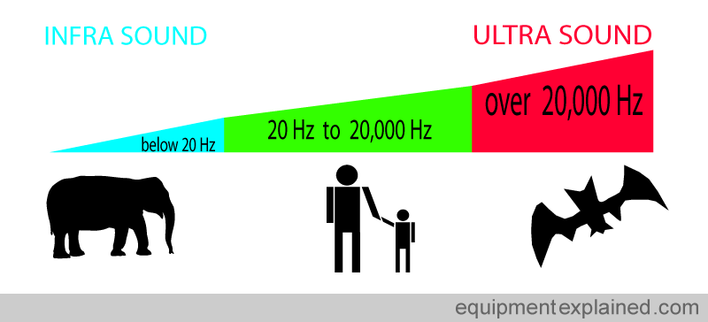
1. What sort of frequency will a high pitched sound have?
High Low Wide
2. Which of the following is not a use of ultrasound:
Imaging of unborn children
Quality control checks in industry
Security scanning of bank notes
3. What is the frequency of infrasound?
Below 20Hz
Between 20-20 000 Hz
Above 20 000 Hz
4. What type of waves are sound waves?
Sound isn't actually a wave Longitudinal Transverse

Properties of the two types of seismic wave that can travel through the Earth
 | P waves | S waves
type of wave | longitudinal | transverse
relative speed | faster | slower
can travel through | solids and liquids | solids only

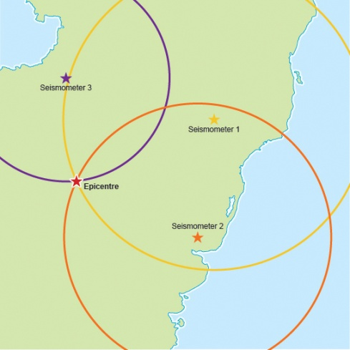 | How is the Epicentre of an earthquake found (plan your answer here)  .................................................................................................  ..............................................................................................  ...............................................................................................  ...............................................................................................  ...............................................................................................  ..............................................................................................  ...........................................................................................  .............................................................................................

Seismic waves - Higher tier
The speed of P waves and S waves increases as they travel deeper into the mantle. They travel through the Earth in curved paths, but they change direction suddenly when they pass through the boundary between substances in different states.
S waves  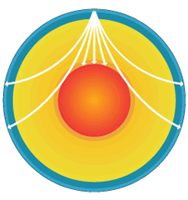 | P waves  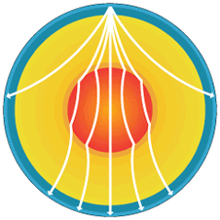

1. What is the Earth's outer core made of?
Solid nickel and iron Liquid nickel and iron A thin layer of rock
2. How do tectonic plates move?
Gravity From the movement of convection current is the mantle
Blown by the wind
3. Which of the following is the correct properties of an S wave?
Longitudinal, fast moving and can travel through solids and liquids
Longitudinal, slow moving and can travel through solids only
Transverse, slow moving and can travel through solids only
4. What is the process called that is used to locate the epicentre of an earthquake?
Triangulation Pinpointing Seismometer
H Paper
1. What causes seismic waves?
The gravitational pull of the moon Movements inside the earths crust
Seismometers
2. What is the epicentre?
Point on the earth directly above the focus of an earthquake
The movement in the earth's crust that starts an earthquake
The first human habitation that an earthquake hits
3. Which wave would reach a seismometer first?
Both would arrive at the same time S P
4. Which type of wave is longitudinal?
P S Both waves are longitudinal
5. What happens to waves as they reach the boundaries of rock types?
They are refracted only They are reflected only
They are both reflected and refracted
6. Which of the following statements about the Earth's structure is correct?
The crust is liquid. The outer core is liquid. The outer core is solid.
7. Starting at the centre of the Earth, the correct order for its layers is:
crust --> mantle --> core core --> crust --> mantle
core --> mantle --> crust
8. Which of the following statements about the Earth's structure is correct?
The crust is liquid. The outer core is liquid. The outer core is solid.

Interpreting the evidence - Higher tier

A summary of some of the evidence of the Big Bang and its interpretation
Evidence | Interpretation
The light from other galaxies is red-shifted. | The other galaxies are moving away from us. This evidence can be used to explain both the Big Bang theory and Steady State universe.
The further away the galaxy, the more its light is red-shifted. | The most likely explanation is that the whole universe is expanding. This supports the theory that the start of the universe could have been from a single explosion.
Cosmic Microwave Background (CMB) | The relatively uniform background radiation is the remains of energy created just after the Big Bang.
Red-shift is used to explain both the Steady State and Big Bang theories of the universe. Cosmic Microwave Background radiation is evidence for the Big Bang theory only. This discovery has led to the Big Bang theory becoming the currently accepted model.
1. What is a nebula?
A protostar
The remains of a star once it has completed its lifecycle
Difference between characteristics in different organisms
2. What happened to the density of a nebula when a star forms?
Increases
Decreases
Stays the same
3. In the formation of a star what do hydrogen nuclei fuse to form?
Carbon
Helium
Neon
4. What is the average lifespan for stars similar to our sun?
1 billion years
10 billion years
100 billion years
5. What does a massive star form when it has fused its available hydrogen and helium?
Red supergiant
Red giant
Green giant
6. What is formed when a massive star begins to collapse and then explode?
Neutron star
Black hole
Supernova
7. When is a neutron star formed?
The remains of a massive star have a low density
The remains of a massive star have no density
The remains of a massive star have a high density
8. When is a black hole formed?
The remains of a massive star have a low density
The remains of a massive star have no density
The remains of a massive star have a high density
9. Why can't light escape from a black hole?
The gravitational pull is too weak
The gravitational pull is too strong
There is no light in a black hole
10. About how long ago do scientists believe the universe began?
137 million years
1,370 million years
13,700 million years
11. Which is the main scientific theory for the origin of the universe?
The Big Bang Theory
The Oscillating Universe Theory
The Steady State Theory
12. Which piece of evidence supports the Big Bang theory?
The more distant galaxies are moving the slowest.
The more distant galaxies are moving the quickest.
The more distant galaxies are moving towards us.
13. What material have scientists suggested explains some of the unexpected observations of the universe?
Bright matter
Dark matter
Dull matter
14. What is the name for the change in the light emitted by a moving object?
Red shift
Blue shift
Ultra violet shift

Converging lenses
A lens is transparent block that causes light to refract (changes the direction the light travels in). A converging lens (or convex lens) is curved on both sides. This means the light rays coming out of it come together at a point – they converge. | 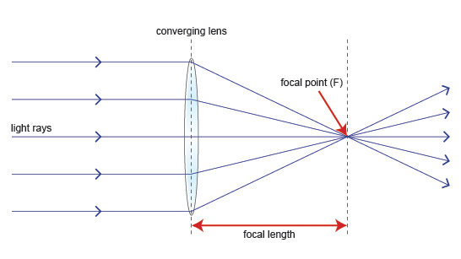
Refracting telescopes  Bends light through a lens so that it forms an image. There are a few problems with refracting telescopes: some of the light reflects off the lens so the image is very faint  large lenses are needed to improve the magnification – this can be difficult to do perfectly. | 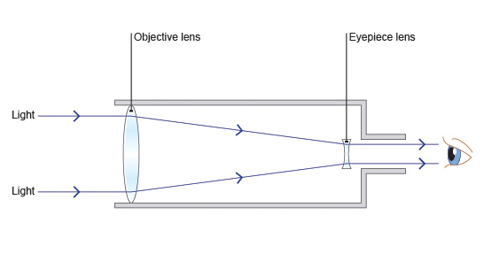
Reflecting telescopes  In a reflecting telescope the image is formed by reflection from a curved mirror. It is then magnified by a secondary mirror. | 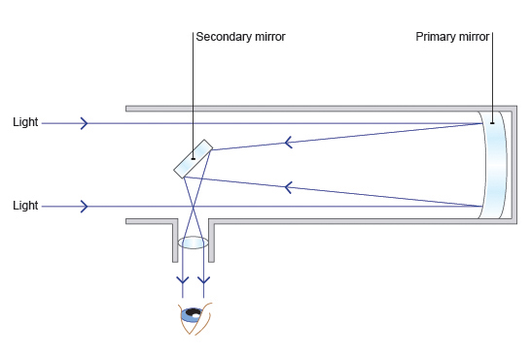
1. What does refract mean?
Light rays are absorbed as they pass into a different medium
Light rays bounce back as they pass into a different medium
Light rays change direction as they pass into a different medium
2. Which way do light rays bend through a convex lens?
Together at a converging point Away from each other - they diverge
They do not pass through, they bounce back
3. Who developed the heliocentric model of the universe?
Galileo Copernicus Ritter
4. If an object was 2 focal lengths in front of a lens, how would the image appear?
The image would be inverted
The image would be bigger
The image would appear further away than 2 focal lengths
Ionising radiation

Ionising radiation
Radioactive substances give out radiation all of the time. There are three types of nuclear radiation: alpha, beta and gamma. Alpha is the least penetrating, while gamma is the most penetrating. Nonetheless, all three are ionising radiation: they can knock electrons out of atoms and form charged particles.
Radiation can be harmful, but it can also be useful - the uses of radiation include to:
- detect smoke
- gauge the thickness of paper
- treat cancer
- sterilise medical equipment.

Types of radiation
- alpha
- beta
- gamma.
The thicker the substance, the more radiation is absorbed. The three types of radiation penetrate materials in different ways.
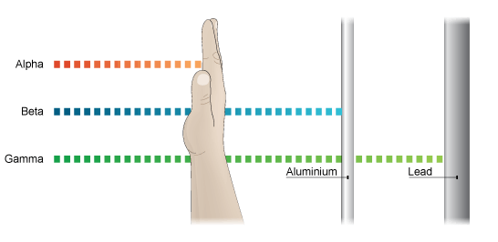
6. What is ionising radiation?
Radiation that can knock electrons out of atoms
Radiation that is always dangerous
Radiation that can only be stopped using lead sheets
7. Which type of radiation is the least penetrating?
Alpha
Beta
Gamma
8. Which type of radiation travels the furthest from its source in air?
Alpha
Beta
Gamma

