Q1. (a) Complete the following sentence:
Sound is produced when an object ...............................................
(1)

(b) Choose words from the list to complete the following sentences:
higher louder lower quieter
(i) If the frequency is increased, the pitch of the sound becomes ........................
(ii) If its amplitude is increased, the sound becomes ............................................
(2)

(c) The diagram shows a pre-natal scan.
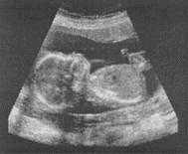

(i) What type of waves are used for pre-natal scanning?
...........................................................................................................................
(1)

(ii) Explain why we cannot hear these waves.
...........................................................................................................................
(2)
(Total 6 marks)

Q2. The table gives the frequencies of sound that different animals can hear.

Animal | Lowest frequency it can hear in Hz | Highest frequency it can hear in Hz
Human | 64 | 23 000
Dog | 67 | 45 000
Mouse | 1 000 | 91 000
Rat | 200 | 76 000
Cat | 45 | 64 000
Tuna | 50 | 1 100
Canary | 250 | 8 000
Chicken | 125 | 2 000

(a) (i) Which animal can hear the lowest sound frequency?
...........................................................................................................................
(1)

(ii) Which animal can hear the smallest range of frequencies?
...........................................................................................................................
(1)

(b) (i) What is the name given to sound frequencies higher than those that humans can hear?
...........................................................................................................................
(1)

(ii) Give one industrial use of this type of sound.
...........................................................................................................................
(1)
(Total 4 marks)

Q3. (a) A student uses a microphone to send different sounds to an oscilloscope. The diagrams show five traces, A, B, C, D and E, on the oscilloscope. All the traces are drawn to the same scale.
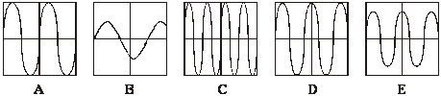
(i) Which three diagrams show traces with the same amplitude?
Diagrams .......... , .......... and .......... .
(1)
(ii) Which two diagrams show traces with the same frequency?
Diagrams .......... and .......... .
(1)

(b) The diagram shows the sound frequencies which some living things can hear.
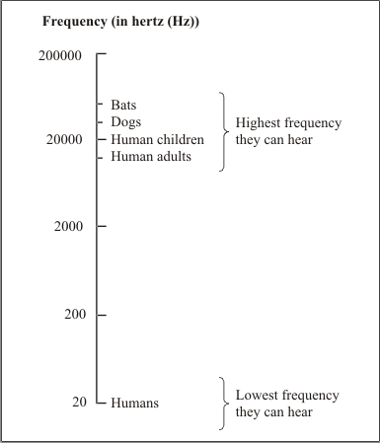
(i) What is the widest range of frequencies that a human child can hear?
..........................................................................................................................
(1)

(ii) Why can some dog whistles be heard by dogs but not by humans?
..........................................................................................................................
..........................................................................................................................
(1)

(c) An ultrasound scan can be used to make a picture of a baby in its mother’s womb. An ultrasound transmitter and detector are placed above the mother’s womb. Ultrasound goes into the body of the mother and into the body of the baby.
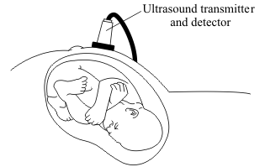
Use the correct words from the box to complete the sentences.
detector reflection refraction sound substance transmitter

(i) When the ultrasound crosses from one ................................................. to another,
some ultrasound becomes an echo caused by ................................................. .

(ii) This information is collected by the ultrasound .................................................
and made into a picture on a screen.
(3)
(Total 7 marks)

Q4. (a) This information is from a science magazine.

Electronic systems can be used to produce ultrasonic waves.
These waves have a frequency higher than the upper limit for hearing in humans.

Complete the sentence by choosing the correct number from the box.

20 2000 20 000 200 000

The upper limit for hearing in humans is a frequency of ............................................ Hz.
(1)

(b) An electronic system produces ultrasound with a frequency of 500 kHz.
What does the symbol kHz stand for?
.....................................................................................................................................
(1)

(c) (i) State one industrial use for ultrasound.
...........................................................................................................................
(1)

(ii) State one medical use for ultrasound.
...........................................................................................................................
(1)

(d) An ultrasound detector is connected to an oscilloscope.
The diagram shows centimetre squares on an oscilloscope screen. Each horizontal division represents 2 microseconds.
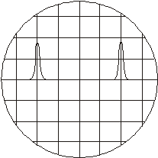
Calculate the time, in microseconds, between one peak of one ultrasound pulse and the peak of the next.
.....................................................................................................................................
Time = .............................. microseconds
(1)

(e) Ultrasounds are partially reflected when they reach a boundary between two different media.
The time taken for the reflection from the boundary to reach the detector can be seen
from the screen.
What can be calculated from this time interval?
.....................................................................................................................................
.....................................................................................................................................
(2)

(f) Explain what action scientists should take if they find evidence that ultrasonic waves may be harmful to human health.
.....................................................................................................................................
.....................................................................................................................................
.....................................................................................................................................
(2)
(Total 9 marks)

Q5. The diagram shows how ultrasonic waves can be used to clean a watch.
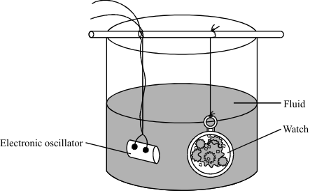

Suggest how this method cleans the watch.
...............................................................................................................................................
...............................................................................................................................................
...............................................................................................................................................
...............................................................................................................................................
(Total 2 marks)

Q6. (a) What is ultrasound?
..................................................................................................................................
..................................................................................................................................
(1)

(b) The picture shows a pregnant woman having an ultrasound scan and the image produced by the scan.
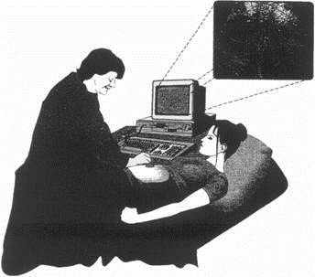
To produce the image, a very narrow beam of ultrasound pulses is fired into the mother’s body. The reflected pulses are used to build up the image of the unborn baby.

(i) Why is it important to have a very narrow beam of ultrasound waves?
........................................................................................................................
........................................................................................................................
(1)
(ii) Why is it possible to produce a very narrow beam with ultrasound but not with normal sound waves?
........................................................................................................................
........................................................................................................................
(1)

(iii) The image produced by ultrasound is not as clear as an image produced by X-rays. Why is ultrasound used for looking at unborn babies rather than X-rays?
........................................................................................................................
........................................................................................................................
(1)

(iv) Give two important pieces of information about an unborn baby which can be gained from the image produced by an ultrasound scan.
1 .....................................................................................................................
........................................................................................................................
2 .....................................................................................................................
........................................................................................................................
(2)
(Total 6 marks)

Q7. (a) A microphone connected to an oscilloscope picks up the sound from a siren. The trace produced on the oscilloscope screen is shown below.
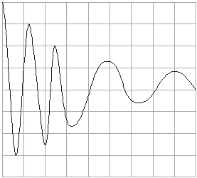
Describe how the wave changes as it goes across the screen from left to right (→).
To gain full marks in this question you should write your ideas in good English. Put them into a sensible order and use the correct scientific words.
.....................................................................................................................................
.....................................................................................................................................
.....................................................................................................................................
.....................................................................................................................................
.....................................................................................................................................
(3)

(b) An African bat produces a sound wave with a frequency of 212 kHz and a wavelength of 0.0016 m.
(i) The sound made by the bat is above the limit of human hearing.
What name is given to this type of sound?
...........................................................................................................................
(1)

(ii) Write down the equation that links frequency, wavelength and wave speed.
...........................................................................................................................
(1)

(iii) Calculate the speed of this sound wave through the air. Show clearly how you work out your final answer.
...........................................................................................................................
Wave speed = ............................... m/s
(3)
(Total 8 marks)

Q8. The diagram shows an ultrasound monitor being used to scan a fetus.
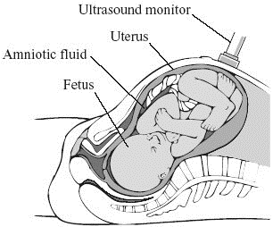

The table shows the velocity of ultrasound waves in different tissues of the fetus.

Tissue | Velocity of ultrasound in m/s
Amniotic fluid  (liquid surrounding fetus) | 1540
Bone | 3080
Kidney | 1561
Liver | 1549
Muscle | 1585

Explain why we are able to see the different parts of the fetus in an ultrasound scan. You may use information from the table in your answer.
To gain full marks in this question you should write your ideas in good English. Put them into a sensible order and use the correct scientific words.
...............................................................................................................................................
...............................................................................................................................................
...............................................................................................................................................
...............................................................................................................................................
...............................................................................................................................................
(Total 4 marks)

Q9. (a) An endoscope is an instrument used by doctors for looking inside patients. A bundle of thin optical fibres pass light into the patient’s body, a second bundle of fibres carry reflected light back to the doctor.
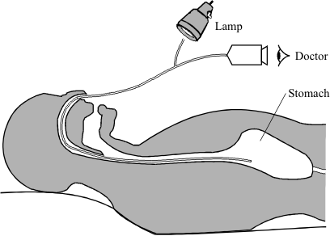

(i) Complete the diagram below to show how an optical fibre is able to pass light into a patient’s body.
(2)

(ii) Give one advantage of using lots of thin fibres to make the bundles, rather than a few thick fibres.
............................................................................................................................
............................................................................................................................
(1)

(iii) Give one further example of the practical use of an optical fibre.
............................................................................................................................
............................................................................................................................
(1)

(b) The diagram shows a wave travelling through a stretched spring.
In what way is this wave the same as a sound wave?
.....................................................................................................................................
(1)

(c) Sound waves travel faster in liquids than in gases. Why?
.....................................................................................................................................
.....................................................................................................................................
(1)

(d) A bat uses ultrasound to find its way around. Explain how.
.....................................................................................................................................
.....................................................................................................................................
.....................................................................................................................................
.....................................................................................................................................
(2)
(Total 8 marks)

Q10. (a) Sound travels through air, water and glass at different speeds. Through which of these materials does sound travel:
the fastest; .............................................
the slowest? ...........................................
(2)
Give a reason for your choice of answers.
...................................................................................................................................
...................................................................................................................................
(1)

(b) The bar chart shows the frequencies of sound which different animals can make and can hear.
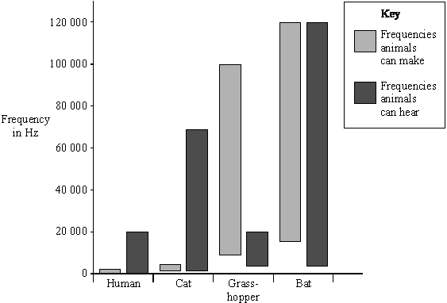

(i) Which of the animals can make sounds which are beyond their own hearing range?
..........................................................................................................................
(1)

(ii) What name is given to the sounds which a cat can hear but a human cannot?
..........................................................................................................................
(1)

(c) The diagram shows a trawler searching for a shoal of fish. Pulses of high frequency sound emitted from the trawler are reflected back to the trawler. The pulses are displayed on a cathode ray oscilloscope.
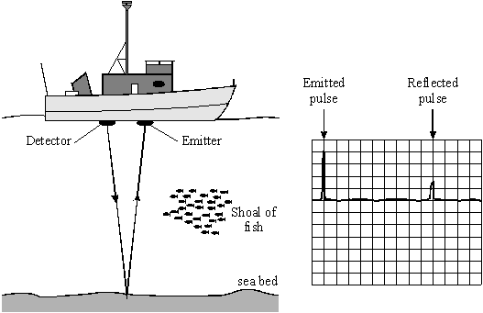

Complete the diagram below to show the pattern seen on the cathode ray oscilloscope as the trawler passes over the shoal of fish.
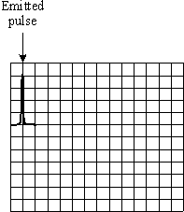
(2)
(Total 7 marks)

Q11. (a) The diagrams show oscilloscope traces for the same musical note played on two different instruments. The oscilloscope settings are not changed.
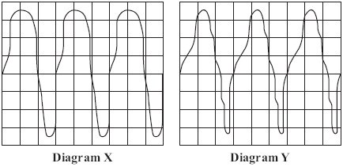

(i) How can you tell, from the diagrams, that it is the same musical note?
...........................................................................................................................
...........................................................................................................................
(1)

(ii) How can you tell, from the diagrams, that the musical note has been played on different instruments?
...........................................................................................................................
...........................................................................................................................
(1)

(b) This passage is from an electronics magazine.

Electronic systems can be used to produce ultrasound waves.
These waves have a higher frequency than the upper limit for hearing in humans.
Ultrasound waves are partially reflected when they meet a boundary between two different media.

(i) Approximately what is the highest frequency that humans can hear?
State the number and the unit.
...........................................................................................................................
(1)

(ii) What does the word media mean when it is used in this passage?
...........................................................................................................................
...........................................................................................................................
(1)

(iii) What happens to the ultrasound which reaches the boundary between two different media and is not reflected?
...........................................................................................................................
...........................................................................................................................
...........................................................................................................................
...........................................................................................................................
(2)
(Total 6 marks)

Q12. Pigs have a layer of fat in their skin. Underneath the fat is a layer of muscle. Ultrasonic waves are used to measure the thickness of the layer of fat. An ultrasound transmitter and detector are attached to the skin of the pig.
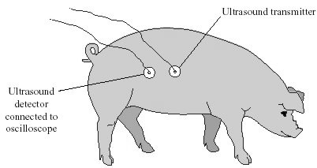

(a) Explain why ultrasound can be used to measure the thickness of the layer of fat.
.....................................................................................................................................
.....................................................................................................................................
.....................................................................................................................................
.....................................................................................................................................
(2)

(b) The oscilloscope does not measure distance directly.
(i) What does the oscilloscope measure in this case?
...........................................................................................................................
...........................................................................................................................
(1)

(ii) What other information is needed to calculate the thickness of the layer of fat in a pig?
...........................................................................................................................
...........................................................................................................................
(1)
(Total 4 marks)

Q13. The picture shows a pre-natal scan obtained using ultrasonic waves.
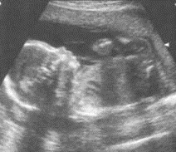

(i) Explain how ultrasonic waves are used to produce the image of an unborn baby.
.....................................................................................................................................
.....................................................................................................................................
....................................................................................................................................
.....................................................................................................................................
(2)

(ii) Give another use for ultrasonic waves.
.....................................................................................................................................
(1)
(Total 3 marks)

Q14. Ultrasound can be used in industry for detecting internal cracks in metals.
(a) State two features of ultrasound.
1 ..................................................................................................................................
2 ..................................................................................................................................
(2)

(b) The diagram shows an ultrasound transmitter and detector fixed to the front of a metal block. The block has an internal crack.
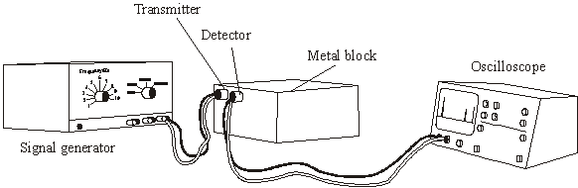

The diagram below shows the screen of the oscilloscope connected to the detector.
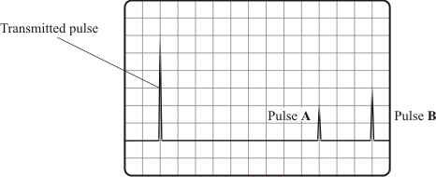
(i) Explain why pulse A and pulse B occur.
..........................................................................................................................
..........................................................................................................................
..........................................................................................................................
(2)

(ii) The metal block is 120 mm from front to back. What is the distance, in mm, from the front of the block to the internal crack?
Distance = .................... mm
(1)
(Total 5 marks)

M1. (a) vibrates (owtte)
for one mark
1

(b) (i) higher
for one mark
1
(ii) louder
for one mark
1

(c) (i) ultrasonic (ultrasound)
for one mark
1

(ii) different frequency / wavelength / pitch
gains 1 mark
but
high frequency / pitch, higher frequency /pitch (lower frequency / pitch wrong)
gains 2 marks
2
[6]

M2. (a) (i) cat
1

(ii) tuna
1

(b) (i) ultrasound
allow ultrasonic
1
(ii) cleaning / quality control / flaw detection / medical scanning /
animal scaring / sonar
1
[4]

M3. (a) (i) A, C and D
any order but all three required and no others
1
(ii) D and E
either order but both required and no others
1

(b) (i) 20000 (Hz) to 20 (Hz)
accept ‘19980 (Hz)’
or vice-versa
1

(ii) frequency (of dog whistle) too high (for humans to hear) / frequency
above 20000 Hz
accept ‘it is ultrasound’
accept ‘sound from the whistle is ultrasonic’
1

(c) (i) substance
1
reflection
correct order essential
1

(ii) detector
1
[7]

M4. (a) 20000
accept any unambiguous indication
1
(b) kilohertz
credit misspellings
credit ‘1000 hertz’ or ‘1000 Hz’
accept 1000 oscillations/beats/waves per second
1

(c) (i) cleaning (e.g. something delicate such as a watch)
or quality control/flaw detection
credit any appropriate extra Specification response
e.g. sonar
1
(ii) pre-natal (scanning)
do not credit just ‘scanning’/medical scanning/ scanning a baby
credit any appropriate extra Specification response
e.g. destruction of (kidney) stones or cleaning teeth
1

(d) 8 (μs)
1
(e) distance (1)
between the boundary and the detector (1)
accept ‘between the boundary and the source’
accept any correct use of speed = distance/time
2

(f) examples
publish/tell doctors/the public (1) ... their evidence/results/research/data (1)
carry out more research/tests (1) ... to make sure/check reliability (1)
allow a wide variety of appropriate responses
valid point (1) appropriate example/qualification/expansion/etc. (1)
allow just ‘stop using them/ultrasonic waves’ (1)
allow using them (only) for industrial purposes (1)
2
[9]

M5. (ultrasonic) waves or vibrations or oscillations in fluid
N.B. must mention fluid or liquid
or water
1
idea of shaking dirt particles off watch
allow cavitation / implosion of small bubbles
1
[2]

M6. (a) sound with a frequency above audible
do not accept answer in terms of λ
do not accept sound which cannot be heard unless obvious from context
accept above 20 kHz
1

(b) (i) to show detail or to give a clear image/picture
accept the generators or transducers can be small
accept so the beam does not spread out/beam in focus
not ‘good picture’
1

(ii) (much) smaller wavelength
allow higher frequency/pitch
1

(iii) no damage to living cells (provided low power)
accept the converse
accept no damage to baby or not dangerous to baby
1

(iv) any two forms
sex
stage of development
or specific examples
abnormalities
general health
potential problems (at birth)
accept specific examples e.g. umbilical cord around neck
size of head
accept multiple births
2
[6]

M7. (a) any two from:
• amplitude decreasing
accept siren / sound getting quieter
do not accept sound decreases
• wavelength increasing
• frequency decreasing
accept pitch decreasing
ignore reference to transverse wave
ignore reference to speed
contradictory statements within each point lose the mark
2
Quality of written communication
all emboldened terms in candidate’s answer used correctly
1

(b) (i) ultrasound or ultrasonic
1

(ii) wave speed = frequency × wavelength
accept speed / velocity for wave speed
accept v = f λ
do not accept w for λ
do not accept s for v
accept
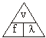
provided subsequent calculation
shows a correct method
1

(iii) 339.2 or 340 or 339
allow 1 mark for using 212 000
allow 1 mark for correct substitution
an answer of 0.3392 or 0.34 or 0.339 gains 1 mark only
award full credit for a correct numerical answer with the unit changed to km/s
3
[8]

M8. Quality of written communication
correct use of three scientific terms from speed / velocity, reflection,
density, time, boundary
1
any three from:
different tissues have different densities
ultrasound travels at different speeds / velocities in different tissues
reflection
accept bouncing back
from tissue boundaries
time taken to return
3
[4]

M9. (a) (i) total internal reflection shown (2 – 8 reflections)
1
angles look correct (by eye) (2 – 5 reflections)
1

(ii) can be bent more (without loss of light)
accept easier to get into patient or more flexible
accept more detailed or better image
accept if some fibres broke system would not fail
do not accept to pass more light - neutral
1

(iii) any one of the following:
do not accept any further endoscopy uses
(telephone) communications (carry (laser) light) for surgery
or operations
torches
guides in cars
table lamps or ornamental lights
do not accept telephone wires
1

carry TV signals
carry computer data or information
cable TV or cable telephone
do not accept TV or telephone or computers without qualification
do not accept bomb disposal unless qualified
accept to stimulate children with learning difficulties

(b) (both) longitudinal
accept both have compressions or rarefactions
accept both have high or low pressure regions
accept both transfer energy
do not accept 'need a medium'
1

(c) liquids have a greater density
or
molecular spacing in gases is greater
1

(d) (bat) transmits or emits ultrasound or pulses or signals or sound or waves
allow one mark if response is in terms of distance and time
1
picks up reflected ultrasound or signals or waves or sound or echo
allow 1 mark for echo location
1
[8]

M10. (a) glass
1
air
must be in correct order
1

closer the particles faster the speed
answer must show a comparison
or
particles in glass closest in air furthest apart
accept the denser the material the faster the sound travels
or
sound travels faster in solids than gases
incorrect explanation negates credit
1

(b) (i) grasshopper
(ii) ultrasound
accept ultrasonic
1

(c) all of reflected pulse closer than given in original diagram
accept a cluster of pulses ignore a reflected pulse in original position any pulse drawn to right of original negates credit
1
reflected pulse smaller than emitted but greater than 1 square high
accept cluster of pulses provided one part fulfils height_ criteria
2
[7]

M11. (a) (i) same frequency / period / pitch / wavelength
ignore references to amplitude
1

(ii) differences in waveform / shape / quality
accept the diagrams are not identical
1

(b) (i) 20 000 Hz / hertz
or 20 kHz / kilohertz
in both cases, if the symbol rather than the name is used, it must be correct in every detail
1

(ii) material(s) / substance(s) (through which sound travels)
1

(iii) is absorbed
accept (some) sound (energy) is transformed / transferred as heat / thermal energy
1
is transmitted
accept is refracted
accept changes speed
accept changes velocity
do not accept is diffracted
do not accept is diffused
do not accept is dissipated
1
[6]

M12. (a) (ultrasound) waves reflected
accept ‘bounce off’
1
at boundary / from muscle
1

(b) (i) time
1
(ii) speed of (ultrasound) waves
1
[4]

M13. (i) (partly) reflected when they hit a (boundary between two) different media
or substance or tissue
accept named substances
do not accept bounce back
1
time taken for reflected wave (to return) is used to produce the image
1

(ii) any one from:
cleaning a delicate mechanism / jewellery
do not accept cleaning
welding plastics
cutting textiles
mixing emulsion paints
sonar
motion sensors (in burglar alarms)
do not accept burglar alarms

removing dental plaque
industrial quality control
breaking up kidney stones
treating injuries
1
[3]

M14. (a) any two points:
do not credit features which are true of sound in general eg longitudinal waves
• humans cannot hear ultrasound
• it has a very high frequency / pitch
do not credit just ‘has a high frequency / pitch’
• above the (upper) limit for humans / above 20 000 Hz
2

(b) (i) ultrasound / waves are reflected
...are bounced is insufficient, but
...echo is acceptable
1
Pulse A indicates / is the crack
Pulse B indicates / is the back (of the block or crack)
need to mention both A and B to get this mark
1

(ii) 90 (mm)
accept any answer in the range 88 – 92 (mm)
1
[5]

E1. Parts (a) and (b) were well answered by most candidates.
In part (c)(i) only a minority managed "ultra-sound" to gain the mark, the common distractor was "ultra-violet". In part (c)(ii) many candidates gained the mark for increased pitch or frequency, the more able often went far beyond the mark scheme and gave answers in terms of frequencies above 20 000 Hz. A few candidates spoilt their answers by referring to increased frequency and reduced or small amplitude. Where a candidate gives two answers, one right and one wrong, the examiner cannot pick which answer to mark and marks are not awarded.

E2. (a) Most candidates could extract at least one correct figure from the table.

(b) In part (i) the term ultrasound or ultrasonic was not known by many. Examiners saw several references to supersonic and even a few to ‘panasonic’. In (ii) some candidates were confusing ultrasound with microwaves, which led them to giving answers concerning radar.

E3. (a) (i) Most candidates identified the diagrams which showed traces with the same amplitude.
(ii) Two thirds of candidates identified the two diagrams showing traces with the same frequency.

(b) (i) Just over half of the candidates chose the correct range that a human child can hear.
(ii) Just over half of the candidates gained a mark but those that did not often failed to mention that the frequency of the whistle was above 20 000 Hz. It was not sufficient to state that dogs can hear higher frequencies than humans.

(c) (i) Approximately a third of candidates gained both marks whilst three quarters of candidates gained at least one mark.
(ii) Nearly two thirds of candidates identified that the information is collected by the ultrasound detector and gained a mark.

E4. Foundation Tier
(a)(b) The majority of candidates chose the correct response and nearly all knew that the symbol kHz stands for kilohertz.
(c) (i)(ii) A significant minority of candidates could give an industrial use for ultrasound and a majority could give a medical use. It should be noted that vague responses such as ‘scanning organs’ did not gain a mark.
Candidates needed to be more precise eg ‘scanning the kidneys’ or ‘scanning an unborn baby’.

(d) Many candidates were able to interpret the diagram, and the information given about the scale, and correctly deduce that the time interval is 8 microseconds.
(e) Few candidates were able to deduce that if the time interval is known then the distance travelled can be calculated.
(f) Most candidates obtained a mark for the suggestion that, in this imaginary event, we should stop using ultrasonic waves but few had any sensible qualification to make and seemed unaware to the harm this reaction could cause.

Higher Tier
(a) Most candidates answered this correctly.
(b) Nearly all candidates gained the mark for this question.
(c) (i)(ii) Most candidates could give an industrial use and a medical use for ultrasound. It should be noted that vague answers such as ‘scanning organs’ or ‘scanning babies’ did not gain credit.
Candidates needed to be more precise eg ‘scanning the kidneys’ or ‘scanning an unborn baby’.

(d) Most candidates were able to interpret the diagram, and the information given about the scale, and correctly deduce that the time interval is 8 microseconds.
(e) Over half the candidates gained one mark by deducing that if the time interval is known then the distance can be calculated but few of these candidates were able to state what the distance is in this case.
(f) Nearly all candidates obtained a mark for the suggestion that, in this event, we should stop using ultrasonic waves and about half of these candidates had a sensible qualification to make such as the need for further research.

E5. Foundation Tier
This proved to be probably the most difficult question on the paper for the foundation tier candidates.
The better ones realised that waves travelled through the fluid (which was often thought erroneously to be water). However, hardly any candidates appreciated how these waves could then dislodge the dirt particles. It was common to see reference to the waves dissolving the dirt or killing bacteria on the watch.

Higher Tier
The better candidates realised that waves travelled through the fluid (which was often thought erroneously to be water). However, surprisingly few appreciated how these waves could then dislodge the dirt particles. It was common to see reference to the waves dissolving the dirt or killing bacteria on the watch.

E6. Foundation Tier
Part (a) was poorly answered with very few candidates being able to give a reasonable definition of ultrasound. In part (b) most candidates thought that a wider beam would cause problems for both the mother and baby. Few considered that a narrow beam would give more detail. Most candidates were able to give sensible answers in part (b)(iv).

Higher tier
Part (a) was answered poorly with very few candidates being able to give a reasonable definition of ultrasound. In part (b) most candidates thought that a wider beam would cause problems for both the mother and baby. Few considered that a narrow beam would give more detail. Most candidates were able to give sensible answers in both part (b)(iii) and part (b)(iv).

E7. In part (a) few candidates were able to score full marks. The majority of candidates showed a poor understanding of amplitude, frequency and wavelength. Many answers contained contradictions, such as ‘frequency increases and pitch decreases’. Part (b)(i) was disappointing with many candidates unable to remember the word ultrasound or ultrasonic. The equation in part (b)(ii) was often correct but the subsequent calculation in part (b)(iii) was rarely correct, a common error being to leave the frequency in kHz.

E8. This question was very poorly answered by the majority of candidates. Many had the idea that different speeds of ultrasound are used to identify different tissues. Few explained that partial reflection, caused at a boundary between tissues of different densities, enabled time to be measured. The Quality of Written Communication mark was rarely awarded, candidates failing to use the terms described above.

E9. Foundation Tier
Large numbers of candidates were able to demonstrate a working knowledge of the ray diagram for an optical fibre and many understood the reasons for thin fibre bundles being employed. Many correct applications were given in part (a)(iii) but rather too many employed a similar medical application to that already given. In part (b) candidates generally described the diagram, rather than mentioning ‘longitudinal’. Many answers to part (c) suggested ‘more particles’ but fewer inferred particle concentration. In part (d) many candidates identified that the bat listened to sounds, but many answers implied that the objects in its path produced signals rather than the bat itself. Few candidates understood that both the emission and detection of ultrasound involved the bat.

Higher Tier
Most candidates were able to demonstrate a working knowledge of the ray diagram for an optical fibre and understood the reasons for thin fibre bundles being employed. Many correct applications were given in part (a)(iii) but rather too many employed a similar medical application to that already given. In part (b) candidates generally described the diagram, rather than mentioning ‘longitudinal’. Many answers to part (c) suggested ‘more particles’ but fewer inferred particle concentration or proximity of particles. In part (d) many candidates identified that the bat listened to sounds, but many answers implied that the objects in its path produced signals rather than the bat itself. Few candidates understood that both the emission and detection of ultrasound involved the bat.

E10. Foundation Tier
In part (a) the majority of candidates incorrectly gave ‘air’ and then ‘glass’. Many erroneous explanations were given in terms of ‘sound particles’ travelling easily through a gas. Part (b) was generally answered well, although a significant number of candidates could not recall the term ‘ultrasound’. In part (c) few of the responses were correct for both pulse size and position.

Higher Tier
In part (a) a significant number of candidates incorrectly gave ‘air’ and then ‘glass’. Many gave an erroneous explanation in terms of ‘sound particles’ travelling easily through a gas. Those candidates correctly giving ‘glass’ then ‘air’ usually gave a correct reason for their choice. Part (b) was generally answered well, although a significant number of candidates could not recall the term ‘ultrasound’. In part (c) only the most able candidates saw the significance of both amplitude and position. Many candidates also included the reflected pulse from the original graph which was unnecessary and, unless clearly labelled, often spoilt their answer.

E11. (a) (i) The majority of candidates scored a mark.
(ii) Most candidates were able to explain that the diagrams represent different musical instruments because there are differences in detail between their shapes.
(b) (i) Most candidates knew the numerical value of the required frequency but some of them lost the mark because of careless use of units as illustrated by ‘20 000 kHz’.
(ii) In part (b)(ii) most candidates understood the meaning of the word ‘media’ in the context of the short passage on ultrasound.
(iii) Most candidates were able to obtain one mark out of the two for stating that some of the ultrasound is absorbed.

E12. Ultrasound still tends to confuse most candidates.
(a) Those who read and applied the information in the introduction to the question, scored best. These candidates realised that some ultrasound waves would be reflected from the layer of muscle underneath the fat. Weaker candidates ignored this information and answered in terms of ante-natal pictures.
(b) Many realised that the oscilloscope measures time, but only the most able candidates realised that wave-speed was needed in (ii).

E13. The majority of candidates realised that the ultrasonic waves were reflected from the unborn baby, although a number of candidates used the unacceptable term ‘bounce back’. Very few candidates mentioned the time taken for the reflected wave to return as being used to produce the image. In part (b)(ii) most uses given were correct, but the answer ‘industrial cleaning’ was too vague to gain credit. A few candidates gave uses of gamma rays.

E14. (a) Most candidates secured both marks by writing that ultrasound has a frequency greater than 20 000 Hz and so cannot be heard by humans. However, some candidates offered responses which are true for sound in general, ‘It’s not as fast as light’ for example, and did not gain any credit.

(b) (i) Most candidates realised that the pulses are caused by ultrasound being reflected, though some candidates did not secure the mark because they offered ‘rebounded’ or ‘bounced’. Most candidates thought that pulse A indicates the crack and pulse B indicates the back of the block, or the back of the crack. Either interpretation gained credit provided that both pulses were identified.
(ii) Most candidates correctly offered an answer in the range 88 – 92 (mm).

