Q1. The diagram shows a transformer made by a student. The student has designed the transformer to make a 6 V light bulb work using a 2 V power supply.
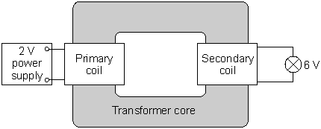

(a) Draw a ring around the correct answer to complete the following sentences.

(i) For the transformer to work, the student | must use an a.c.  can use either an a.c or a d.c.  must use a d.c.

power supply.
(1)

(ii) On the primary coil there are 30 turns of wire. For the lamp to work brightly

less than 30
exactly 30
more than 30
there must be |  | turns of wire on the secondary coil.

(1)

(b) What is the transformer core made from?
Give a reason for your answer.
........................................................................................................................
........................................................................................................................
........................................................................................................................
........................................................................................................................
(2)
(Total 4 marks)

Q2. (a) The basic structure of a transformer is a primary coil of insulated wire, an iron core and a secondary coil of insulated wire.
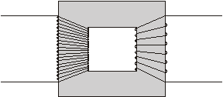

(i) Why is the core made of iron?
...........................................................................................................................
...........................................................................................................................
(1)

(ii) Explain how a transformer works.
...........................................................................................................................
...........................................................................................................................
...........................................................................................................................
...........................................................................................................................
...........................................................................................................................
...........................................................................................................................
...........................................................................................................................
...........................................................................................................................
(4)

(b) A small step-down transformer is used in the charger for an electric screwdriver.
The input to the transformer is 230 V a.c. mains supply and the output is 5.75 V a.c.
There are 3200 turns on the primary coil.
Use the equation in the box to calculate the number of turns on the transformer’s secondary coil.

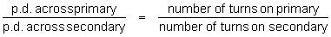

Show clearly how you work out your answer.
.....................................................................................................................................
.....................................................................................................................................
Number of turns = ..............................
(2)
(Total 7 marks)

Q3. (a) The diagram shows a transformer.
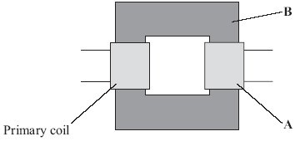

(i) What is part A?
...........................................................................................................................
(1)

(ii) What is part B and what is it made of?
...........................................................................................................................
...........................................................................................................................
(2)

(iii) When there is an alternating current in the primary coil, what is produced in part B?
...........................................................................................................................
...........................................................................................................................
(2)

(b) Transformers are used in the National Grid. The diagram shows part of the National Grid.
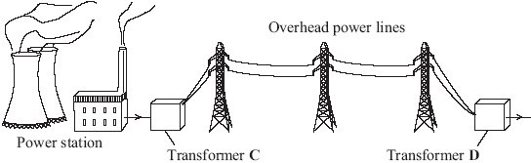
Complete the two spaces in the sentence.
Transformer C is a ............................................. transformer and transformer D is
a ............................................. transformer.
(1)

(c) This is an item from a newspaper.
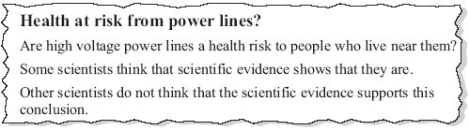
Which two suggestions would reduce the possible risk to people’s health?
Put a tick () in the box next to your answers.
Do not build new houses near to existing power lines.
Move the power lines so that they take the shortest routes.
Move each power station to the centre of the nearest city.
Build new power lines away from where people live.
Use more transformers in the National Grid.
(2)
(Total 8 marks)

Q4. The diagram below shows a transformer.
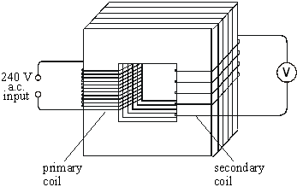

(i) Name the material used to make the core of the transformer.
.....................................................................................................................................
(1)

(ii) The primary coil has 48 000 turns and the secondary coil 4000 turns.
If the input voltage is 240 V a.c., calculate the output voltage.
.....................................................................................................................................
.....................................................................................................................................
Answer ......................................... V
(2)

(iii) Explain how the use of such a transformer could be adapted to transform a low voltage into a higher voltage.
.....................................................................................................................................
.....................................................................................................................................
(1)
(Total 4 marks)

Q5. (a) The diagram shows a transformer.
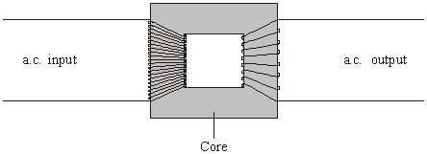

(i) Is the transformer in the diagram being used as a step-up transformer or as a step-down transformer?
Put a tick () in the box next to your answer.
a step-up transformer
a step-down transformer
Explain your answer.
...........................................................................................................................
...........................................................................................................................
(1)

(ii) Why is insulated wire, and not uninsulated wire, used to make the coils?
...........................................................................................................................
...........................................................................................................................
(1)

(iii) Why is the core made of iron?
...........................................................................................................................
...........................................................................................................................
(1)

(b) A transformer has 500 turns on its primary coil and 7500 turns on its secondary coil. The potential difference across the primary coil is 150 volts.
Use the equation in the box to calculate the potential difference across the secondary coil.
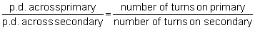

Show clearly how you work out your answer.
.....................................................................................................................................
.....................................................................................................................................
.....................................................................................................................................
Potential difference across the secondary coil = .............................. volts
(2)

(c) Step-down transformers are used between power lines and people’s houses.
Explain why.
.....................................................................................................................................
.....................................................................................................................................
.....................................................................................................................................
(2)

(d) Before 1926, large towns had their own local power stations. After 1926, these power stations were connected to form the National Grid.
Explain the advantage of having a National Grid system.
.....................................................................................................................................
.....................................................................................................................................
.....................................................................................................................................
.....................................................................................................................................
(2)
(Total 9 marks)

Q6. (a) This notice is on the back of a television set.
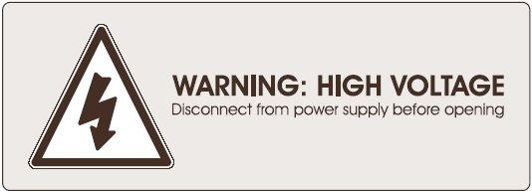
The transformer used in the television set has 75 turns on its primary coil. The potential difference (p.d.) across the primary coil is 230 volts and the p.d. across the secondary coil is 32 200 volts.

Use the equation below to calculate the number of turns on the secondary coil.
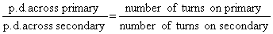
Show clearly how you work out your answer.
....................................................................................................................................
....................................................................................................................................
....................................................................................................................................
Number of turns on the secondary coil = ....................
(2)

(b) The diagram shows the structure of a transformer.
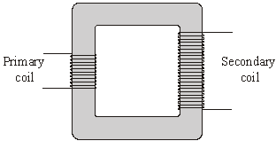
Explain how the transformer works.
....................................................................................................................................
....................................................................................................................................
....................................................................................................................................
....................................................................................................................................
....................................................................................................................................
....................................................................................................................................
(3)
(Total 5 marks)

Q7. A transformer is used to reduce the 230 V a.c. mains to the 12 V supply required for the lighting system. The transformer has 1150 turns on its primary coil.
(i) Write down the equation which links the number of turns of each transformer coil to the voltage across each transformer coil.
....................................................................................................................................
....................................................................................................................................
(1)

(ii) Calculate the number of turns on the secondary coil of the transformer. Show clearly how you work out your answer.
....................................................................................................................................
....................................................................................................................................
....................................................................................................................................
number of turns on the secondary coil = .........................
(2)
(Total 3 marks)

Q8. (a) The drawing shows a small transformer used to recharge the battery in a 4.2 V mobile phone from a 230 V mains supply.
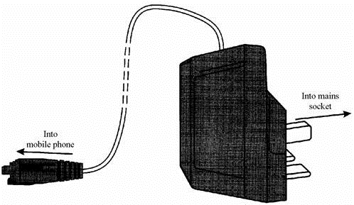
Explain how you know that this is a step-down transformer.
.....................................................................................................................................
.....................................................................................................................................
(1)

(b) A transformer consists of an insulated coil of wire, called the primary coil, on one side of a core. Another coil of insulated wire, called the secondary coil, is on the other side.
Give two features of the core.
1 ..................................................................................................................................
2 ..................................................................................................................................
(2)
(Total 3 marks)

Q9. (a) The diagram represents a simple transformer used to light a 12 V lamp. When the power supply is switched on the lamp is very dim.
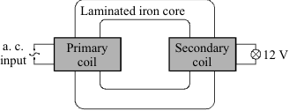

(i) Give one way to increase the voltage at the lamp without changing the power supply.
............................................................................................................................
............................................................................................................................
(1)

(ii) What is meant by the iron core being laminated?
............................................................................................................................
............................................................................................................................
(1)

(b) Electrical energy is distributed around the country by a network of high voltage cables.
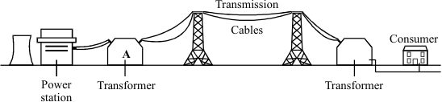

(i) For the system to work the power is generated and distributed using alternating current rather than direct current. Why?
............................................................................................................................
............................................................................................................................
(1)

(ii) Transformers are an essential part of the distribution system. Explain why.
............................................................................................................................
............................................................................................................................
............................................................................................................................
(2)

(iii) The transmission cables are suspended high above the ground. Why?
............................................................................................................................
(1)

(c) The power station generates 100 MW of power at a voltage of 25 kV. Transformer A, which links the power station to the transmission cables, has 44 000 turns in its 275 kV secondary coil.
(i) Write down the equation which links the number of turns in each transformer coil to the voltage across each transformer coil.
............................................................................................................................
............................................................................................................................
(1)

(ii) Calculate the number of turns in the primary coil of transformer A. Show clearly how you work out your answer.
............................................................................................................................
............................................................................................................................
............................................................................................................................
Number of turns = ........................................
(2)

(d) The diagram shows how the cost of transmitting the electricity along the cables depends upon the thickness of the cable.
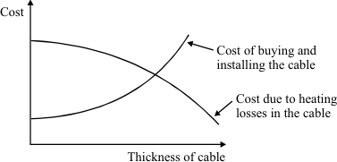

(i) Why does the cost due to the heating losses go down as the cable is made thicker?
............................................................................................................................
(1)

(ii) By what process is most heat energy lost from the cables?
............................................................................................................................
(1)
(Total 11 marks)

Q10. (a) An appliance in a house has a transformer. The transformer is used to reduce the voltage to the level needed by the appliance.
The diagram shows the transformer.
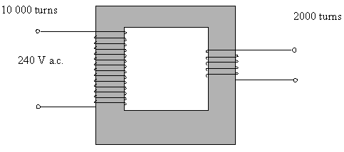

(i) Name the material used for the core of the transformer.
...........................................................................................................................
(1)

(ii) The transformer has 10 000 turns on the input side and 2000 turns on the output side. If the mains voltage of 240 volts is applied to the input, calculate the output voltage. You may find the following information helpful:
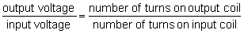
...........................................................................................................................
...........................................................................................................................
...........................................................................................................................
...........................................................................................................................
(3)

(b) Explain, in terms of magnetic fields, how a transformer works.
.....................................................................................................................................
.....................................................................................................................................
.....................................................................................................................................
.....................................................................................................................................
.....................................................................................................................................
.....................................................................................................................................
(4)

(c) A 12 V car battery is connected to the input leads of the transformer. It is hoped to reduce the voltage to 2.4 V in order to run a small motor. When the output voltage is measured it is found to be zero.
Explain why the output voltage is zero.
.....................................................................................................................................
.....................................................................................................................................
.....................................................................................................................................
.....................................................................................................................................
(2)
(Total 10 marks)

Q11. The drawing shows an experiment using a low voltage supply, a joulemeter, a small immersion heater and a container filled with water.
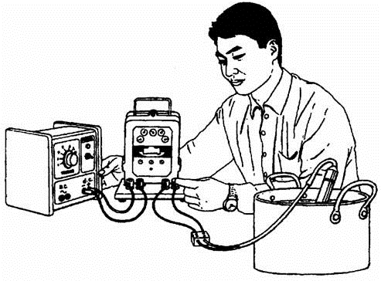
The immersion heater is designed for use in a tropical fish tank. It is connected to a step-down transformer supplied by 230 V a.c. mains.

The inside of a step-down transformer consists of three main parts. Name the three parts and briefly describe them. You may add to the diagram to help you to answer.
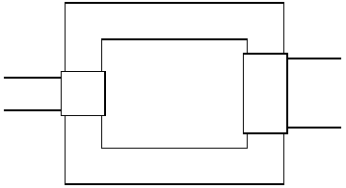
...............................................................................................................................................
...............................................................................................................................................
...............................................................................................................................................
...............................................................................................................................................
...............................................................................................................................................
...............................................................................................................................................
...............................................................................................................................................
...............................................................................................................................................
...............................................................................................................................................
(Total 4 marks)

Q12. The diagram shows the basic structure of a transformer.
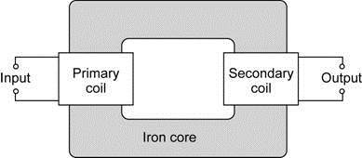

(a) Explain how a transformer works.
........................................................................................................................
........................................................................................................................
........................................................................................................................
........................................................................................................................
........................................................................................................................
........................................................................................................................
........................................................................................................................
........................................................................................................................
........................................................................................................................
(5)

(b) A transformer is used to change the 230 volt mains electricity supply to the 12 volts needed to operate a low voltage halogen lamp. The current through the halogen lamp is
4 amps.
Calculate the current drawn by the transformer from the mains electricity supply.
Assume that the transformer is 100 % efficient.
Write down the equation you use, and then show clearly how you work out your answer.
........................................................................................................................
........................................................................................................................
........................................................................................................................
........................................................................................................................
........................................................................................................................
Current = ........................................... amps
(2)
(Total 7 marks)

M1. (a) (i) must use an a.c.
1
(ii) more than 30
1

(b) iron
reason can only score if iron is chosen
1
because it can be magnetised (and demagnetised) easily
1
[4]

M2. (a) (i) (quickly) becomes magnetized
or (quickly) loses its magnetism
or ‘it’s (a) magnetic (material)’
any reference to conduction of electricity/heat nullifies the mark
1

(ii) any four from:
• insulation prevents electricity/current flowing through the iron/core
or ‘insulation so electricity/current only flows in the wires/turns/coils’
• alternating current/a.c. in the primary (coil)
• produces a changing magnetic field (in the iron/core)
• (and hence magnetic) field in the secondary (coil)
• induces/generates/produces an alternating potential difference/p.d./voltage across the secondary (coil)
• (and hence) alternating current/a.c. in the secondary (coil)
4

(b) 80 (turns)
or credit (1) for any equation which if correctly evaluated would give 80 example
example
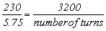
2
[7]

M3. (a) (i) secondary(coil) / output (coil)
do not accept just coil
1

(ii) core
do not accept for either mark it is made out of iron ore
1
(laminated soft) iron
allow 1 mark for ‘it is made out of iron core’
1

(iii) magnetic field
accept magnetism / magnetic force
1
(which is) changing / alternating
direction (of field) changes / strength (of field) varies
scoring second mark is dependent on first mark
1

(b) ...step-up .... step-down ...
both in the correct order
1

(c) Do not build new houses ....
1
Build new power lines away ....
deduct 1 mark for any other(s) to a minimum total of (0)
1
[8]

M4. (i) iron
for 1 mark
1

(ii) 20
gains 2 marks
else working
gains 1 mark
2

(iii) reverse input/output
for 1 mark
or increase secondary turns
1
[4]

M5. (a) (i) step-down (transformer) because fewer turns on the output/secondary (coil)
no credit for just ‘step-down transformer’
accept ‘…less turns…’
do not credit ‘…fewer coils…’
or ‘the p.d. across the input / primary will be greater than the p.d. across the output / secondary’
1

(ii) to prevent a short (circuit)(through the turns of wire or through the core
do not credit references to safety or heat (insulation)
1

(iii) (easily) magnetised (and demagnetised)
accept ‘(it’s) magnetic’
do not accept ‘because it’s a conductor’
1

(b) 2250
correct substitution
eg gains 1 mark

or appropriate transformation
eg (p.d. across secondary =) 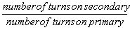

× p.d. across primary gains 1 mark
2

(c) any two from:
• to reduce the voltage / p.d. (of the domestic supply)
or to reduce to 230 V
allow ‘to reduce to 240 V’
do not credit ‘reduce current to 230V’
• higher voltage difficult to insulate
• higher voltage (would) result in (fatal) electric shock
not just ‘less dangerous’
• domestic appliances are not designed for (very) high
voltage (input) / (are designed) for 230V
do not credit ‘to increase efficiency’ / ‘to save energy’ do not credit just ‘it’s safer’
2

(d) any two (1) each
• if the (local) power station breaks down / fails / demand /
load exceeds supply
1
or words to that effect
• electricity / power can be switched from elsewhere in the
system / from other power station(s)
or words to that effect
• electricity can be generated in places remote from customers
or words to that effect
• (in total) fewer power stations are needed
• power available in rural / remote areas
• National Grid allows for (better) control of supply and demand
do not credit just cheaper / more efficient / safer
1
[9]

M6. (a) 10 500
allow 1 mark for 75 × 32 200 ÷ 230
2

(b) any three from:
• alternating current (a.c.) in the primary (coil)
• produces a changing magnetic field / flux (in the core)
• which is made of (laminated soft) iron
• this induces
must be idea of inducing something in the secondary coil
• an alternating potential difference across the secondary coil
accept voltage for potential difference
3
[5]

M7. (i) 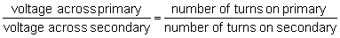

accept input for primary
accept output for secondary
accept 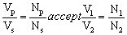 or correct transposition
1
(ii) 60
allow 1 mark for correct transformation
2
[3]

M8. (a) output voltage less than (the) input voltage
or p.d. across output less that p.d.
across input or output is (only) 4.2 V
(whereas) the input is 230V
or WTTE (words to that effect)
1

(b) any two from
(made of soft) iron
laminated
or designed to reduce eddy currents
or made of thin slices with slices of insulating material between them
core(s) joined to make a ring

2
[3]

M9. (a) (i) one of the following:
• increase number of turns on the secondary coil
• decrease number of turns on the primary coil
1

(ii) constructed in (thin) layers
1

(b) (i) transformers only work with a c
1

(ii) used to increase or decrease or change voltage or current
reducing the energy or heat or power loss (along the cables)
1
or reduce to safe domestic level
must be consistent with first answer
1

(iii) (several metres of) air gives good electrical
insulation (between cables and earth)
or reduce chance of earthing or sparks or arcing
or to avoid people touching it
1

(c) (i) 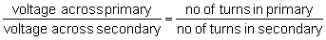

accept 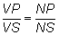

or 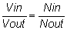
1

(ii) Np = 4000

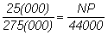 for 1 mark
2

(d) (i) resistance of cable decreases
1
(ii) convection (to the air)
or
conduction (to the air)
not radiation
1
[11]

M10. (a) (i) Iron
for 1 mark
1

(ii) V/240 = 2000/10 000
V = 48
V
for 1 mark each
3

(b) changing current in primary causes changing (magnetic) field in core links to secondary inducing voltage (emf) in secondary (NOT current) secondary voltage/current is alternating
for 1 mark each
4

(c) magnetic field not changing/no electromagnetic induction because direct current
for 1 mark each
2
[10]

M11.
each mark may be gained from a written description or from a caption on the diagram or from both together but do not credit if there is any contradiction between them
one coil on each side
1
of insulated wire
or insulated coil
1

number of turns on primary coil/coil 1/input coil greater than number of
turns on the secondary coil/coil 2/output coil
this must be clear for example do not credit more coils do not credit bigger coil
1
core of laminated iron
or core of (soft) iron
1
[4]

M12. (a) an alternating input / current to primary (coil)
1
which produces an alternating magnetic field
accept changing magnetic field for alternating magnetic field
if first mark point scores then ‘alternating’ not required here
1
in the (iron) core
this magnetic field links with the secondary coil
1
which induces an (alternating) voltage / p.d. across the
secondary (coil)
1

(b) 0.21
accept 0.2 or any answer that rounds to 0.21
allow 1 mark for correct equation
ie power input = power output
or
allow 1 mark for substitution into correct equation
ie 230 × I_{p} = 12 × 4
2
[7]

E2. (a) (i)(ii) It was a common erroneous statement that the core of a transformer conducts electricity.
Many candidates, in their responses to (a)(ii), failed to include any reference to the changing or alternating nature of the input, of the magnetic field or of the output.
Few candidates explained why the coils are made of insulated wire.
(b) Most candidates gained both marks.

E3. Foundation Tier
(a) (i) A majority of candidates identified the secondary coil.
(ii) Only a small minority of candidates could identify the transformer’s core and state that it is made of iron.
(iii) A small minority of candidates gained any credit for magnetic field, and only the better candidates knew it is alternating. Most candidates claimed that the current passes through the core to the secondary coil.

(b) The majority of candidates correctly identified the ‘step-up’ and ‘step-down’ transformers.

(c) The majority of candidates gained both marks by realising that to reduce the risk, new houses should not be built near to existing power lines and that new power lines should not be built near to where people live.

Higher Tier
(a) (i) Nearly all candidates could name the secondary coil.
(ii) The majority of candidates could name the core and knew that it is made of iron.
(iii) The majority of candidates knew that there is a magnetic field in the core, but only about half of these candidates knew that it has to be a changing magnetic field.
Examiners were disappointed to note that a significant proportion of candidates continue to suggest that the core conducts an electric current from one coil to the other.

(b) Nearly all candidates correctly identified the ‘step-up’ and ‘step-down’ transformers.
The majority of candidates were able to identify two appropriate suggestions for reducing possible health risks from power lines.

E4. The answers to this question were generally pleasing. In (iii) the expected scoring response was to reverse the input and output terminals but full credit was also given to the many candidates who correctly rewired the transformer.

E5. (a) (i) There was no mark just for ticking the second box. Candidates had to explain how they knew that the transformer in the diagram is being used as a step-down transformer. Many failed to do this because they wrote that there are more coils on the output side than there are on the input side. Candidates are expected to distinguish between the terms ‘coils’ and ‘turns’ with reference to a transformer. Some correctly stated that there are fewer turns on the output coil.
(ii) About a quarter of candidates correctly explained that, otherwise, the current would be conducted through the core or would short across the coil. Those who suggested that the insulation would reduce or prevent heat transfer or protect against electric shock did not gain the mark.
(iii) Most candidates incorrectly thought this was because iron is an electrical conductor. Others had the correct idea when they stated that iron is a magnetic material and they gained a mark for this. Others went further and stated that iron is a soft magnetic material and so it is easily magnetised and easily demagnetised.

(b) About half the candidates were able to use the equation correctly to calculate the potential difference across the secondary coil.
(c) Many candidates knew this was to reduce the potential difference. Few candidates knew that it increases the current. The difficulty in insulating high voltage was hardly ever referred to. Vague statements such as, ’It’s safer’, did not gain the second mark.
(d) The most popular form of an answer which gained two marks was to state that if the local power station breaks down then the National Grid will enable other power stations to be used. Very few answers were in terms of supply and demand.

E6. (a) Most candidates were able to rearrange the numbers to 75 × 32 200 ÷ 230 and so correctly gave 10 500 as the number of turns, a minority of candidates incorrectly added a unit.
(b) There were many incorrect answers. Some candidates seemed to have invented their own set of questions; ‘Is this a step-up or a step-down transformer? How do you know and what else might it be used for?’ Others wrote about current or, voltage, flowing through the core to the secondary coil. A significant minority of candidates misunderstood the term ‘turns’ and seemed to think that the coils rotate.

E7. This question was often high scoring.
Most candidates could recall the equation needed in this part and many candidates went on to calculate the correct answer.

E8. Most candidates gained the mark in (a) and gave at least one correct feature in (b). Some students thought that soft iron is soft, as they had written ‘made of iron’ as their first feature and ‘soft’ as their second feature.

E9. Candidates found part (a) difficult. Many answers simply described changing number of turns without specifying the coil or if it would cause an increase or decrease. The vast majority of candidates seemed to think that a laminated iron core was covered in plastic. Part (b) was not well understood, with few sensible responses given to part (iii). In part (c) many candidates were able to produce the correct equation and continue to complete a correct calculation. In part (d) the better candidates were able to relate their answer to resistance.

E10. Part (a) was well answered, very few missed iron as the transformer core material and the great majority calculated the output voltage correctly. In part (b) a few totally correct answers were obtained but many candidates gave inadequate information. The fact that the magnetic field had to be changing to induce a voltage was not appreciated in this context by many candidates, even those who were to go on and answer part (c) correctly. For those candidates who did start their answers with an a.c. in the primary coil many scored near full marks, the only common error being to induce a current rather than a voltage in the secondary coil. In part (c) many candidates attributed the zero output voltage to the battery supplying d.c. rather than a.c. but fewer went on to explain that without a changing magnetic field a voltage would not be induced.

E11. Many candidates appeared to think that a current is meant to flow from the input coil to the output coil through the core of a transformer. They either stated this was the case or omitted to mention that the coils are of insulated wire. Many answers muddled coils and turns and only a minority was sure that for a step-down transformer the greater number of turns would be on the input coil.

